Mental Health and Disabilities
By Emma Jago (she/her)
Stigma around mental health has declined significantly in recent years. Often when someone thinks about trauma, their initial thoughts relate to victims of sexual assault, family violence, war, major accidents, and emergency services personnel. Although these are of high importance, it is also essential to recognise that there are rarely discussions around the impact on one’s mental health that results from living with a disability.
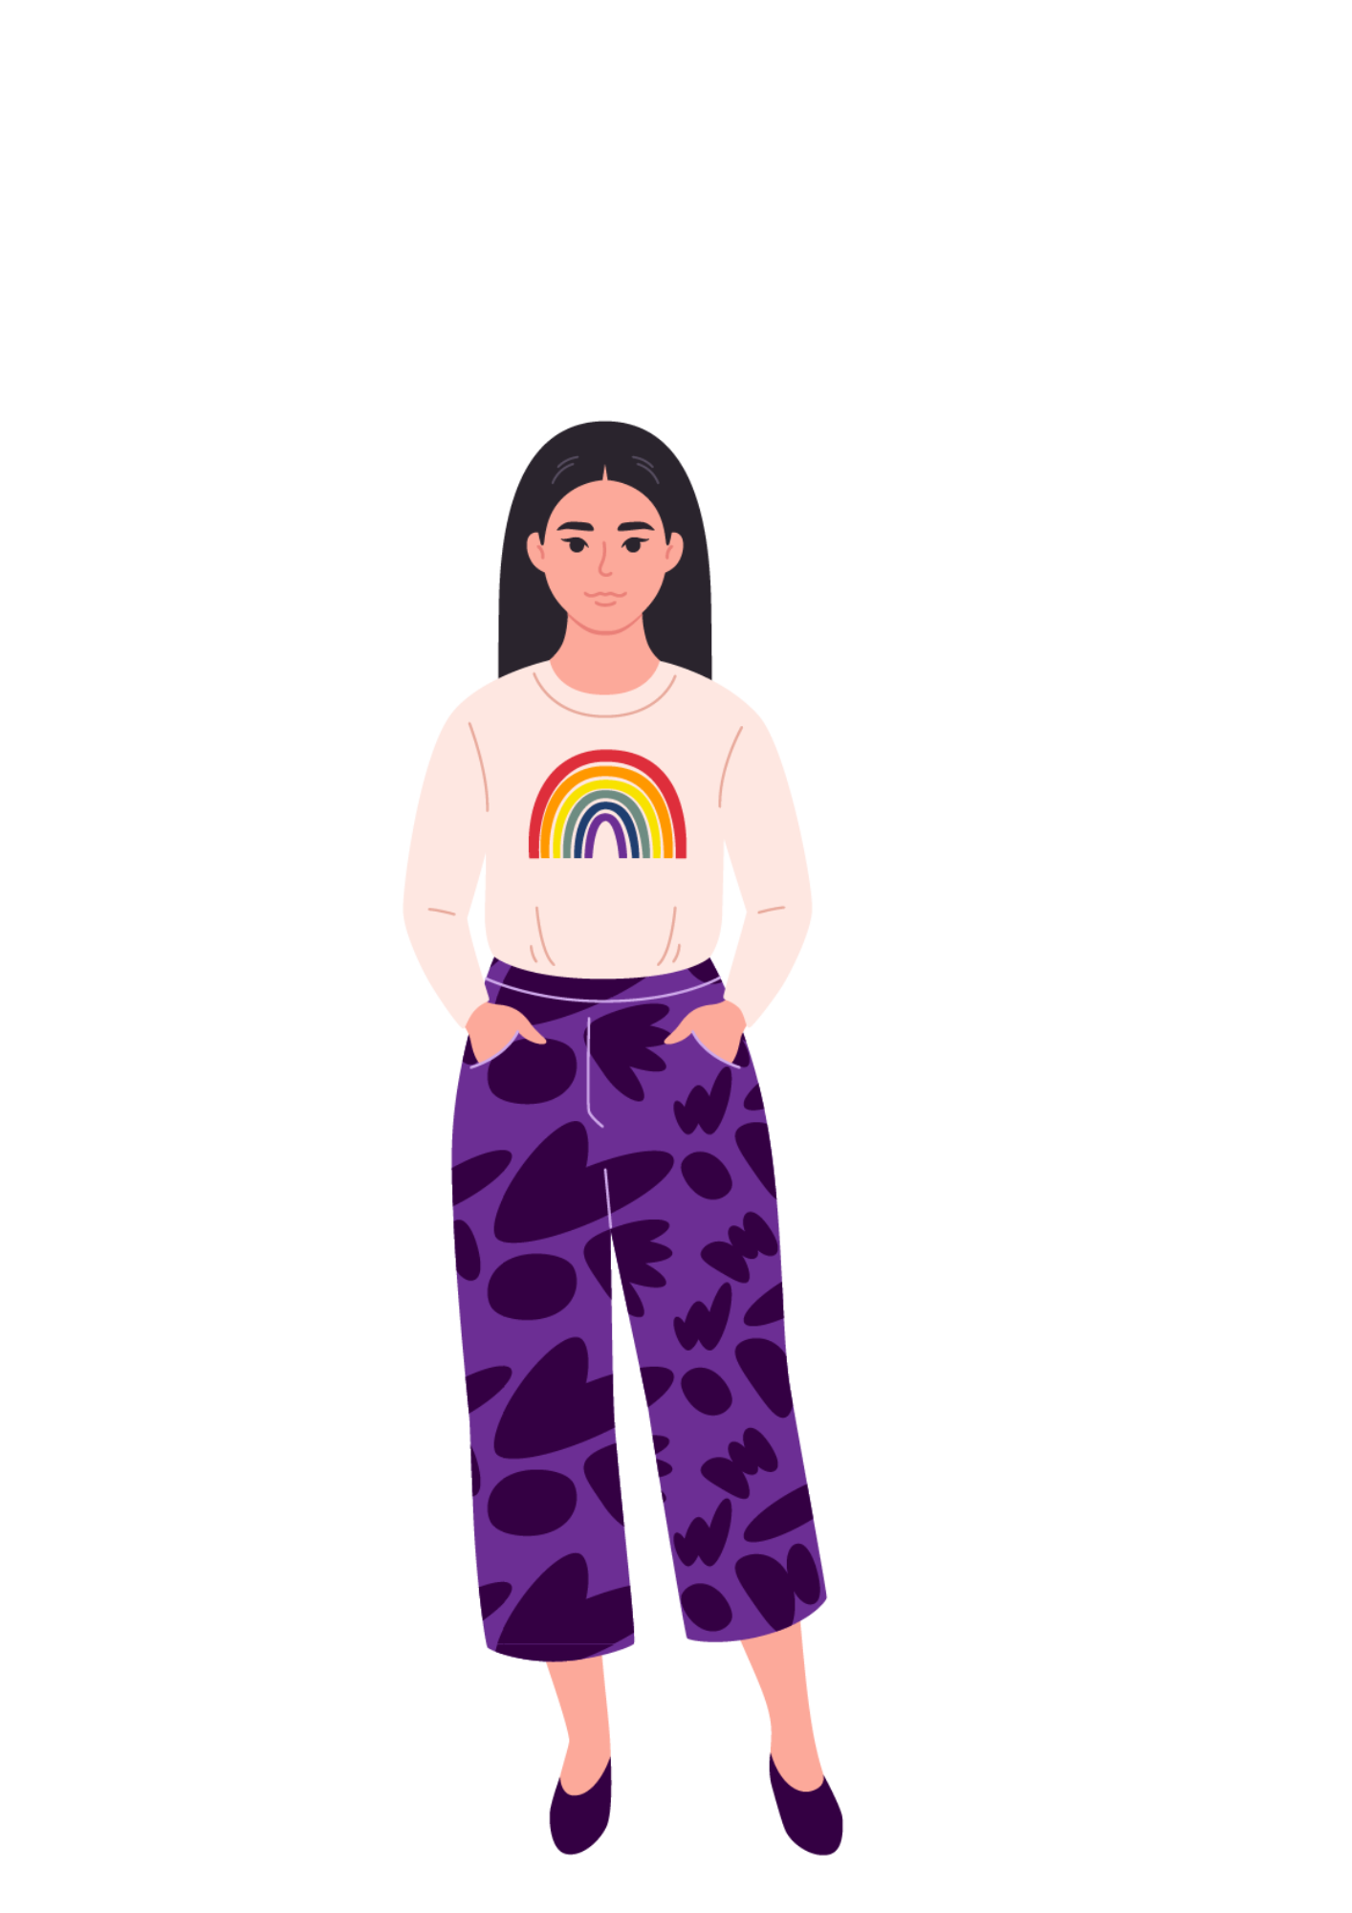
There are personal accounts that can be found on social media that make it clear that many people have encountered experiences where they are treated differently by society as a result of their disability.

Poor mental health is very common among those of us who are seen as “different,” in society. One might have a disability, be a member of the LGBTQI community, be a person of colour, or have differing beliefs, etc. Due to being seen as “different”, we are often treated in different ways that can cause our mental health to decline.

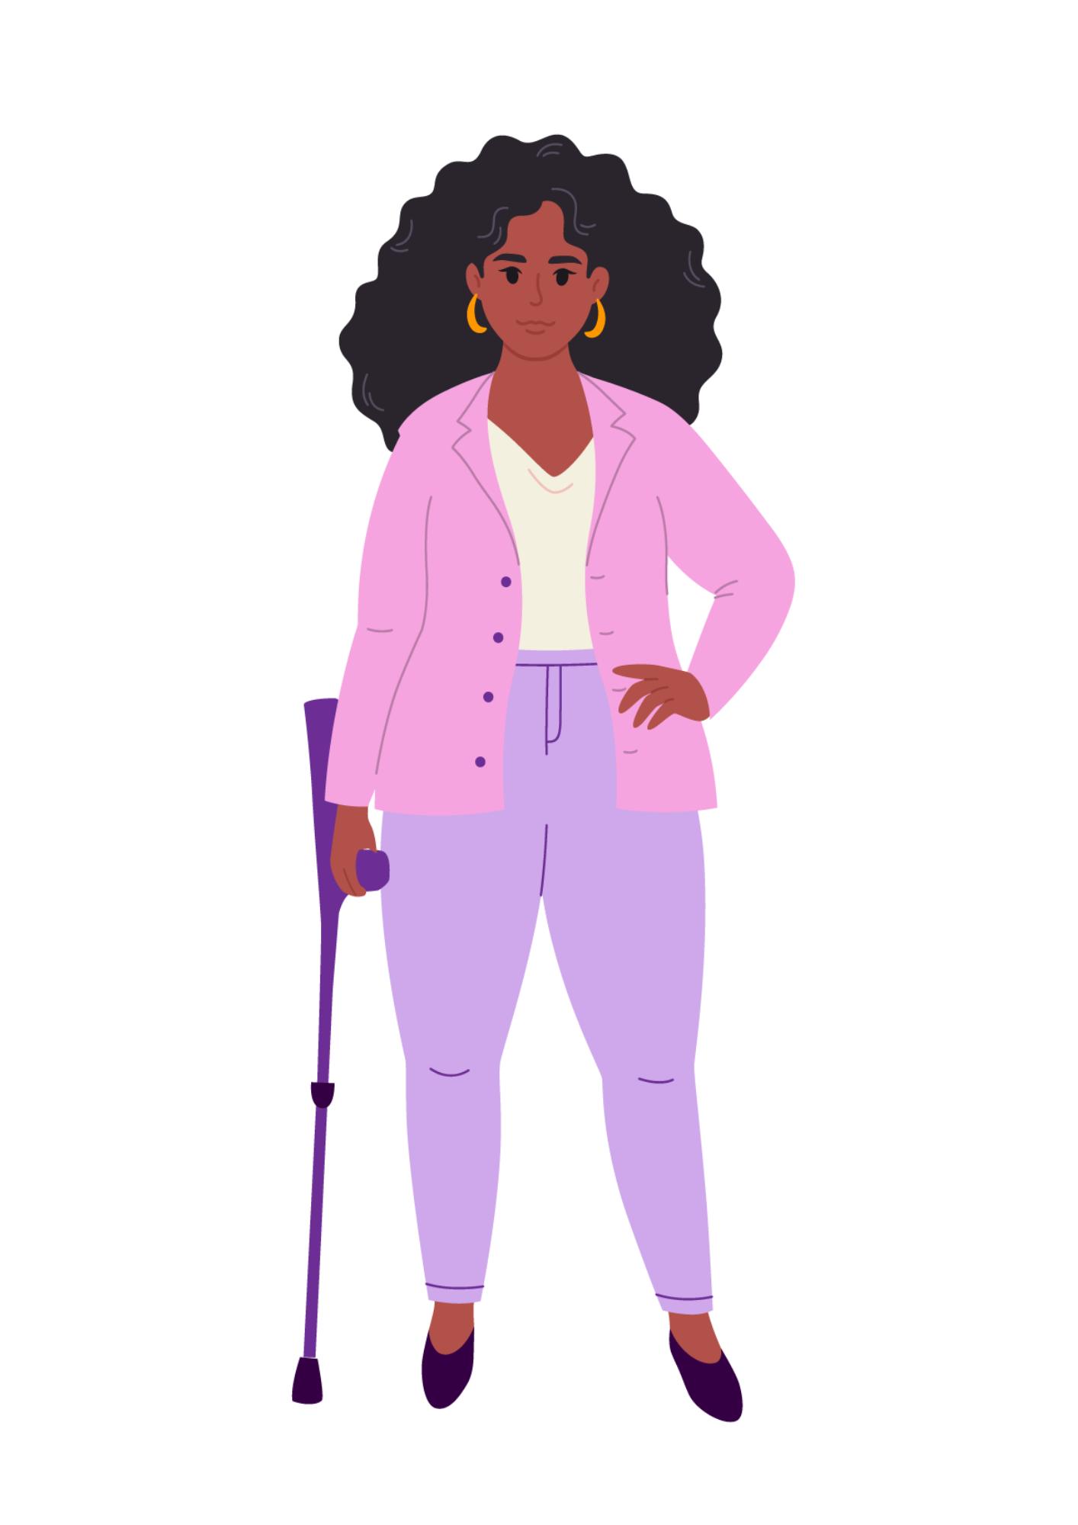
Unfortunately, many people lack understanding and knowledge that diverse people are still people, and ought to be treated like everyone else. In addition, those who are seen as “normal,” often cannot understand what it is like to be on the outside. Consequently, those who are seen as “outsiders,” are often bullied and/or excluded at school by their peers and/or teachers, have difficulty finding and keeping employment, experience discrimination, and experience being treated differently or as a lesser member of society. This can result in isolation, depression, anxiety, trauma, and other diagnosis that can have a negative impact on the mental health of an individual.

If you are like me, you might be thinking that your disability, the colour of your skin, religion, or identifying as LGBTQI as the problem. Perhaps your brain tells you something like “if I did not have a disability, I would not be bullied.” If this is the case, I would like to offer a different perspective: that it is not you or your identity that is the problem. We would experience less of an impact on mental health if people were more accepting, open minded, less judgmental, inclusive, understanding, and reasonable. Thus, although it can be difficult to acknowledge and accept, the problem is not you and your disability, identity, sexual orientation, religion, colour, whatever separates you from your colleagues/peers/community.

Can you imagine a world where Braille is everywhere, audio description is the norm, Auslan is a given, wheelchair inaccessibility does not exist patience was expected and given, everyone accepted for who they are and how they identify, and discrimination abolished? It is the world that needs to change, not you.
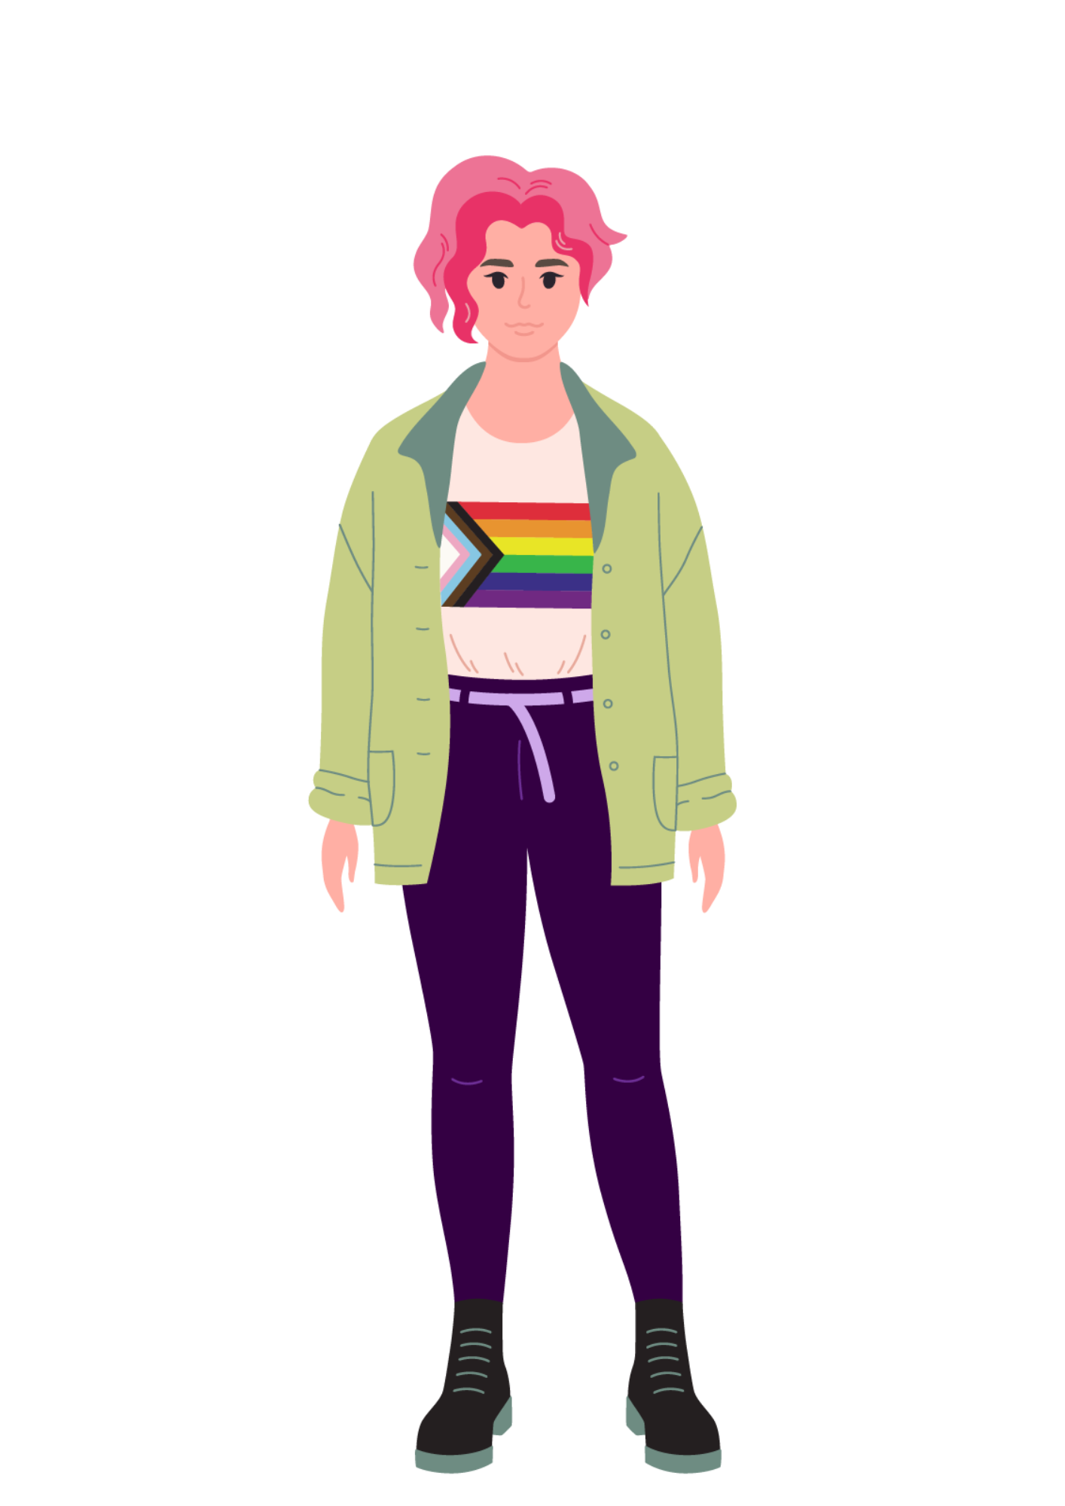
Mental health has a big impact on one’s life socially, physically, spiritually, and emotionally. It is important to acknowledge that there are many contributors to a decline in mental health, one of which is the effects from living with a disability and/or how this intersects with other identities such as sexual orientation, race, gender, and religion. Our experiences can shape us, but they do not define us. It is okay to feel however you feel, and all emotions are valid. If you are struggling with your mental health or think you could benefit from support, please reach out. There is no shame in mental health, seeking mental health professionals, or being on medication and spending more time on self-care for mental health.

Throughout my life I have often felt that I am the problem because if I were not disabled: I would have fitted in and had friends at school, no alternative formatting would be required for education, and life would generally be a lot easier if I did not have a disability. Despite the logic in this, I have reached the point of realising that my disability is not the problem. It has not been an easy journey, and for some people it might be a long road to acceptance.
There are people who understand what you have gone or are going through, even though it may not feel like it. I do not know yet what comes after the realisation and acceptance that my disability and I are not the problem. I have a long and bumpy road ahead of me regarding mental health with no idea what is around the corner. There are limited resources on disability and mental health, but there are people on my team and there are people in your corner too.

You might find connection through:
Social media
- Reddit
- Facebook
- WhatsApp groups

In person
- Disability specific organisations like WDV
- LGBTQI / age / faith / cultural / other identity based groups
- Hobby / interest based community groups

Mental Health Professionals
- GP doctors – making a mental health care plan
- Psychologist/counselor – mental health professional
(cannot manage medication)
- Psychiatrist – mental health medication
(can manage medication)

Support Services
- Beyond Blue
Phone: 1300 22 4636.
Online chat – https://www.beyondblue.org.au/support-service/chat.
Beyond now – beyond blue suicide prevention plan app

- Blue Knot
Phone: 1300 657 380
Email: helpline@blueknot.org.au

- Headspace
Phone: 1800 650 890
Online chat: https://headspace.org.au/online-and-phone-support/connect-with-us/

- Lifeline
Phone 13 11 14
SMS – 0477 131 114
Online chat – https://lifelinedirect.org.au/hunter/services/crisis-chat
A list of further Support Services is available at www.wdv.org.au

