# new wdv logoAboriginal and Torres Strait Islander flagsLGBTQIA+ Pride flag

**Participant Application Form**

**The Victorian**

**Enabling Women Leadership Program**

**Autumn, 2025**

## About WDV

Women with Disabilities Victoria (WDV) is an organisation run for and by women and gender diverse people with all kinds of disabilities.

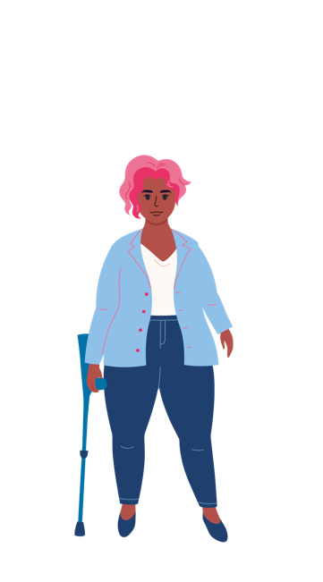Our members are people of all ages, backgrounds and lifestyles. We strive to be a safe and inclusive service for all women and gender diverse people.

We advocate for our right to safety and respect with a focus on empowerment and leadership.

## About Enabling Women

The Victorian Enabling Women Leadership Program (the Program) is a community-based Program, where we explore leadership in fun and meaningful ways.

During the Program you will also work with a mentor, who will support you to achieve a leadership goal.

The Program will be delivered in a **hybrid way**. You can choose to attend in person at WDV’s office **in Melbourne’s CBD, or online via** **Zoom.**

There will be up to **14 participants**.

**Program sessions and the Graduation will held be on Wednesdays,**

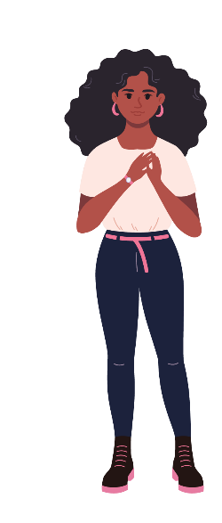There will be **8 program sessions**, that will each run for **3 hours**. **Breaks** will be included.

Program sessions will run from **April 2 – May 28.** There will be **no Program session on Wednesday April 23.**

In June we will have a **Graduation** event to celebrate your success of completing the Program.

**The program is open to:**

* Women and gender diverse people, who are
* aged 18+ and who
* live, work, study or play in the state of Victoria, and
* Identifies as someone
* with disability (physical, sensory, intellectual, cognitive, etc.)
* who is Deaf / deaf / hard of hearing
* who lives with chronic illness, and / or pain
* who is neurodiverse, e.g. autistic, lives with ADHD, OCD, learning disabilities, tics, etc.
* who lives with mental health challenges.

## *Graphic of a woman with grey hair and light skin. She is mid-clap.* Completing the Application form

Application forms can **be completed electronically, by hand, or by recording your answers in a video or audio recording.**

There is also an **Easy Read version** of this Application Form. You can find it on[WDV’s website](https://www.wdv.org.au/our-work/our-work-with-women/enabling-women-leadership-program/)or call Bridget on **03 9286 7813** for a copy.

If you are using a computer to fill out the below form, you can check boxes with a mouse click or use the spacebar key on the keyboard.

Completed applications should be emailed to Bridget at [leadership@wdv.org.au](mailto:leadership@wdv.org.au)

If you are submitting a video or audio version, please email Bridget at [leadership@wdv.org.au](mailto:leadership@wdv.org.au)or call her on **03 9286 7813** to discuss how to send the file.

## Help and More information

**Do you have questions or need help to fill out this form?**

If you would like more information, or help to fill out this form, please contact Bridget.

**Phone**: **03 9286 7813**

**Email:** [leadership@wdv.org.au](mailto:leadership@wdv.org.au)

## Application Form

## Your details

|  |  |
| --- | --- |
| Information required | Your response |
| First name |  |
| Family name |  |
| *Optional* Pronouns *E.g.. she/her or they/them* |  |
| Year of birth |  |
| Postal address |  |
| Suburb |  |
| Postcode |  |
| Best contact number |  |
| Email |  |
| *Optional* ****Do you identify as Aboriginal and/or Torres  Strait Islander?**** | Yes – Aboriginal  Yes – Torres Strait Islander  No |
| ****Do you speak a language other than English at home?**** | Yes. What language/s?  No |

## 

## Questions about you

|  |  |
| --- | --- |
| Information required | Your response |
| 1. What are your passions and interests? |  |
| 2. Why are you interested in doing this program? |  |
| 3 a. Thinking about your gender, and disability, (or other areas of life) what things may stop you from doing the things you want to do? |  |
| 3 b. Have you been able to overcome this? | ☐ Yes  ☐ No |
| 3 c. If yes, what did you do? |  |
| 4. What connections do you have with the state of Victoria? (E.g. where you live, work, study, etc.) |  |
| 5. Do you currently, or have you previously participated in any WDV Programs / projects? What were they? |  |
| 6 What groups are you currently, or have you previously been a part of? What do / did you do with the group? E.g. Group committees, sporting clubs, Church groups, committees, |  |
| 7. How did you hear about the Enabling Women Leadership Program? |  |

## Participation Questions

|  |  |
| --- | --- |
| Requirement | Your Response |
| 1. Do you expect to participate mostly in person, or online? | In person  Online  It depends / unsure |
| 2. Do you have access to a computer or tablet, with internet at home? | Yes – computer  Yes – tablet  No |
| 3. Is the internet connection reliable? | Yes  No  Sometimes |
| 4. If you have a computer, does it include these things? | Microphone  Webcam  Speaker  Headphones |
| 5. If you do not have the right equipment at home, and you want to participate online, what can we do to support you? |  |
| 6. Have you done an online video meeting before? | Yes - Zoom  Other – what did you use?  No |
| 7. Would you like any help to use Zoom? | Yes – please tell us in what ways?  No  Not sure |
| At times we may talk about confronting topics (for example, gender based violence).  7 a. Do you feel comfortable participating online from your home? | Yes  No  Not sure |
| 7 b. Do you have a safe space at home to be alone and do the Program? | Yes  No  Not sure |

## Support and access

|  |  |
| --- | --- |
| Requirement | Your Response |
| Are there any access requirements, or supports that may help you to fully participate? | If you think you may need one of these supports, please tick the box and provide more information if requested. |
| Attendant care |  |
| Note-taker |  |
| Interpreter | If yes, what language? |
| Wheelchair access |  |
| Dog guide / Service animal facilities | If yes, what requirements? |
| Transport / accessing the venue | If yes, what requirements? |
| Information in alternative formats | If yes, what formats? |
| Dietary requirements | If yes, what requirements? |
| Do you have any other access or participation requirements? | If yes, what requirements? |

Completed applications should be emailed to Bridget at WDV - [leadership@wdv.org.au](mailto:bridget.jolley@wdv.org.au).

If you have questions, or want to submit a video or audio version, please email [leadership@wdv.org.au](mailto:bridget.jolley@wdv.org.au), or call Bridget on **03 9286 7813** to discuss how to send the file.

**Thank you for your application!**