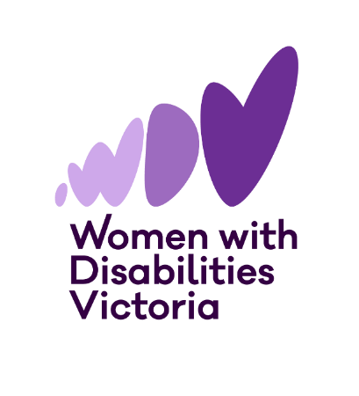

**Participants Wanted**

**The Victorian**

**Enabling Women Leadership Program**

**Autumn, 2025**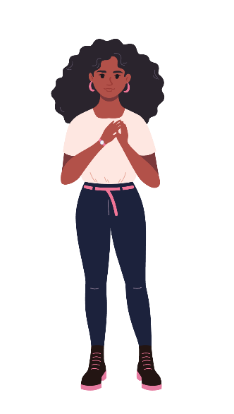

**Do you want to become a stronger leader?  
Are you someone who identifies as a woman or gender diverse person with disability?  
Are you connected with the state of Victoria?

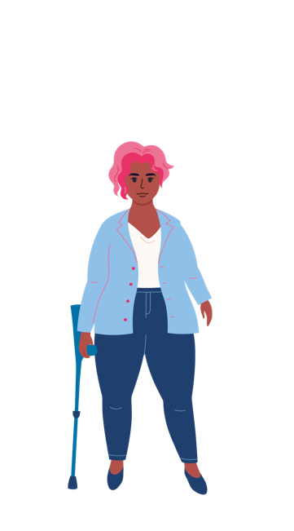**Come join us, and become the leader you want to be, as part of the Enabling Women Leadership Program!**

**You will:**

* build confidence
* explore who you are
* reflect on your strengths (the things you’re good at)
* learn more about your human rights
* practise speaking up
* work with a mentor to achieve a leadership goal
* become a better leader in your community.

****Where:** In person at WDV’s Melbourne office, or online via Zoom

**What:** 8 x 3-hour group program sessions, 5 individual mentor sessions, and a Graduation Celebration

**When:** Program sessions and the Graduation will be onWednesdays, Program sessions will run from April 2 – May 28. The Graduation will be held in June.

*Please note: There will be no Programs session on April 23.*

**Cost:** FREE

**Included in the Program:**

* All materials – folder, workbook, activity and craft supplies, etc.
* Access supports
* snacks

**To find out more, and to apply:**

Visit our [website](https://www.wdv.org.au/our-work/our-work-with-women/enabling-women-leadership-program/), including for various accessible application forms.

To ask questions about the Program, or to get help completing an application form, please contact Bridget Jolley.

**Email:** [leadership@wdv.org.au](mailto:leadership@wdv.org.au)

**Phone:** 03 9286 7813

