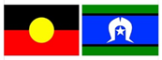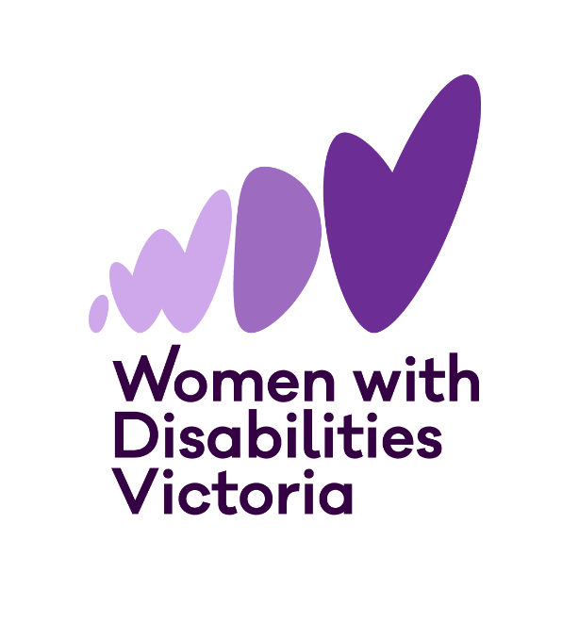



**Information and Application Form**

**The Victorian**

**Enabling Women Leadership Program**

**Autumn, 2025**

# infomration symbolA purple circle with a white question mark in it

# Information and help to apply

**Do you want more information, or help to apply?**

1. Go to [WDV’s website](https://www.wdv.org.au/our-work/our-work-with-women/enabling-women-leadership-program/)

Or

2. You can contact **Bridget at WDV.**

Email: [leadership@wdv.org.au](mailto:leadership@wdv.org.au)

Phone: 03 9286 7813

# PART A:

# Introduction to the Enabling Women Leadership Program



**Women with Disabilities Victoria (WDV)** is an organisation run for and by women and gender diverse people with all kinds of disabilities.

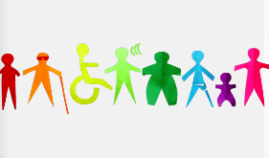Our members are people of all ages, backgrounds and lifestyles.

We are a proud LGBTIQA+ ally.

We want to be a safe space and to include all women and gender diverse people with disabilities.

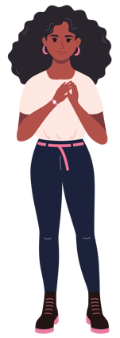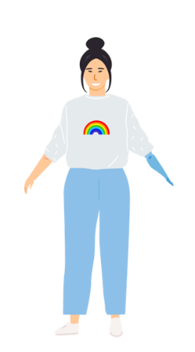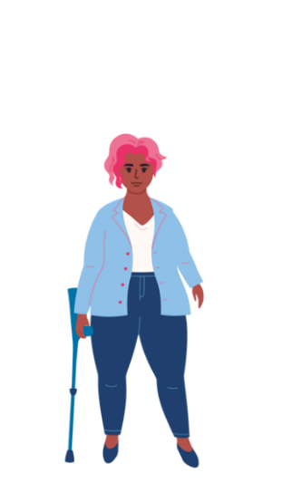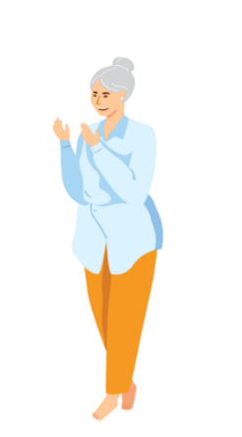

We focus on rights to safety and respect.

This includes being able to speak up for ourselves and being leaders.

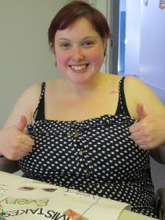In **The Enabling Women Leadership Program (also known as the Program)** women and gender diverse people with disability learn how to become stronger leaders.

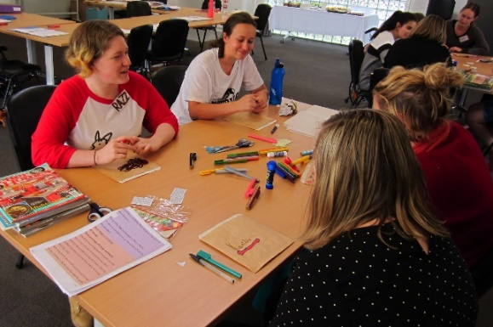

We do this in fun and meaningful ways.

Map of Meblourne CBD. A purple arrow points to the WDV office on Bourke St

The Program will be **hybrid**.

This means you can attend in person at the WDV Office in Melbourne CBD

Or

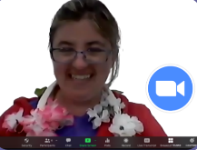

Online via Zoom.



There will be **8 Program sessions**.

A purple circle with a number and arrow


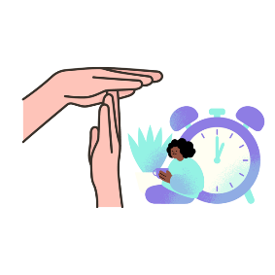

Each session will be **3 hours long**.

Sessions will include breaks.



Program sessions will be on **Wednesdays, 1:00 – 4:00pm**

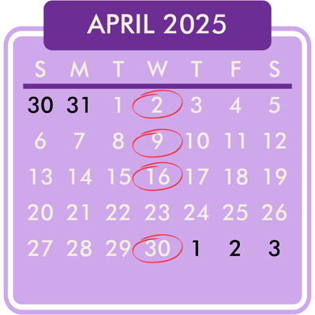

Program sessions will run from

**April 2 – May 28.**

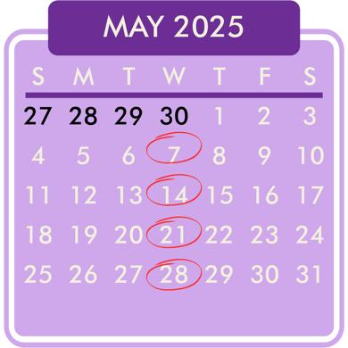There will be **no Program session on Wednesday April 23.** The Graduation will be held in June.

****The Program will have up to 14 participants.

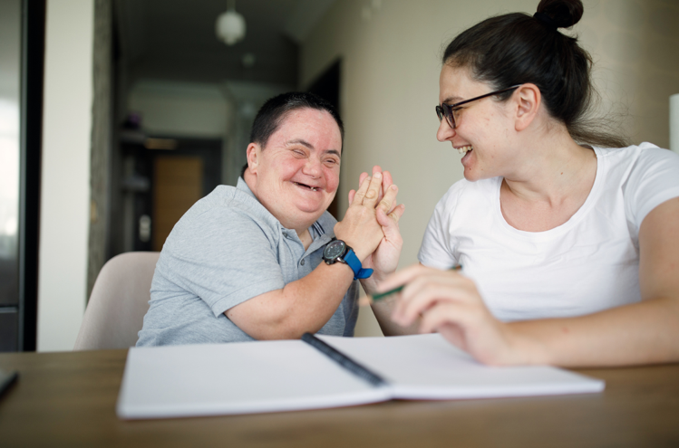

During the Program, participants will work with a **mentor**.

**Mentors support people to achieve a goal.**

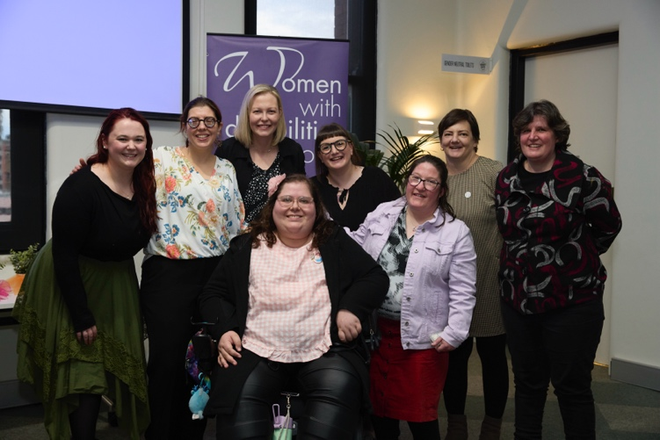

The Program will finish with a **Graduation celebration**.

# Who can participate?

**You can participate, if you**

* 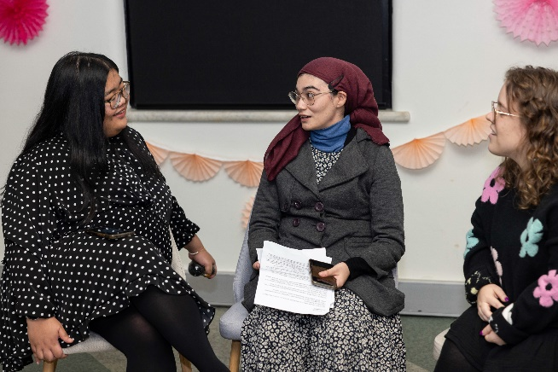are a woman or gender diverse person, who is

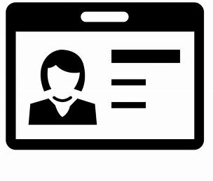

* aged 18+, and

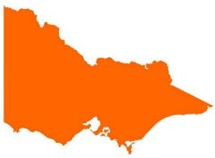

* lives, works, studies, volunteers or plays in the state of Victoria, and
* 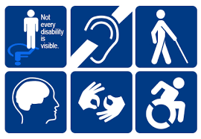who identifies as someone
* with disability (physical, sensory, intellectual, cognitive, etc.)
* who is Deaf / deaf / hard of hearing
* who lives with chronic illness, and / or pain
* who is neurodiverse, e.g. autistic, lives with ADHD, OCD, tics, learning disabilities, etc.
* who lives with mental health challenges.

**Completing the Application Form**

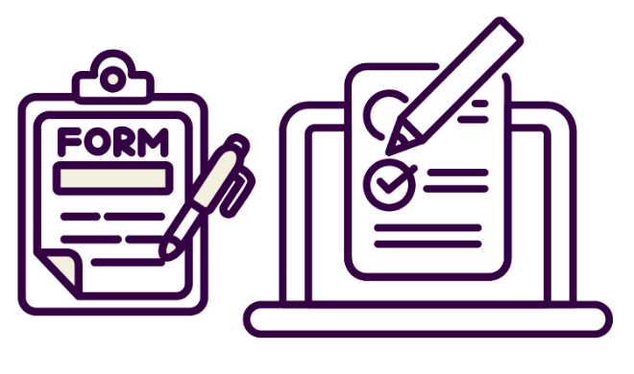To take part in the Enabling Women Leadership Program, you will need to fill out this **Application Form**.

A purple circle with a white question mark in it


**If you want help:**

You can ask someone you trust to help complete and send the form.

Or,

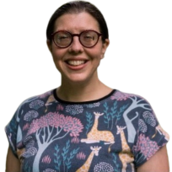

You can also contact **Bridget** at WDV for help answer questions and fill in the form.

Email: [leadership@wdv.org.au](mailto:leadership@wdv.org.au)

Phone: 03 9286 7813

**You can fill out the form:**

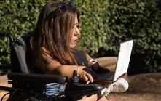

* On a computer,



* By hand,

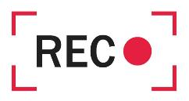

* Or record your answers in a video or audio recording.

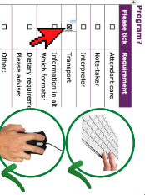

If you are using a computer to fill out the form, click the mouse or use the spacebar key to select check boxes.



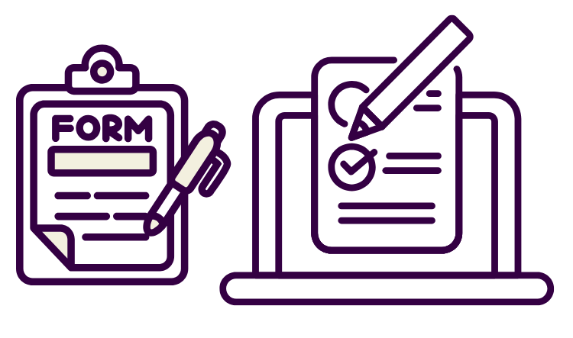**Please email Bridget at WDV the completed form, or contact Bridget and let her know you have made a recording.**

You can **contact Bridget via email or phone.**

Email: [leadership@wdv.org.au](mailto:leadership@wdv.org.au)

Phone: 03 9286 7813



**PART B:**

**Application Form**

# Your Details

\***Optional\*** = only answer if you want to

|  |  |
| --- | --- |
| Information required | Your response |
| Person poinint to a name tag on their chestFirst and last name |  |
| *3 people of diverse appearance. Beside each one a label. "He/Him", "She/Her" and "They/Them".* *Optional*  Pronouns | *How should people refer to you? Examples “she”, “they”, “he”, or something else.* |
| Calendar and birthday cakeYear of birth |  |
| A map of victoria and a picture of a houseStreet Address |  |
| A map with a push pin stuck to it Suburb  and  Postcode |  |
| Phone iconBest contact phone number |  |
| Email iconEmail address |  |
| Picture of the world surrounded by words in different languages*Optional*  ****Do you speak a language other than English at home?**** | Yes – what language/s?  No |
| The Aboriginal and Torres Strait Islands flags*Optional*  ****Do you identify as Aboriginal and/or Torres  Strait Islander?**** | Yes – Aboriginal  Yes – Torres Strait Islander  No  Prefer not to say |

# Questions about you

|  |  |
| --- | --- |
| Information required | Your response |
| 1. *A woman playing an acoustic guitar in her wheelchair* What do you do for fun? |  |
| 1. Person raising hand to show interestWhy do you want to do this Program? |  |
| 1. *A "welcome" mat with a red crross drawn through it*  Has anything stopped you from doing activities and other things you want to?   Particularly because of your gender or disability? | Yes  No  Not sure  If yes, what sort of things? |
| 1. The back of a wheelchair user with her arms raised in celebration. She has broken through the graphic of a barrier, that is now split in half.  Did you get through the problem?   If yes, how? | Yes  No  Not sure  If yes, how? |
| 1. Map of Victoria, filled in orangeWhat connection do you have with Victoria? | *Examples, where you live, study, work, volunteer,or play.* |
| 1. Photo of a group of diverse women and non binary people with disability, some with arms raised proudly. Do you, or have you been part of any WDV programs or pojects? What ones? | *Examples: Member events, Hubs, Workshops, etc.* |
| 1. A group of people runningWhat groups are you a part of now, or have been in the past? What do / did you do with these groups? | *Examples: Peer group, committees, sporting club, Church, community groups. Etc.* |
| 1. Photo of a hand holding a smart phone. Graphics of social media floating out of it. And a laptop computer with the WDV logo on it. How did you hear about the Enabling Women Program? |  |

# Participation Questions

|  |  |
| --- | --- |
| Information required | Your response |
| 1. Grahphic of a woman with a thinking face. Two thought bubbles above her. 1 contains a meeting in person. 2 a person working on a computer by themselves Will you mostly participate in person or online? | In person  Online  It depends / unsure |
| 1. Desktop computer screen with the internet connection logo on it. It is all green indicating full internet connection. Do you have a tablet or computer with internet at home? | Yes – computer  Yes – tablet  No |
| 1. Two internet connection logos. The first one is all green indicating full internet connection. A thumbs up next to it. The second logo is only 1/4 green indicating no or little connection. A thumbs down next to it.  Does the internet work well? | Yes  No  Sometimes / Not sure |
| 1. A pair of headphones. A pair of speakers. A webcam.If you have a computer can you use these things with your computer? | Microphone  Headphones  Speaker  Webcam / camera |
| 1. Graphic of an open package, coming out of it is a headset with microphone. If you think you may need extra help or equipment to join online, what help or equipment do you think you might need? |  |
| 1. A person at a desk engaged in conversation with people in an online meeting on a desktop computer. Have you done an online video meeting before? | Yes - Zoom  Yes – Other. What did you use?  No |
| 1. Picture of a red push button that reads "Help"Zoom iconWould you like any help to use Zoom? | Yes – Please tell us in what ways?  No  Not sure |
| 1. Graphic of a young woman sitting cross legged on the floor with a laptop computer in her lap. She is smling. Do you feel comfortable doing the Program at home when talking about   uncomfotable topics? | Yes  No  Not sure / It depends |
| 1. In a red circle a woman looking comfortable. A Lock symbol and a green tick next to her. Do you have a safe place at home to be alone and do the Program? | Yes  No  Not sure / It depends |

# Access and Supports

The next two pages ask about access and supports.

Are here any access needs or supports that could help you to fully participate?

If you think you may need one of these supports, please tick the box and provide more information.

|  |  |
| --- | --- |
| Information required | Your response |
| A woman using a powered wheelchair and a woman crouching beside her. Attendant care | To help with eating, going to the bathroom, etc.  Yes - Tell us more: |
| A person with Down syndrome talking and smiling and a woman writing in a book. Note-taker | To help take notes of what’s said, your ideas, etc.  Yes - Tell us more: |
| A person smiling with the hand up  Interpreter | Yes - Tell us more: |
| A black background with a black square  Description automatically generated with medium confidenceWheelchair access | Yes |
| icon for service dogDog guide or service animal facilities | For if we ever meet in person.  Yes - Tell us more: |
| graphic of taxiTransport / accessing the venue? | If yes, what requirements? |
| Easy Read LogoInformation in other ways | Examples: Examples: Easy English, braille, audio, etc.  Yes - Tell us more: |
| Gluten Free Symbol, Halal Symbol, Vegan Symbol and an image of a soft food plate. Dietary requirements | Examples: Vegan, Halal, or soft foods, etc.  Yes - Tell us more: |
| A plus iconOther  What else could help you to participate? | Yes - Tell us more: |

****If you have completed the application form on a computer, phone, tablet, or by hand,, please email Bridget at WDV your **completed application form –** [**leadership@wdv.org.au**](mailto:leadership@wdv.org.au)

This includes sending photos of your hand written form.



If you **want help to fill out the form**, or if you **made a recording**, you can **email or call Bridget** to discuss things further.

Email: [leadership@wdv.org.au](mailto:leadership@wdv.org.au)



Phone: 03 9286 7813

**Thank you for your application!**