**2025 Brenda Gabe Leadership Award**

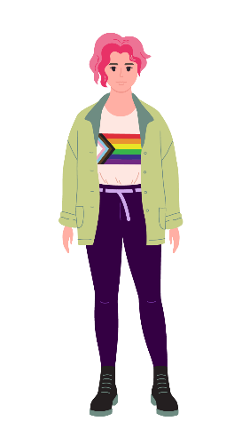  
Celebrating Women and Gender Diverse People with Disabilities

## Find out more here

[www.wdv.org.au/BrendaGabeAward](http://www.wdv.org.au/BrendaGabeAward)

## About the Award

The Brenda Gabe Leadership Award is a biennial award which recognises and rewards outstanding leadership from women and gender diverse people with disabilities in Victoria.

Women with Disabilities Victoria (WDV) invites nominations of individuals or groups who have made a contribution which has either:

* Directly benefited women and gender diverse people with disability, or
* Ensured a more inclusive community for women and gender diverse people with disability in Victoria.



Winner of the 2023 Annual Brenda Gabe Leadership Award Mel Guiney.

The photo is a black and white headshot of Mel who has short dark wavy hair and is wearing a blazer and patterned scarf.

## Eligibility

You can nominate **yourself** or **your group** (self-nomination) or **any individual** who:

* Identifies as a woman or a gender diverse person, and
* Aligns with the values and ethos of WDV, and
* Is 18 years of age or over, and
* Identifies as living with a disability/disabilities; and
* Resides in Victoria.

We encourage the nomination of women with diverse backgrounds and/or life experiences.

|  |
| --- |
| Nomination Period **Nominations open: Thursday 13 March 2025**  **Nominations close: 5:00pm Wednesday 23 April 2025** |

## Presentation of the 2025 Brenda Gabe Leadership Award

The recipient of the award will be announced at WDV’s Member’s Event on Tuesday 27 May 2025 and will receive a $2,000 prize for professional development or a capacity-building project.

The recipient will be required to:

* Provide a proposal for the use of the award money (note: the award money cannot be used entirely for purchasing equipment).
* Attend meetings (online or in person) with WDV representatives once every 6 months for the 18 months following receipt of the award.   
  (These meetings will be used as check-ins and to support the recipient. The award recipient will also be offered the opportunity to discuss with the Board how else they could be reasonably supported.)
* Provide a demonstration of the use of the award money, including a report discussing the impact of the professional development or project, by March 2027.

## To nominate or find out more

To find out more about the award, including how to nominate and details about previous nominees and recipients, please visit:

www.wdv.org.au/BrendaGabeAward

If you would like more information about nominating for this year’s award, please contact Elysia Johnston at WDV:

**P** (03) 9286 7814

**E** bgla@wdv.org.au

## Photo of Brenda Gabe. Brenda is facing the camera smiling and waving and is wearing a purple top and a name badge.About Brenda Gabe

Brenda Gabe became a devoted disability advocate after being diagnosed with multiple sclerosis in 1994. The dedicated mother, psychologist and former champion swimmer was a much-loved member of WDV who represented the organisation on multiple committees and forums. Brenda worked tirelessly on many advocacy campaigns including accessible housing and transport, as well as gender and disability related campaigns, including preventing violence against women with disability.

## Acknowledgement

WDV gratefully acknowledges the significant contribution and support provided by Dr. Helen Sykes AM, Director of Future Leaders, in making this award possible.