 **Why do I need to be married with kids?**

**Breaking down the taboos of being a single and childfree woman.**

Media tile.
With a pink question mark and words "Julie, are you looking for a boyfriend?" "What do you want in a partner?" "Do you want kids?"


I get a variation of these questions at least once a week. Often from family, friends, or peers who are in a

relationship. It is automatically assumed that just because someone isn’t in a relationship that they’re miserable and wallowing in self-pity and want unwanted advice on how to find a partner.

These conversations make me think of Hannah Ferguson’s feminist manifesto called *Taboo*, and how she says, ‘Our default belief system is that a single woman is somehow sadder than an unhappily partnered one.’

I don’t blame people for asking me this question because it is an inbuilt belief due to *social constructionism,* but I can be frustrated with it.

Social constructionism is about how we understand and perceive the world. How people, objects, and events are given allocated meanings based off assumptions and personal/group preferences. This is discussed further in the handbook [The Palgrave Handbook of Critical Social Psychology, written by Viv Burr and Penny Dick.](https://link.springer.com/chapter/10.1057/978-1-137-51018-1_4)

What this means is nothing in life has meaning, until we give it meaning. Ideas and objects, etc, only have meaning because we give them meaning. For example, pink is mainly seen as a colour for girls and blue is mainly seen as a colour for boys. Many gender reveal celebrations use these colours to find out or announce what gender the parents are expecting their unborn baby to be. Also, people buy clothes in these colours specifically thinking of the item being for a boy or girl. When in reality, pink and blue are just colours and any gender can wear those colours – western society has just made pink and blue represent two different genders. Whereas historically, [in the 1700s](https://www.vam.ac.uk/articles/in-the-pink-colour-in-menswear?srsltid=AfmBOor3ezUZkTf-eJmq0_j6PzLgH-zc3_a2LtG4BoCxJw94y0LwffZq), European men wore pink as a sign of wealth and power. It wasn’t until the 20th century that pink became associated with femininity. Social constructionism works with changing meanings based on the current thinking of society.

It is common to believe a woman should aspire to being a wife and being a mother, and therefore a woman who is in a relationship is happy, and a woman who is single is miserable.

When I’m asked about boyfriends and kids, I smile politely and go along with the narrative. We discuss what I’m looking for in a guy (do they have to be short statured, or can they be average height, etc), and we brainstorm the different ways I can meet guys (because there aren’t many guys in the places I work or the community spaces I’m part of, which means I have to go ‘looking’ for them). We laugh about it. We have the same conversation over and over and over. Sometimes it’s fun having these hypothetical conversations and coming up with different scenarios of how I’ll meet my future boyfriend. But the frequency of these conversations and going through the same scenarios makes me feel inadequate being on my own and creates a pressure that I should start actively looking for a boyfriend when I’m comfortable with my life as is. Every time I tell myself that this will be the last time I go along with it, that I’ll simply tell them I’m not interested in having this conversation, I’m not looking, I don’t need suggestions, I am enough. But it just seems easier to go along with the narrative and wait until they’re satisfied to move on.

There is a negative stereotype surrounding single women that there’s something ‘wrong’ with them for being single because they can’t ‘get a man’. She must be ugly (when a woman is viewed as ‘ugly’, there is the stigma that she doesn’t deserve to be with anyone), or a workaholic, or too high maintenance, or too immature, or too picky, or too independent. These negative stereotypes stem from the fear of women objecting to their ‘traditional’ role in society and challenging men’s power and privilege. A woman having high standards is viewed as something negative, when really, she already has a life that is fulfilling and is just looking for someone who can complement her life. Women are shamed for being too picky, and they are also shamed for not being picky enough, and are called derogatory terms like ‘slut’ for hooking up with people casually – women can’t win either way.

It ultimately sends the message that a single woman is less than a person. How did we, as a society, sink this low that we think a woman who is single can’t even be considered a complete person?

People with intersectional identities face other layers of stigma and negative stereotypes. This includes women with disabilities. There are ideas that if an able-bodied person is in a relationship with a person who has a disability, it’s because they feel sorry for them. If two people with disabilities are in a relationship with each other, it’s because no able-bodied person wants to be in a relationship with them. They think people with disabilities are unworthy of being in love and are not sexual beings. There are also many people with different gender identities, such as trans women and non-binary people, who face other layers of negative stereotypes and discrimination, compared to cis gendered, heterosexual women.

Another negative stereotype is that single women hate men. But I don’t hate men, I hate the patriarchy. I hate the system. I hate the systemic oppression. I hate the way many men treat women as less than, as sub-human, and only exist for their approval. I hate that our society is built on a system which makes it easier for men to be seen as successful than it is for women.

Media tile.
Words "I don't hate men. I hate the patriarchy. I hate the system. I hate the systemic oppression."

Hannah Ferguson says in her book, ‘I don’t hate men, I date men.’ I’ve been in relationships with men, and I’m open to being in a relationship, but I’m not going out of my way to find the right guy to be in a relationship with. I don’t feel like something is missing. Just because I’m not actively seeking out a guy, it is assumed I’m sitting around passively. But I’m not sitting around passively, I am living my life – I am writing, I am playing and competing in sports, I am working, I am upskilling, I am volunteering my time for causes greater than myself, I am meeting new people, I am saying yes to new opportunities, and I’m trying new things that sound like fun. I also have many fulfilling relationships with family, friends, and within my community spaces. As Hannah Ferguson says, ‘Being romantically untethered does not make single women alone, it means they only want people in their life who complement it.’

Many men feel like they are competing with other men for a woman. [Evolution shows us](https://www.sciencedirect.com/science/article/abs/pii/S0167268121003152) that a man’s reproductive success depends on him outcompeting other men. But in modern times, although sometimes women do see it as comparing men and sometimes men see it as competing against other men, it’s more-so that men are competing with a woman’s free time. I, and many other women, often assess, *Is spending time with this man better than spending time on my own?* I’m going to keep living my life the way I intend, and I will have relationships when the right person can match the value I get from these other areas of my life.

As many women in their 20s experience, my parents have asked me when am I having kids – when am I going to give them grandkids? Because before a woman is even born, due to social constructionism, it is dictated that she must provide.

My sister is two years younger than me, and when she had a baby, I was relieved, because I thought that would mean my parents would stop asking me when I was going to have kids. But the question simply changed to when am I going to give her child a cousin? I fully respect my sister’s decision to have kids, because it is her choice, it is what she wants. But I should have the same respect in return – my belief that I currently don’t want to have kids should be respected just as equally.

As Hannah Ferguson says in her book, ‘One of my constant battles is the feeling that, if women do not become mothers, they are expected to do something earth-shattering instead.’ As soon as I read this quote, I had a revelation that perhaps this is a contributing reason to why I am such an overachiever.

It's this societal pressure that I feel like since I don’t have kids and don’t plan on having kids any time soon, that I need to have a ‘valid’ reason why. I need to demonstrate I’m using my time ‘wisely’ and that I’m contributing to society.

I am driven to write because I have stories that demand to be told, I am driven to volunteer because I want to give back to the community, and I am driven to advocate because, as a person with a disability, I experience the ableism and hear/witness the ableism of my friends with disabilities. I want to see social change, and I want to be part of it.

Kids become a key priority in their parents’ life, which is as it should be. But I'm worried if I have kids, I won’t be able to do these important things I love, and I will no longer be living my life on my terms. My whole life will revolve around them – making sure they’re fed, taking them to school and after school activities, etc. And I will be living my life in the pockets of theirs – writing during their nap time, squeezing in a short workout between after school activities, giving up staying out late because it the kids’ bedtime, etc. I will have a lot less time for all the things I want to do, and I will have to prioritise the most important things and lose the rest.

Although I love being busy and doing a lot of different things, this societal pressure of needing to demonstrate I’m using my time ‘wisely’ might be what drives me to overcompensate, to push myself to burn out. It’s why every job rejection, writing fellowship rejection and writing submission rejection feels deeply personal and like a slap in the face. Because if I’m not having kids, if I’m not getting a job, if I’m not winning an award, if I’m not getting a writing fellowship, if I’m not advocating for people with disabilities, it means I’m not using my time ‘wisely’ – so what *am* I doing?

No one sees the behind-the-scenes, all the effort and contribution that goes into these things and the benefits we get out of them. They only see the finished product, and they see the rejections if we choose to show them. And people only *value* the finished product.

I am pushing myself to burn out, and for what? Just so people can stop asking me when am I going to get into a relationship? When am I going to have kids? It doesn’t matter how many things I achieve, because they still keep asking.

Why should I have to compensate for not having kids? Although my body is biologically designed to have kids, why does it mean I have to use it for that function? It is an option, it is not an obligation, but society makes us feel like it is an obligation.

Due to social constructionism, I feel guilt about being physically able to have kids and choosing not to. But all children deserve to be raised by parent/s who want to love, care, and support them, and I, and many other women, are not currently in that position and may never be.

There are also many women who want kids but are unable to physically conceive. [A study conducted in 2023 by Yue Xie, Yue Ren, Changmin Niu et al](https://pmc.ncbi.nlm.nih.gov/articles/PMC9869765/) shows that there are about 72 to 80 million women worldwide who are of childbearing age who are infertile/unable to conceive. There is a lot of negative stigma surrounding women who are infertile, causing these women to feel shame and to suffer in silence. In social situations, it is quite common for the topic of relationships and children to be raised, which is often a very uncomfortable topic for people who are infertile and makes them feel further isolated and shamed. It is heartbreaking knowing there are so many people who want to conceive but are unable to, and how they are shamed for something they have no control over.

When friends, family, peers, etc, bring up questions about having kids unprompted, although they don’t mean to do damage, it can still cause a lot of shame and negative stigma. As a society, we need to unlearn this behaviour and stop asking unwanted questions surrounding children. What kind of message are we sending if we only value women for having kids/being mothers? We also need to stop saying that only women can become pregnant, give birth, and are ‘mums’. Trans men, non-binary, and gender fluid people do as well. And it’s important to acknowledge that trans, non-binary, and gender fluid people experience different expectations and pressures when it comes to parenthood that are equally or even more unfair.

Our society operates based on the tradition of men having careers, and women in support roles. The average 9-5 work day is designed for men who clock off at night and go home to housewives who cook dinner for them, look after the rest of the house, and takes on more parental responsibilities. Now with women working the same 9-5 hours as men, there is still the burden for women to cook dinner, clean, deal with household matters, and actively parent when they get home from work. According to the [Australian Government’s Status of Women Report Card 2024](https://genderequality.gov.au/status-women-report-cards/2024-report-card), women do over 9 hours a week more unpaid work and care than men. When women look after their kids, it’s just called looking after their kids. But when men look after their kids, it’s called babysitting. The same report card has found that female parents do 1 hour and 15 minutes more unpaid childcare a day than male parents.

Men get to advance their careers with or without a wife and kids, but women must always be seen as wanting to balance motherhood and their careers. And if a woman doesn’t have children, it may be viewed as a sacrifice to her career. When a woman doesn’t have the goal of motherhood, she is shamed for not having kids, she is expected to cover shifts for colleagues, and she is often given less flexible working arrangements.

A [study conducted by Chief Executive Women (CEW) in 2023](https://44137160.fs1.hubspotusercontent-na1.net/hubfs/44137160/01_Website%20Content/Downloadable%20Resources/General/Research%20and%20Resources_Research/Research_Census/2023%20Census%20FINAL.pdf) found that only 9% of CEOs in ASX300 companies are women. ASX300 is a stock market list that includes the 300 largest, top-performing Australian companies in a variety of industries. The pathway to become CEO is incredibly challenging for women and gender diverse people as 82% of CEO pipeline roles are held by men. These are jobs that CEOs often have before becoming a CEO. A [study conducted by Maaike van der Vleuten, Eva Jaspers, and Tanja van der Lippe](https://www.tandfonline.com/doi/full/10.1080/1550428X.2020.1862012#d1e219) in 2020 shows that both male and female same-sex relationships in western countries divide their hours of paid labour equally. However, for unpaid/household labour, female same-sex couples divide the household tasks more equally than male same-sex couples. Because household tasks are a female gender-role expectation, females feel more pressure to complete these tasks than men and therefore divide them equally. Whereas men have the freedom to allocate these household tasks based on their preferences, which leads to more contrast and inequality. This is further discussed in the study [‘Same-Sex Couples’ Division of Labour from a Cross-National Perspective](https://www.tandfonline.com/doi/full/10.1080/1550428X.2020.1862012#abstract)’.

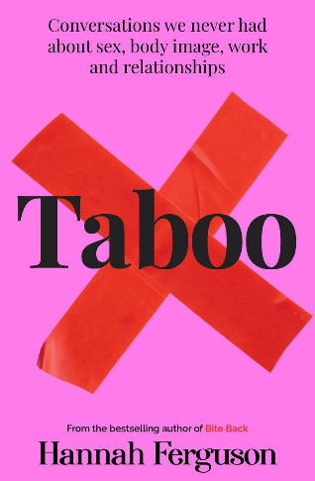In her book, Hannah Ferguson says, ‘From the moment we are born, girls quickly understand that the worst thing a woman can be is alone. By ‘alone’, we do not mean without community – just without a partner.’

ID: A picture of Hannah Fubook with a pink cover, a big red x over the word Taboo.

It is assumed that just because I’m ‘alone’ that I’m ‘lonely’. But the last I checked, ‘alone’ and ‘lonely’ are not synonyms.

I am part of so many different, wonderful communities that meet my needs, and that complement my interests and passions, and what I have to offer. They fill my cup. For example, writing is often seen as a lonely and isolating hobby. One you do sitting in your room, on your own, not talking to anyone. For me, it is anything but lonely. I enjoy the quiet, contemplative aspects of writing, and I am also lucky to be part of an amazing writing community. I work for a small business which runs after school creative writing sessions for kids, and the team members all enjoy writing, so we started to meet up outside of work to write, strengthening our friendships. We had a few writing days a year and also started going on writing retreats. At the beginning of last year, my friend took this a step further and started a weekly in-person writing group for us and a weekly online writing group for the wider community to join us to make writing a regular practice. We have a yearly tradition to go on a summer and winter writing retreat, with some extra writing days peppered throughout the year. Although our weekly writing group started with the focus on our writing, it evolved to be so much more. Many of us were in the job hunting trenches, so each week we’d rant about our latest rejection and receive validation in return, or get a pep talk from the group in preparation for an upcoming job interview. And we do many, many tarot readings asking all sorts of questions about our life. It is anything but lonely.

Having a disability grants me access to two extra communities – the disability community, and within that, the short statured community. There are a lot of great things about being short statured, but there are also a lot of struggles. Hanging out with other short statured people, we share our struggles. When we realise our struggles are universal, we’re able to joke about them with each other, making difficult situations more bearable. It’s something we can only do with other short statured people, and it makes us feel less alone.

Of course aspects of my identity, such as my disability, have influenced my life pursuits. I’ve competed internationally in basketball and soccer at the World Dwarf Games in Germany (we won a silver medal in basketball). And now I’m undertaking para-powerlifting training with the goal to compete in national and international competitions. And obviously, I wouldn’t be working at WDV as an Expert by Experience group member if I wasn’t disabled.

Hanging out with these communities has helped me develop my disability pride and feel proud to be short statured and have a disability. People who assume I’m sad and lonely because I don’t have a partner de-value my friendships and my communities. Being part of these communities give me so much value and fulfilment – things every person deserve. I get so much value from being in these communities, and I also contribute a lot of value in a non-compensating way. My contributions shouldn’t have to be about compensating for not having kids, they should be seen as a separate way of existing in the world.

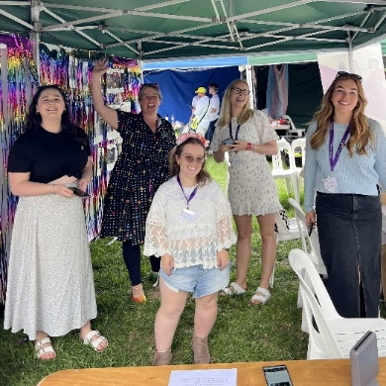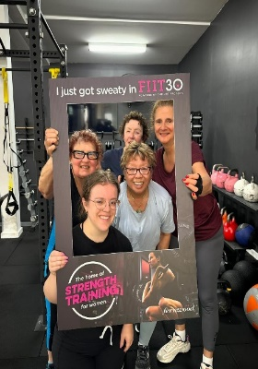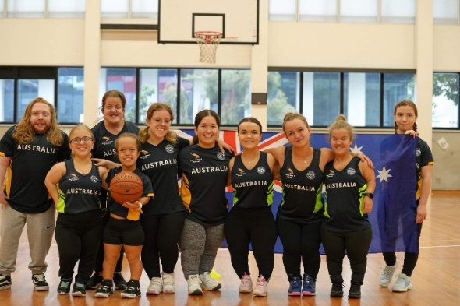

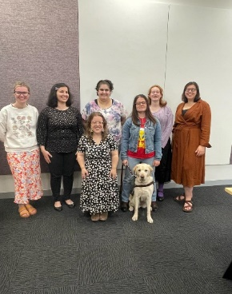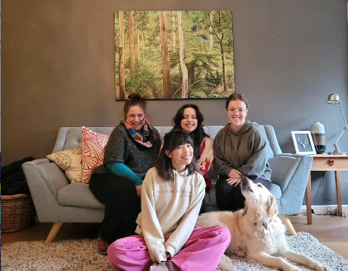

The next time I’m asked about getting a boyfriend and why aren’t I actively looking for one, I’ll just send them the link to this article to read. I won’t go along with the charade. I won’t just smile and giggle demurely. I don’t need to compensate for not being in a relationship and for not having kids. I don’t need to make excuses and show I’ve been using my time ‘wisely’ to the point of burnout. It is perfectly valid to not now - or ever, want to be in a relationship, and/or to not now - or ever, want to have kids. In the same way we first thought pink was a masculine colour, but then changed it so pink is seen as feminine and has started becoming gender-neutral, we can change our thoughts, opinions, and views on relationships and kids. For questions like ‘Do you want a boyfriend?’ or ‘Do you want kids?’, we need to normalise ‘No’ as a full answer and without defence.

**References**

1. [In the Pink: Colour in Menswear by vam.ac.uk](https://www.vam.ac.uk/articles/in-the-pink-colour-in-menswear?srsltid=AfmBOoplpNwvWk_eOoAk-tq_CW3PyoqkjviwyYJEyIyqzakkm6ZNwKbA)
2. [On the Evolution of Male Competitiveness by Ingela Alger](https://www.sciencedirect.com/science/article/abs/pii/S0167268121003152)
3. [Same-Sex Couples’ Division of Labor from a Cross-National Perspective by Maiike van der Vleuten, Eva Jaspers, and Tanja van der Lippe](https://www.tandfonline.com/doi/full/10.1080/1550428X.2020.1862012#abstract)
4. [Social Constructionism by Viv Burr and Penny Dick](https://link.springer.com/chapter/10.1057/978-1-137-51018-1_4)
5. [Status of Women Report Card 2024 by the Australian Government](https://genderequality.gov.au/status-women-report-cards/2024-report-card)
6. [Taboo by Hannah Ferguson](https://affirmpress.com.au/browse/book/Hannah-Ferguson-Taboo-9781923046634)
7. [The Impact of Stigma on Mental Health and Quality of Life on Infertile Women: A Systematic Review by Yue Xie, Yue Ren, Changmin Niu, Ying Zheng, Ping Yu, and Lin Li](https://pmc.ncbi.nlm.nih.gov/articles/PMC9869765/)
8. [Women’s Working Hours: The Interplay Between Gender Role Attitudes, Motherhood, and Public Childcare Support in 23 European Countries by Wouter Andringa, Rense Nieuwenhuis and Minna Van Gerven](https://www.emerald.com/insight/content/doi/10.1108/ijssp-10-2014-0073/full/html)