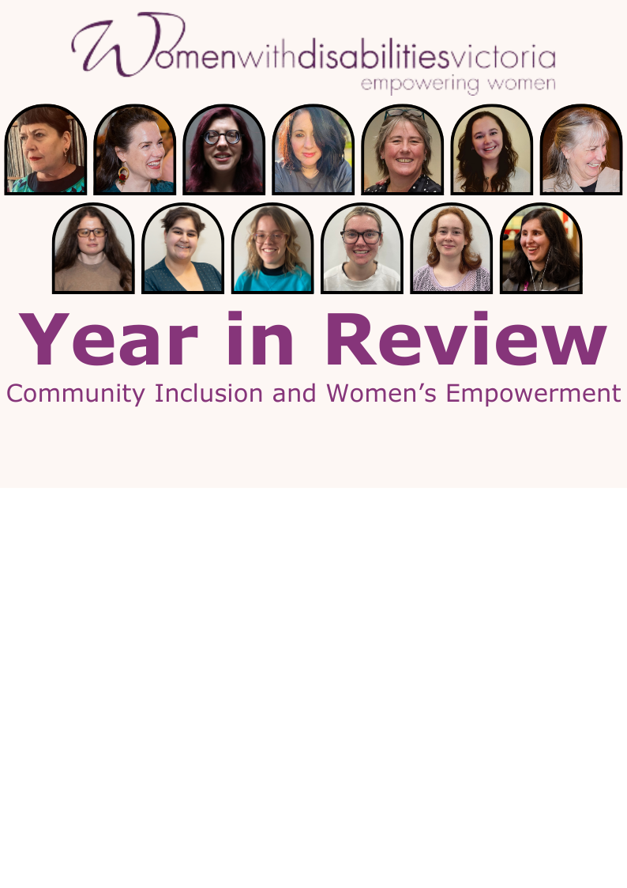

2024 was a big year for WDV’s Community Inclusion and Women’s Empowerment (CIWE) team. There were some lows and many incredible highs. It was a year we celebrated ten years of the Enabling Women Leadership Program, we held youth and general statewide programs; our Hubs embraced new members and took on issues with expertise and our Youth Experts continued their vital advocacy.

The CIWE team begins 2025 with enthusiasm and passion for our work, but once again the Program is looking down the barrel of funding cuts. We thank our community for their continued support and encourage those with the power and privilege to make a positive impact on women and non-binary people with disability to do so this year by following and amplifying WDV’s Community Inclusion and Women’s Empowerment team.

### January 2024

CIWE kicked off the new year at **Midsumma Carnival** with members of WDV’s Operations and Health teams celebrating disability, gender and queer pride.

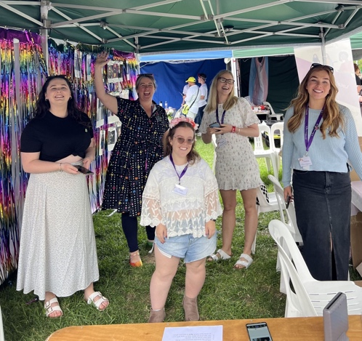

*Image Description: Some of the WDV Midsumma stall crew. Staff members from left to right, Vanessa Davis, Libby Price, Julie Dickson, Elysia Johnston, and Melissa Jolley, are standing within the stall with big, happy smiles. They are facing the camera, standing on grass, in front of the rainbow wall.*

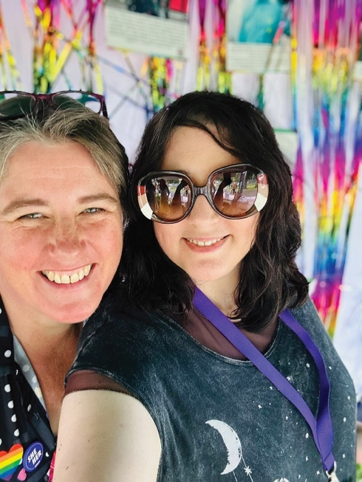

*Image Description: Selfie photo of WDV Midsumma stall crew members Libby Price and Brigitte Stone, they are standing in front of the rainbow streamers of the stall and smiling at the camera.*

|  |
| --- |
| The CIWE team completed **Essentials of Engagement** training receiving their **IAP2 Australasia’s** Certificate of Engagement.  *Image*  While the **Bendigo Hub** farewelled the Hub’s first ever Liaison Officer, Emma Klemm as she set out after some exciting opportunities.  *Image Description: Bendigo Hub members with smiles are standing and sitting at a café.* |
| |  | | --- | |  | |
|  |

### February 2024

For the second year running the CIWE team headed down the highway to the **Having a Say Conference** in Geelong. Women’s Empowerment Officer (WEO) Brigitte Stone joined Hub Liaison Officers (HLO) Libby Price and Jenny Godwin in presenting an interactive workshop. While Bridget Jolley (WEO – Youth and Leadership Programs), Sara Franzoni (Leadership Hub Coordinator) and Liz Wright (Manager) looked after the WDV stall answering questions and making our now famous disability pride badges for the passing conference delegates and guests of the **Our Choice Expo**.

*Image Description: WDV information table at the Our Choice Expo. Liz, Sara, Libby and Jenny smile at camera. 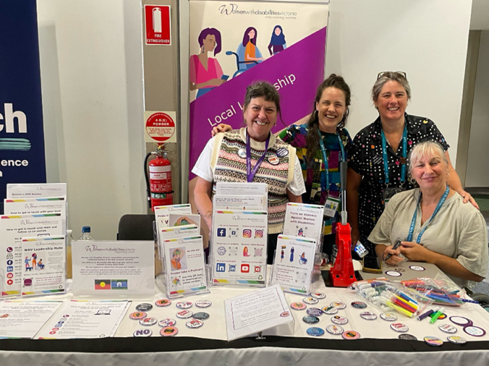*

With the **tenth anniversary** of the **Enabling Women Leadership Program** marked on the 2024 calendar the team got to work planning a multi-modal celebration. Including an event, a magazine and film our plans were ambitious ones! Filming and production began on the EW10 Magazine and video with content creator Jessica Dean.

### March 2024

|  |
| --- |
| Members of theCIWE and **Youth Experts** teams, joined with the other programs of WDV to deliver the **International Women’s Day** event **Count Us In: Accelerating Gender Equality** **for Women with Disabilities Through Economic Empowerment**. Youth Expert Husna Amani was a featured speaker on the day, delighting guests with her strength, compassion and curiosity. |
| |  | | --- | |  | |
| |  | | --- | |  | |
| |  | | --- | |  | |
| |  | | --- | |  | |
| |  | | --- | |  |   Image |
| |  | | --- | |  | |
| *Image descriptions: Guest panellist Husna Amani @huzmanygomez16 (WDV Youth Expert by Experience) takes part in the panel discussion. Husna is wearing a khaki green shirt with the purple IWD ribbon on it. She is using a braille note-taker.* |

### April 2024

|  |
| --- |
| WDV celebrated **10 years of the Enabling Women Program** with an event at the **Geelong Arts Centre**. Guests were welcomed with an evening of music, food, drinks and guest speakers. WEOs and hosts for the evening –Bridget and Brigitte premiered the celebration magazine and video featuring staff and participants from the past ten years. State Member for Geelong - Christine Couzens was a special guest speaking as the local member of parliament, and on behalf of the Minister for Women. Local member for Bendigo the Hon Maree Edwards MP provided a pre-recorded video declaring her support for the Program. While local councillors Cr Sarah Hathway and Cr Elise Wilkinson enjoyed the in-person event with live music from local artist Isabella Khalife.  [More from the 10 Years of the Enabling Women Program](https://www.wdv.org.au/our-work/our-work-with-women/enabling-women-leadership-program/10-years-of-the-enabling-women-program/) |
| |  | | --- | | Group photo of everyone standing in front of the '10' balloons. Everyone is smiling and facing the camera. | |
| |  | | --- | |  | |
| |  | | --- | |  | |
| |  | | --- | |  | |
| |  | | --- | |  | |
| |  | | --- | |  | |
| |  | | --- | |  | |
| *Image description: Group photo of CIWE team, Experts and WDV CEO Nadia Mattiazzo in front of the '10' balloons. Everyone is smiling and facing the camera.*  Applications opened for the **Statewide Enabling Women Leadership Program.**   |  | | --- | |  | |

### May 2024

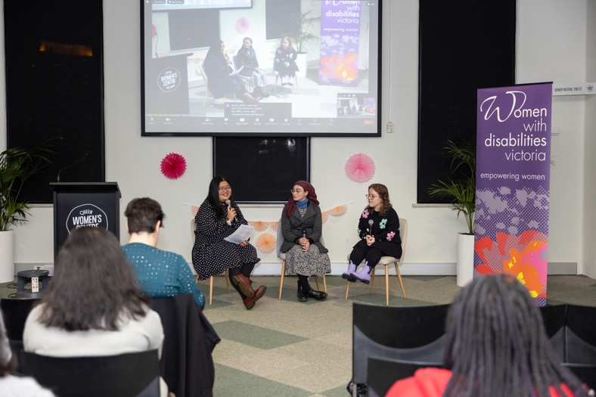May was an exciting month for **Enabling Young Women 2023/24** participants who together celebrated completing the Program with a hybrid **Graduation** event at the **Queen Victoria Women’s Centre**. At the event graduates Julie and Venetia-Maria answered questions about their experiences of the Program. Fellow graduate Julia facilitated the conversation leading to thoughtful and impactful discussions about leadership and disability. Strength pots and other empowering projects developed during the Program were also on display for attendees which included participant, friends family, mentors and WDV staff.

*Image Description: The graduation panel discussion in front of large screen and WDV banner.*

"I joined the program to help me gain confidence, help me understand my disability and to learn more about others, including people who are already in my life and new people that I meet. I became more curious when I started learning about disability in many ways. I learnt how to be a better leader and to lead others.” – Nangoun

*Image Description: Nangoun holding up her strength pot – decorated with empowering words. She holds a gift bag in the other hand. She is smiling.*

|  |  |
| --- | --- |
| |  | | --- | |  | |
|  |

As part of the State Government’s **Inquiry into Women's Pain** State Member for Geelong - Christine Couzens, Bellarine - Alison Marchant and Lara - Ella George, hosted aGeelong forum. Brigitte Stone our WEO and a fierce advocate for women and non-binary people with disability in pain and their rights for fair and equitable recognition, was invited to share her experiences of living with long term chronic pain on the panel and Q&A session.

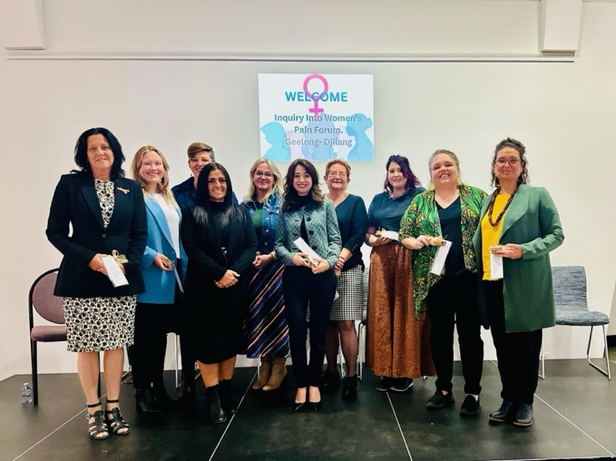

*Image Description: Christine Couzens MP for Geelong and Ella George MP for Lara, Kat Stanley, Corrina Eccles, Julie Spec, Kat Theophanous MP for Northcote and Parliamentary Sec for Women's Health, Luba Pryslak, Brigitte Stone, Marsha Uppill, and Kylie Clarke.*

|  |
| --- |
|  |

Fresh into her role as our newest HLO recruit Vanessa Davis joined Loretta Hart host of **Loretta’s Front Page** on Geelong’s **Pulse FM** for a chat. Loretta is a huge supporter of WDV and our CIWE work.

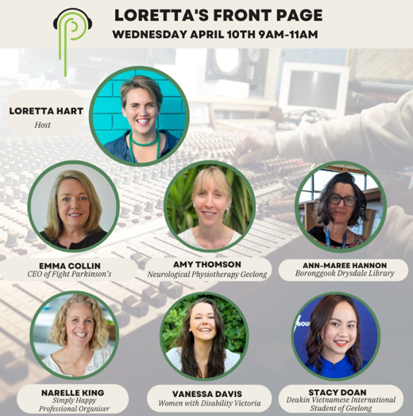

*Image description: there is a background image of a recording studio. Above the image, text reads “Loretta’s Front Page” there is a photo of Loretta Hart, host, with 6 other speakers photographed. They are all smiling and facing the camera, one of the photographs is of WDV staff member Vanessa Davis.*

|  |
| --- |
|  |

As most International Women’s Day events faded into the previous month, Youth Expert, Bella Fantasia brought the theme Count her In, back into focus for her blog; **Count her in.** **And don’t cut her off!** In the piece Bella looks at the role of the disability support pension (DSP) and other government supports in the economic empowerment of women and non-binary people with disability.

|  |
| --- |
|  |
| |  | | --- | |  | |
| Image*Image description: Photo of Bella, she is wearing a blue and black dress and a black hooded jumper. She is smiling at the camera and standing in front of a orange velvet curtain.* |

|  |
| --- |
| To get an idea of how WDV members think and feel about our work, organisation and impact the WDV Comms team ran a **Membership Survey**. To boost interest in completing the survey they offered the chance to win $100 gift card prize.  The lucky winner was **Bendigo Hub member** Ebony Hanson! Congratulations again Ebony.  Image*Image description: Photo of Ebony, wearing a grey top. She is smiling at the camera and standing in front of a a plant at the WDV office, holding a voucher.* |
| |  | | --- | |  | |
|  |
| Leanne Watson has become a much-loved face and advocate around WDV and our community. It came as no surprise then that after just a couple of guest appearances on **Pulse FM** they offered Leanne her own show! As a **WDV Barwon Hub Member** Leanne brings a powerful grassroots perspective to all her interviews. |
| Now formerWDV staff member, but still great friend, Rosie Granland was an early guest star on **Rolling Through Wednesday**. Rosie joined Leanne to talk about the brilliant **Experts in Our Health resources**.  [Experts in Our Health](https://www.wdv.org.au/our-work/our-work-with-women/experts-in-our-health/) |
| |  | | --- | |  |   Image*Image description: yellow social media tile. There is an image of Leanne in a recording studio, Rosie smiling at the camera and Loretta smiling at the camera. Text says "Leannes Wheel life. Rolling Through Wednesday. 4-5pm every Wednesday on 94.7 The Pulse".* |
| As one of the country’s oldest not-for-profits the **Good Shepherd**, provide financial literacy training to help participants develop healthy relationships with money. To share information about financial security, Good Shepherd facilitator Amanie was warmly welcomed by the **WDV** **Moira Hub**. The session was a helpful one, hub members learning lots through discussion and Amanie’s expertise. |

### June 2024

After a fantastic response to the first Statewide generalist program, an impressive total of 13 women and non-binary people with disabilities completed the **2024 Statewide Enabling Women Leadership Program.** Similarly to the program sessions the **Graduation Celebration** offered hybrid participation, the in-person event held at the **Queen Victoria Women’s Centre**. There was a lot of emotion in the room and in private spaces across the State as graduates, supporters and staff celebrated the wonderful achievements and learnings of the Program. However, the knowledge this could be the last Program in a long while if WDV do not receive funding, still loomed. The Graduation itself though, displayed exactly why this Program is so essential to the community. Graduate speeches made us laugh, made us cry and made us so proud that the world now gets to experience these 13 enabled and empowered women and non-binary people with disabilities.

With the end of **WDV’s Health Project** and questions about CIWE program funding remaining un-answered, a day at the zoo was a positive way to come together. This year **WDV’s annual Staff Engagement Day** at the M**elbourne Zoo** had a strong focus on community. WDV were thrilled to have proud Adnyamathanha Woman, Marsha Uppill the Co-Founder and Director of Arranyinha Pty Ltd and her partner Nick lead staff through **Foundational Cultural Respect** **training**.

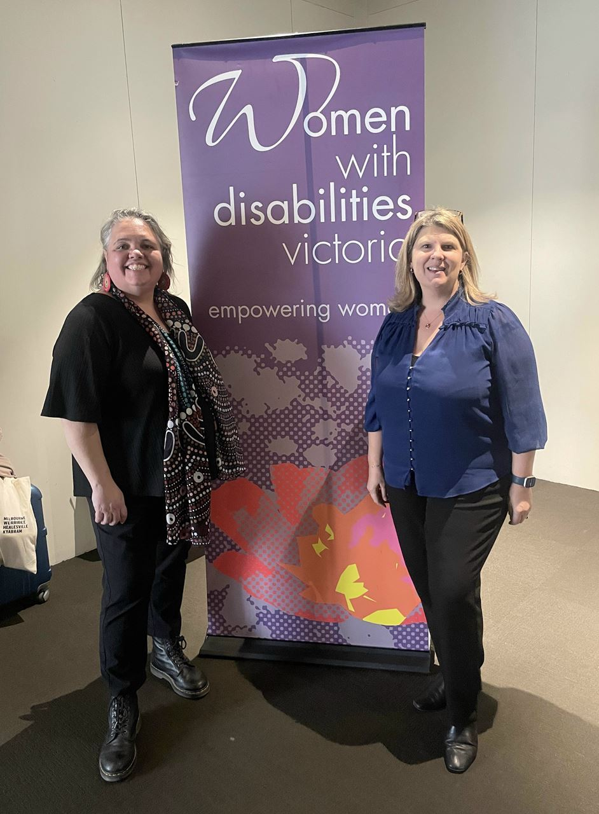*Image description: Photo of Belinda Burns, Director Business Operations, WDV and Marsha Uppill, Director/Co-Founder, Arranyinha. They are standing on either side of a WDV banner, facing the camera and smiling.*

|  |  |
| --- | --- |
| |  | | --- | |  | |
|  |
| June 16 was **Neurodiversity Pride Day**. Following this, WDV is sharing experiences from two of our **Youth Experts by Experience** members. Isabella Fantasia and Emma Jago, explore autism stereotypes, realities, and personal experiences. |
| |  | | --- | | [**Download Resource Word**](https://aus01.safelinks.protection.outlook.com/?url=https%3A%2F%2Fwwdv.wildapricot.org%2FEmailTracker%2FLinkTracker.ashx%3FlinkAndRecipientCode%3DourIuLIIX4YUS9laq3MYUu903ojVbE8i7OPWV7tm6AfTCSWBiHsvfRn2Rz%252ff4mliJD7qqBsjy%252fhIgyPrS1zvDKj4jbjxDwv9H%252b7nkxuLHX8%253d&data=05%7C02%7Cbrigitte.stone%40wdv.org.au%7C96f3c69bf88f468fece908dc90eecc78%7Cfa4a21576e064579b830b92258ec29d1%7C0%7C0%7C638544602581132893%7CUnknown%7CTWFpbGZsb3d8eyJWIjoiMC4wLjAwMDAiLCJQIjoiV2luMzIiLCJBTiI6Ik1haWwiLCJXVCI6Mn0%3D%7C0%7C%7C%7C&sdata=gbU15Mpf3qf2lOG9tVnoHa67Kyh%2FSI%2F7g0Brp8mkmZU%3D&reserved=0) | |
| |  | | --- | | [**Download Resource PDF**](https://aus01.safelinks.protection.outlook.com/?url=https%3A%2F%2Fwwdv.wildapricot.org%2FEmailTracker%2FLinkTracker.ashx%3FlinkAndRecipientCode%3Dr1jWxY7uD%252b0oGsYaNgNu0uwEHK2jhyzMmI2GOOuTvam%252fIfFfcFrP%252bJSQC9dEEC%252fvcUDc2u7r1ru%252fVHVCJCZxds%252b2cmpRS7PU%252fPuW9dOzB24%253d&data=05%7C02%7Cbrigitte.stone%40wdv.org.au%7C96f3c69bf88f468fece908dc90eecc78%7Cfa4a21576e064579b830b92258ec29d1%7C0%7C0%7C638544602581137725%7CUnknown%7CTWFpbGZsb3d8eyJWIjoiMC4wLjAwMDAiLCJQIjoiV2luMzIiLCJBTiI6Ik1haWwiLCJXVCI6Mn0%3D%7C0%7C%7C%7C&sdata=3qhBCCvkqKM915TtQKvzu6aa0en5ON5iVMy1H3k2OZw%3D&reserved=0) | |
| Image  *Image description: Purple tile with an illustration of a person listening to music with headphones, they are wearing a bright green jacket with a yellow sunflower on it. Text says "Autism: The Stereotypes versus The Reality."* |
| |  | | --- | |  | |
|  |

|  |
| --- |
| In the long-awaited news we had been fearing it was finally revealed that along with several other disability-led community programs, WDV was unsuccessful in securing future funding for CIWE programs. **WDV effectively lost 48% of funding resulting in a loss of 36% of staff**. That’s no hubs in the community, no leadership programs, no youth experts and no creative advocacy that the CIWE team do so well. 19 women and non-binary people with disabilities, out of work. At the time WDV CEO Nadia stated "I am devastated...Speaking personally, and I think also from the rest of us at WDV, we will not let our rage at this situation abate. We will respond to this outrageous lack of understanding for who we are and what we do best." And so we did, with the help of our friends and allies we showed how vital Community Inclusion and Women’s Empowerment really is. |

### July 2024

|  |
| --- |
| In response to the **funding shortfall** WDV took to our channels asking for support, leading to an overwhelming community response. Over 700 emails were sent to Minister Rishworth and Minister Shorten, our social media posts were shared hundreds of times and local media examined the impact of losing their local hubs. |
| Members of the CIWE team were excited as an organisation to celebrate the completion of **WDV’s Reflect Reconciliation Action Plan**. Proud Yorta Yorta woman Aunty Jane Rosengrave created a meaningful and colourful artwork for WDV to include in our Reflect Reconciliation Action Plan. Aunty Jane is a disability advocate and artist. She has an intellectual disability and is a fierce self-advocate and champion for others. The beautiful artwork is displayed in the WDV office.  [Learn more about WDV’s RAP and Aunty Jane’s artwork](https://www.wdv.org.au/celebrating-aunty-jane-and-her-rap-artwork/)  Image*Image description: Aunty Jane is standing holding the painting, smiling and facing the camera. Aunty Jane is wearing a purple jumper with the word "Auntie" written in colourful writing.* |
|  |
|  |
| |  | | --- | |  | |
|  |

### August 2024

After weeks of uncertainty, WDV happily announced a **funding reprieve** allowing the CIWE program to operate until June 2025. The four [**Hubs** across Victoria](https://www.wdv.org.au/get-involved/join-a-community-hub/) could be reopened and our [**Women’s Empowerment programs**](https://www.youtube.com/watch?v=rK908qv9aTc&t=10s)offered again. Many of our skilled staff, whose jobs would have been made redundant by the funding shortfall, could be reinstated and continue. This, however, is a short-term solution as WDV look to find long-term sustainable funding for this important work to continue undisrupted.

Also this month we mourned the passing of **Sandra Fueggle**. Sandra was an eager participant for WDV’s vital prevention projects and in 2021 worked within the Community Inclusion and Women’s Empowerment team as **Hub Liaison Officer for Melbourne Outer East** later becoming a regular hub member. Sandra’s former-manager Liz Wright reflected on her time at WDV with fondness and deep respect. “She was a strong and passionate advocate and was known for challenging the status quo and for elevating the rights of women with disability.”

|  |
| --- |
| The talent, dedication and courage of the WDV community was highlighted on the global stage at the **2024 Paris Paralympic Games** by previous **Youth Expert by Experience** staff member Stella Barton. A current WDV member, Stella was selected to represent Australia in the Para-dressage Equestrian team and made us all so incredibly proud!  Image*Image description: a photo of Stella riding her competition horse Bug in an indoor arena Para Dressage competition prior to the Paralympics.* |
| |  | | --- | |  | |
|  |

### September 2024

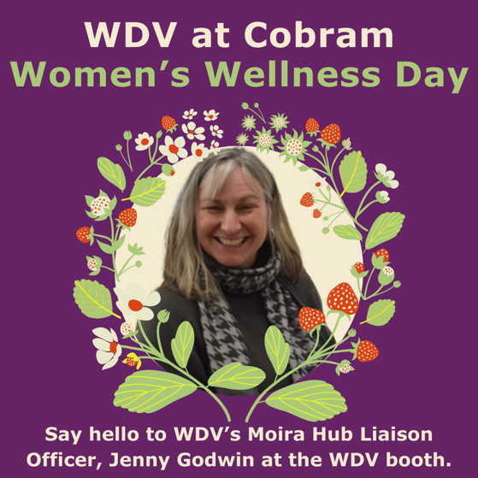After a successful launch last year **Cobram Women’s Wellness Day** was back and so was Moira Hub Liaison Officer, Jenny Godwin. Jenny shared lots of our great CIWE resources and introduced the work of WDV to event goers.

*Image description: a purple social media tile. Photo of Jenny smiling. Floral graphics circle the image. Text reads: WDV at Cobram Women’s Wellness Day. Say hello to WDV’s Moira Hub Liaison Officer, Jenny Godwin at the WDV Booth.*

|  |
| --- |
| Hub Liaison Officer for both Barwon and Bendigo, Vanessa Davis was excitingly nominated in the Youth Affairs Council Victoria **Rural Youth Awards.** Celebrating the achievements and contributions of young people and youth sector workers anywhere in rural or regional Victoria, Vanessa was shortlisted as a finalist in the **Youth Worker making a difference in rural or regional Victoria award**.  Image  *Image description: Ness at the Empowering Women Program, she is laughing and holding the microphone for another participant.* |
| |  | | --- | |  | |
| Also this month Ness and the **Barwon Hub** happily strengthened relationships with the Senior Community Inclusions Coordinator Lizz Ainsworth and **the City of Greater Geelong**. Lizz has been a wonderful supporter of WDV and the local leadership hub providing shared resources and opportunities to further the visibility of women and non-binary people with disabilities in the region. |
| Hosted by the Disability Advocacy Resource Unit (DARU), members of WDV’s **Community Inclusion and Women’s Empowerment team** went to the **Strengthening Disability Advocacy Conference** at NAB The Hall in Melbourne’s Docklands. The event included speakers, panel discussions and an impressive performance from hip hop collective Inkrewsive. Keen to explore big issues in the lives of people with disability, members from WDV's **Youth Experts** and **Melbourne’s Outer East Leadership Hub** took an active part in audience discussions, asking questions and advocating for the rights of women and non binary people with disability across Victoria. |
| |  | | --- | |  | |
| Image*Image description: Photo of 7 women and non binary people with disability from the Community Inclusion and Women’s Empowerment team, Youth Experts and Melbourne’s Outer East Leadership Hub.**They are posed together smiling at the camera, behind them a stage and projector screen featuring the text “2024 Strengthening Disability Advocacy Conference. Thank you for coming”.* |
|  |
| Also this month **Bendigo Hub Member** – Ebony Hanson took theOverlander trainfrom Melbourne to Adelaide for the **National Brain Injury Conference.** Ebony enjoyed reconnecting with old friends and the opportunity to make new ones with similar experiences.  Image  *Image description: Photo of Ebony and two friends in an event space overlooking the Adelaide Oval.* |
| |  | | --- | |  | |
|  |
|  |
| Early in the month **Short Statured People of Australia (SSPA)** held their national convention. During the event, for the first time since 2019, the **McHugh-Henderson Award**, was awarded to **Youth Expert** Julie Dickson. Named after two past chairmen of the association, the award is given to a person of short stature who has made a significant contribution to the development of themselves as an individual and to the enhancement of their position in the community at large, which brought credit to themselves and the SSPA.  Image  *Image description: Photo of Julie Dickson holding McHugh Henderson Award trophy.* |
| |  | | --- | |  | |
|  |

### October 2024

As an organisation WDV held **Mental Health First Aid training** facilitated by Grace Backler, Provisional Psychologist and Licensed Mental Health First Aid Instructor.

|  |
| --- |
|  |
| Recently graduating from the **Enabling Young Women Program 2023/24** where she facilitated the graduation panel discussion and fresh from appearing in **the Enabling Women 10 Year Celebration** video, magazine and as a guest speaker at the event, the CIWE team were thrilled to officially welcome Julia Coscolluela as co-facilitator for the **2024/25 Enabling Women Leadership Program**.  Also getting their start with WDV as aco-facilitator was Ness Davis. Earlier this year Ness became a permanent member of the Community Inclusion and Women's Empowerment team as Hub Liaison Officer for Barwon. To support Leadership Hub Coordinator Sara Franzoni and manager Liz Wright in facilitating the **Bendigo Hub**, during this transitional period, Ness took over as Hub Liaison Officer for both the booming regional locations.  Image*Image description: Photo of Julia receiving her Enabling Young Women Graduation Certificate from Statewide 23/24 Co-facilitator, Ness. They stand in front of a WDV vertical banner. They are both smiling.* |
| |  | | --- | |  | |
| This year has been a great one for collaboration across WDV teams. Highlighted this month when the **Bendigo Hub** welcomed WDV’s Gender and Disability Training Coordinator, Katie Gomes who presented on the topical issue of **Misidentification of Perpetrators** at the Bendigo Hub meeting. Held at hub partner, the **Centre For Non-Violence** (CNV), the Head of Strategy & Impact Robyn Trainor, joined the meeting and contributed information and resources for the group.  Held on October 25, **International Dwarfism Awareness Day**, is a day to celebrate dwarfism (also known as short stature) and to raise awareness to stop the negative stigma. As a proud advocate for the community, Youth Expert Julie Dickson shared **5 facts about dwarfism**.  [Read 5 Facts About Dwarfism](https://www.wdv.org.au/dwarfism-awareness-day/) |

### November 2024

WDV held its **Annual General Meeting** and appointed new board members. There was a strong focus on the importance of community inclusion in the empowerment of women and non-binary people with disabilities.

**Enabling Women Summer 24/25** launched with a Program high 14 participants. The group took a break over the holidays and return in the new year. Good luck to all!

The **Youth Experts by Experience** group welcomed new members Frankie and Teagan. They will join Husna, Emma, Julie and Bella in addressing issues and creating resources unique to the experiences of young women and non-binary people with disabilities in Victoria.

Consulting with WDV’s Senior Policy and Research Officer, the **Youth Experts** made a submission to the **Victorian Government’s Inquiry into Proposed Changes to Social Media Age Limits**.

[Read the Youth Experts Submission to the Victorian Government’s Inquiry into Proposed Changes to Social Media Age Limits](https://www.wdv.org.au/our-work/our-work-with-government/submissions-2/)

From November 25 to December 10 each year the world observes the **16 Days of Activism Against Gender-Based Violence**, a campaign that aims to raise awareness and mobilize action to end all forms of violence against women and girls.Women and gender diverse people with disabilities, experience high rates of discrimination, violence and abuse. To raise awareness and the voices of women and gender diverse people with disability, **Respect Victoria** partnered with Women with Disabilities Victoria in a new campaign. The impactful video series features interviews with several powerful women and non-binary people with disability. Among them **Youth Expert** Bella Fantasia and fellow **Enabling Women** alum Steph and Marie.

[**More about Agency, Access, Action**](https://www.wdv.org.au/agency-access-and-action-women-with-disabilities-victoria-x-respect-victoria/)

|  |
| --- |
| Melissa Jolley, Women’s Health Project Officer at WDV completed her first free cervical and bowel cancer screening educational workshop at the **Barwon Hub**. |
| Sparked by a hub member’s question at the 2024 Disability Advocacy Resource Unit’s (DARU) **“Shaping tomorrow, Empowering Today: Leading the way for Disability Rights”** conference the **Melbourne Outer East Hub** were keen to welcome Commissioner, Dan Stubbs and Senior Community Education Officer, Siobhan Bahn from the **Victorian Disability Worker Commission** (VDWC). They discussed the role of the commission and accessibility around the complaints processes. Joining the session were members of the **Youth Experts** Group and members of **Knox, Maroondah and Yarra Ranges Disability Advisory Committees**. |
|  |

### December 2024

Celebrating a year of creativity, advocacy and connection the normally remote working **Youth Experts** caught up for an in person catch up this month.

*Image Description: Group photo of the Youth Experts by Experience (Teagan, Husna, Julie, Bella, Emma, Frankie) and Women’s Empowerment Officer Youth and Leadership Programs, Bridget Jolley.*

**The Melbourne Outer East Hub** had their holiday celebration earlier this month**.** Lead by the always enthusiasticHub Liaison Officer Libby Price, in a sometimes-complicated year, the Hub reminisced over the many positives they’ve achieved as individuals and as a group in 2024.

*****Image Description: Group photo of the Melbourne Outer East Hub members and Leadership Hub Coordinator Sara Franzoni at a restaurant table. They are all smiling.*

Celebrating the resilience, brilliance and uniqueness of disabled people across the globe, December 3 is recognised as **International Day of People with Disability (IDPWD)**. While the reputation of this day of celebration, solidarity, commemoration and awareness still builds in the mainstream, within our community there were many excellent events across themes and platforms. Held amidst the **16 Days of Activism Against Gender-Based Violence**, disability pride celebrations were tempered with community education and the realities faced by those with disability. Amongst the many events, many of our team getting involved!

**Enabling Women Warrnambool 2015** program assistant Beck Biddle was featured in **Southern Stay Disability Services Inc**.’s IDPWDcelebrations**.** Beck is the first person with an intellectual disability to serve on their board of management and hopes to be an example to others.

**Knox City Council** meanwhile celebrated **Melbourne Outer East Hub** member Shelley Spencer. As a Ferntree Gully local, a mum and a woman with disability, Shelley has been a great asset to the **Knox Disability Advisory Committee.** The chanceto give people living with disability a say in Council matters a major factor why she joined two years ago.

[Read the Article](https://www.knox.vic.gov.au/whats-happening/news/champion-people-disability)

2024 was a rewarding year for **Youth Expert** Julie Dickson, she graduated from the **Enabling Young Women Program** and was accepted into the **Change Our Game Women in Sports Media program**. To cap off an amazing year Julie was announced as the 2024 winner of Arts Access Victoria’s renowned **Lesley Hall Arts and Disability Scholarship**.  “I would like to thank Arts Access Victoria for this amazing opportunity and for this scholarship! It’s such an honour, and it means a lot to know that I am following Lesley Hall’s legacy. She was an amazing disability activist who did so much to advance disability rights,” Julie shared with the announcement. Named after late disability activist Lesley Hall OAM, the annual scholarship honors Lesley’s legacy of tireless advocacy for the rights of people with disability and is awarded to artists who, through their work, challenge assumptions about disability. Receiving a $5000 grant the winning artist is supported in furthering their artistic practice.

Appearing in the bylines of ABC Sport and SOCIETY19, this impressive recognition comes at an opportune time in Julie’s burgeoning career.

Julie is currently writing a young adult novel titled *The Map From Me to You* about a teenage girl with achondroplasia who goes on a road trip with her friends to meet other short statured people, who will help her make a life-changing decision about if she should take a drug that could make her taller.

Earlier this year, Julie was awarded a Writers Victoria Storming the City fellowship, receiving six hours of free mentoring with a writing mentor to work on the novel. Julie was paired with writer and editor Danielle Binks. “Danielle’s insight and feedback on my novel has been extremely valuable,” Julie said about the experience.

“I really wanted to continue the mentorship, which is why I applied for the Lesley Hall scholarship to hopefully receive the funding to do so. So I’m thrilled to be the scholarship recipient, and that I can continue my mentorship to finish writing and editing my novel in hopes of publication.”

From all the team at WDV we are so proud of you Julie. We know this is an early accolade in the Julie Dickson legacy and can’t wait to see what you achieve next. Put us down for a few copies of novel too!

[Hear more from Julie and learn more about the s](https://www.artsaccess.com.au/the-winner-of-the-2024-lesley-hall-scholarship-is-julie-dickson/)cholarship

|  |
| --- |
| Inrecognition of **International Day of People with Disability**, the **City of Greater Geelong** hosted their yearly event the **Geelong Awards for People with Disability**. Excitingly taking home the award was WDV **Barwon Hub** member Leanne Watson. Always humble, Leanne admitted to feeling a little bemused when first hearing her name called as the **Volunteering Award** winner. “So many of us work and volunteer in disability advocacy and allyship. If I am to be singled out, then these people should too. However, I was also relieved that I thought to write a speech, just in case, and had prearranged with my husband to hold the microphone.” Letting the achievement sink in though she’s starting to realise the impact of the win. “After a few days of post award-winning reflection I recognise that my platform on **94.7 The Pulse FM** as a radio presenter of **Rolling Through Wednesday** is doing exactly what my goal was at the beginning. That is, to provide information and a sense of community to people who live with disability, and those they play and work with, as does my website, **Leanne’s Wheel Life**. At the same time, infiltrating the wider community in the quest to normalise disability.” Joining the Barwon Hub five years ago, Leanne has found a real connection with WDV and our work. “WDV has been integral to my acceptance of being an unashamedly disabled woman. I thoroughly enjoy the conversations, sharing and learning from the dedicated and enthusiastic women that work within WDV, and my fellow members. I have made some great local friends through the Hub where we have a comfortable space to share opinions, life events, grievances and wins. We also have guests from various organisations and government entities so that we can gain more knowledge, and advocate for disability by sharing feedback to allow for inclusive accommodations. A particular project that I absolutely loved being part of was being involved in the WDV podcast series, **From The Outsk**irts, in 2023. This is a wonderful podcast highlighting the lives of everyday women who just happened to be disabled. Being a guest on this podcast lead me to being interviewed by Loretta Hart on **94.7 The Pulse FM Geelong**.” Leanne, it seems has a knack for aligning with other strong women like Loretta, a tireless advocate for women's empowerment, who after their second interview together, Loretta totally stunned Leanne by asking if she would like her own show. Given free rein to design the style and messages that she would like, Leanne accepted the challenge and that as she says is how a bookkeeper became a radio presenter. Like her website **Leanne’s Wheel Life** the show **Rolling Through Wednesday** is centred around inclusion, community and hope, offering perspectives from marginalised communities. “I provide a relaxed conversation with many people with various messages, stories, news, and perspectives; from other disabled people, businesses, not for profit organisations, allied-health professionals and more. With a bit of Aussie up-and-coming music and my regular inspect-a- gadget section, I hope my audience feels like part of the conversation and gains understanding, or comfort, knowledge and entertainment.”  [**Read Interview with Geelong Indy**](https://geelongindy.com.au/news/13-12-2024/rolling-into-disability-advocacy/)  A group of people posing for a photo  Description automatically generated  ***Image Description:*** *Group photo of Cr Anthony Aitken, Justine Martin, Mayor Stretch Kontelj OAM, Laura Williamson, Matthew Gardiner; Front – Leanne Watson. Photo via City of Greater Geelong.* |
|  |

|  |  |  |  |  |  |  |  |  |  |  |  |  |  |  |  |  |  |  |  |  |  |  |  |  |  |  |  |  |  |  |  |  |  |  |
| --- | --- | --- | --- | --- | --- | --- | --- | --- | --- | --- | --- | --- | --- | --- | --- | --- | --- | --- | --- | --- | --- | --- | --- | --- | --- | --- | --- | --- | --- | --- | --- | --- | --- | --- |
| Looking to this year, Community Inclusion and Women’s Empowerment Programs and Events for 2025!Barwon Hub **Friday February 28**  Hub Meeting  **Friday March 28**  Hub Meeting – celebrating 10 years  **Friday TBA**  Hub Meeting  **Friday May 23**  Hub Meeting  **Friday June 27**  Hub Meeting  *Celebrating 10 years of peer advocacy and making an impact in their community – 2025 will be a big one for the Barwon Hub. As a group the Hub will look to further their impact on the ever-growing regional city, by identifying issues and opportunities in their experiences living locally. Individual members of the Hub will also look to continue pursuing personal goals and lead their communities as empowered women with disability.*  **For more information about the Barwon Hub please contact:**   |  |  |  |  |  |  |  |  |  |  |  |  |  | | --- | --- | --- | --- | --- | --- | --- | --- | --- | --- | --- | --- | --- | | |  |  |  |  | | --- | --- | --- | --- | | |  |  |  | | --- | --- | --- | | Vanessa Davis​​​​ | |  | | --- | | (She/Her) | | | | Hub Liaison Officer – Barwon | | |  |  |  |  |  | | --- | --- | --- | --- | --- | | T: | |  | | --- | | [03 9286 7810](tel:03%209286%207810) | | M: | 0473 866 104 | | | E: Vanessa.Davis@wdv.org.au | |  Moira Hub **Tuesday February 11**  Hub Meeting with special guest Melissa Jolley from WDV as part of a Cancer Screening Workshop.  **Tuesday March 11**  Hub Meeting  **Tuesday April 8**  Hub Meeting  **Tuesday May 13**  Hub Meeting  **Tuesday June 10**  Hub Meeting  *This year the Moira Hub are looking forward to focussing on disability visibility, accessibility, advocacy and equal opportunity. HLO Jenny said, “We are part of the community and should have more employment prospects, training or volunteering – being involved and doing things that make you happy.” Jenny is also busy locking in guest speakers to share their expertise on these issues and explore paths for Moira Hub Members to have more meaningful and satisfying engagement with the community.*  **For more information about the Moira Hub please contact:**   |  |  |  |  | | --- | --- | --- | --- | | |  |  |  | | --- | --- | --- | | Jenny Godwin​​​​ | |  | | --- | |  | | | | Hub Liaison Officer (Cobram/Moira) | | |  |  | | --- | --- | | M: | 0476 392 389 |   E |   E: Jenny.Godwin@wdv.org.au Bendigo Hub **Wednesday February 19**  Hub Meeting with special guest Melissa Jolley from WDV as part of a Cancer Screening Workshop.  **Wednesday March 19**  Hub Meeting  **Wednesday April 16**  Hub Meeting  **Wednesday May 21**  Hub Meeting  **Wednesday June 18**  Hub Meeting  *With new members and an exciting end to 2024, the Bendigo Hub are looking forward to a big 2025. HLO Vanessa says a key topic this year will be confidence. “We’ll be exploring advocacy and small steps on ways to advocate – how to do this in the community and ways of empowering each other.” This will lead into guest speakers and topics around social connection, peer support and leadership.*  **For more information about the Bendigo Hub please contact:**   |  |  |  |  |  |  |  |  |  |  |  |  |  | | --- | --- | --- | --- | --- | --- | --- | --- | --- | --- | --- | --- | --- | | |  |  |  |  | | --- | --- | --- | --- | | |  |  |  | | --- | --- | --- | | Vanessa Davis​​​​ | |  | | --- | | (She/Her) | | | | Hub Liaison Officer – Bendigo | | |  |  |  |  |  | | --- | --- | --- | --- | --- | | T: | |  | | --- | | [03 9286 7810](tel:03%209286%207810) | | M: | 0473 866 104 | | | E: Vanessa.Davis@wdv.org.au | |  Outer East Hub |

**Monday February 10**

Hub Meeting

**Monday March 17**

Hub Meeting

**Monday April 14**

Hub Meeting

**Monday May 12**

Hub Meeting

**Monday June 16**

Hub Meeting

While 2024 marked a year of personal growth and overcoming barriers, the Melbourne Outer East Hub are preparing to harness that energy and excitement to positively impact their communities. Members of the Hub live in broad demographic area across Melbourne’s Outer East, including Knox, Maroondah and Yarra Ranges. The contrast of urban and rural townships contributing to the unique experiences of women and non-binary people with disability in the area.

**For more information about the Melbourne Outer East Hub please contact:**

|  |  |  |  |
| --- | --- | --- | --- |
| |  |  |  | | --- | --- | --- | | **Libby Price​​​​** | |  | | --- | | (she/her) | | |
| Hub Liaison Officer, Melbourne Outer East |
| |  |  | | --- | --- | | M: | 0473 883 488 | | E: | libby.price@wdv.org.au | |

#### Enabling Women Leadership Programs

Enabling Women will be back in 2025. First up our **Statewide Enabling Women Summer 2024/25** participants will reconnect in the new year and complete the remaining leadership sessions before a graduation celebration.

We will also be taking applications for our second **Statewide Enabling Women Autumn 2025** which will begin in March.

For all leadership enquiries contact [bridget.jolley@wdv.org.au](mailto:bridget.jolley@wdv.org.au)

#### Youth Experts

|  |
| --- |
| Now as a team of 6, in 2025, the **Youth Experts by Experience** will continue to advocate for better understanding and access of young women and non-binary people with disability. They will soon be releasing a **YE magazine**, showcasing their advocacy so far as a group. Advocacy Campaigns and Events |
| The CIWE team are thrilled for the 3rd year in a row to attend VALID’s epic **Having A Say Conference**. Known as the biggest and most fun gathering for people with intellectual disability in the country, this year the conference takes place January 28 – 30 at the Deakin Waterfront in Geelong. The theme is ‘Our Lives, Our Voices!’ As women and non-binary people with disability we know how important it is to share our stories and speak up. With that in mind, WEO Brigitte and HLO Vanessa will be teaming up with former WDV staff member and newly appointed Lecturer, Disability and Inclusion, Education-focused at Deakin University Rosie Granland to present **Lead Your Way**. This workshop will look at messaging and how it influences our ability to speak up and use our voices.  Collaborating with respected content creators **Milk Video**, the CIWE team are excited to release our new promo video celebrating the joy and empowerment that comes when women and non-binary people with disabilities are included. We know that when women and non-binary people with disability are truly included in their community wonderful things can happen. Let’s see what happens next.  **Watch the CIWE video** |
| **Happy 2025 from the Community Inclusion and Women’s Empowerment Team** |
|  |
|  |