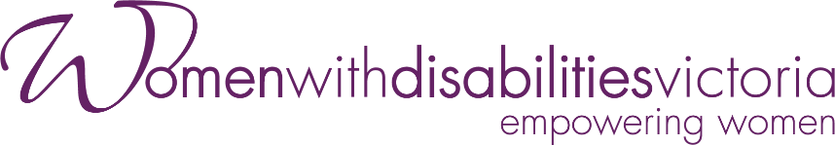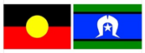**Participants Wanted**

**Victorian Enabling Women Leadership Program**

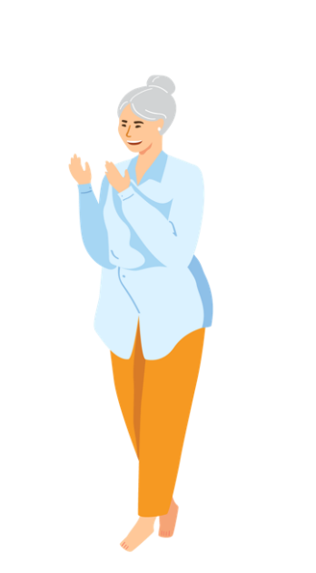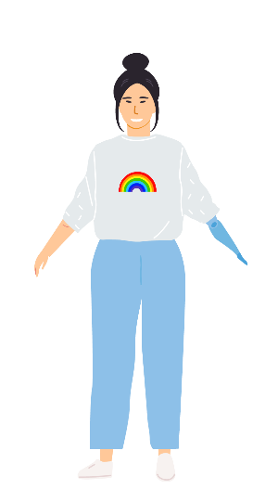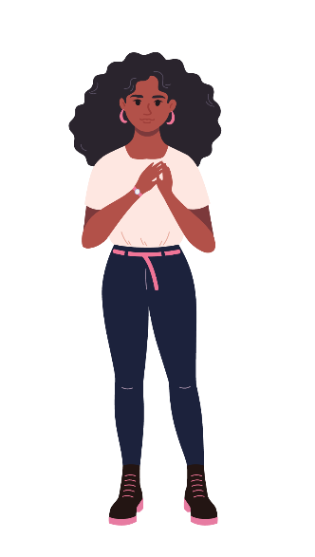****

**Summer**

**2024 - 2025**

Do you want to become a stronger leader?  
Are you someone who identifies as a woman or non-binary person with disability?  
Are you connected with the state of Victoria?

**Come join us, and become the leader you want to be, as part of the Enabling Women Leadership Program!**

**You will:**

* build confidence
* explore who you are
* reflect on your strengths (the things you’re good at)
* learn more about your human rights
* practise speaking up
* work with a mentor to achieve a leadership goal
* become a better leader in your community.

**Where:** In person at WDV’s Melbourne office, or online via Zoom

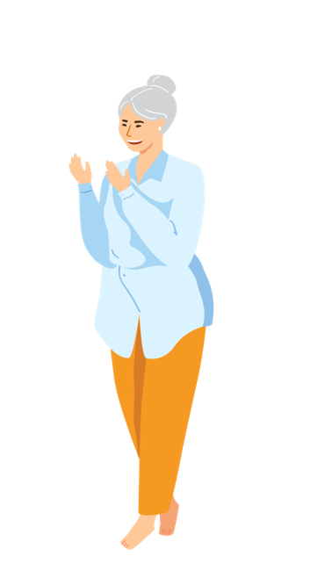

**What:** 8 x 3-hour group program sessions, 5 individual mentor sessions, and a Graduation Celebration

**When:** Program sessions and the Graduation will be onWednesdays, 1-4pm, throughout November 2024 – February 2025

**Cost:** FREE

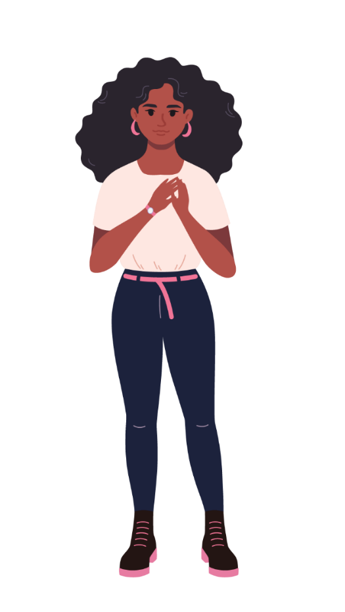**Included in the Program:**

* + - All materials – folder, workbook, activity and craft supplies, etc.
    - Access supports
    - Snacks

**A purple circle with a white letter i in it
**

**To find out more, and to apply:**

Visit our [website](https://www.wdv.org.au/our-work/our-work-with-women/enabling-women-leadership-program/), including for various accessible application forms.

To ask questions about the Program, or to get help completing an application form, please contact Bridget Jolley.

**Email:** [leadership@wdv.org.au](mailto:leadership@wdv.org.au)

**Phone:** 03 9286 7813