# Prevention of Gender and Disability Based Violence Audit Toolkit

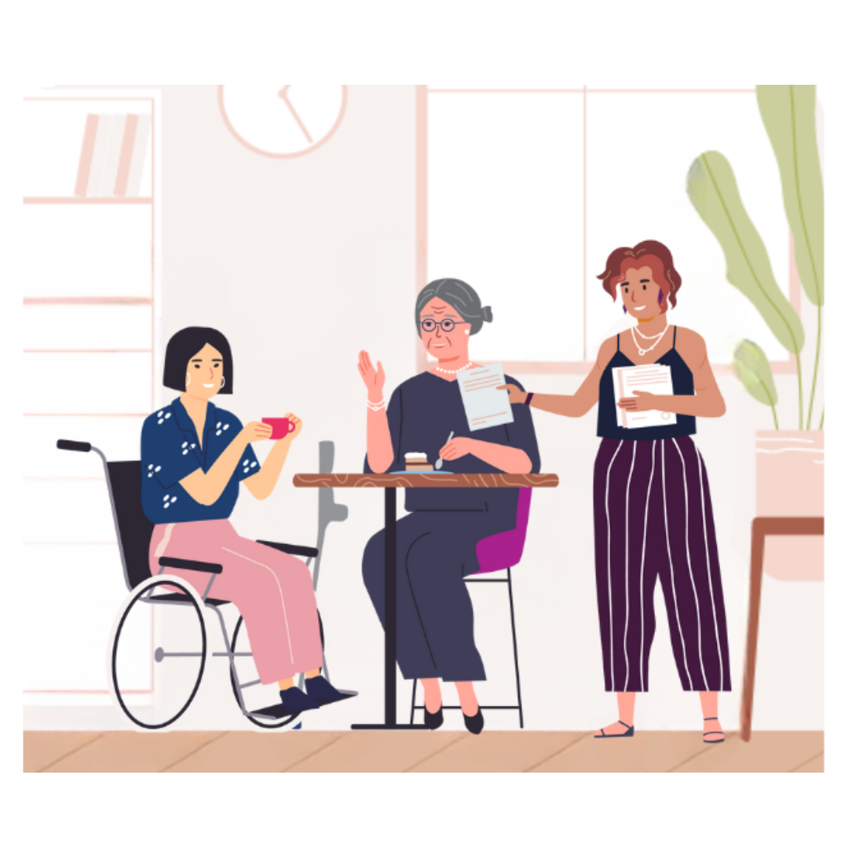Audit 5. Decision making and continuous improvement

# Decision making and continuous improvement

This audit tool supports your organisation to ensure systematic, inclusive, and fit-for-purpose processes for monitoring, evaluation, reporting and embedding learnings into decision making. The questions span across and strengthen efforts in the areas of the previous audit booklets. The notes and examples offer additional resources for further, intentional, continuous improvement.

A continuous cycle of monitoring, evaluation and learning within and across your policy and practice is critical to identify and address barriers and enablers to participation of women and non-binary people with disabilities in your services, events, and activities. Ensuring inclusive practice is part of decision making and improvement presents ongoing opportunities for learning and growth within your organisation, which you can then share with your partners. This contributes towards building evidence and forming a coordinated approach to prevention of gender and disability based violence. Your organisation will show genuine commitment and action to advance the rights of women and non-binary people with disabilities as decision makers in their own lives and communities, including members of your staff with disabilities.

In addition to the advice and resources offered in this booklet, always follow relevant, mandatory requirements and guidance for reporting and information management, as applies to your organisation and work. Remember to also always follow your organisation’s policies and procedures around privacy, ethics, research, and consent.

Reflection

**How does your organisation promote a culture of continuous reflective practice, that values lived experience?**

Example: Our workplace supports formal and informal processes to debrief from activities and incorporates learnings that validate the experience of people with disabilities to create change.

Audit

**1. How does your organisation report to the community on gender and disability inclusive strategic goals and actions?**

Regular reporting to the community on the progress of your organisation’s gender and disability inclusion related goals and actions is important for commitment, transparency, accountability, and continuous improvement. Ensure systematic processes are in place for governance, monitoring, evaluation, reporting, and embedding learnings into future iterations of organisational strategies and plans. Remember to use accessible communication in the development and dissemination of your reports.

The resources at the following websites may be useful for reporting, as adapted to your context.

* Australian Human Rights Commission – Disability Action Plan guide: <https://humanrights.gov.au/our-work/disability-rights/publications/disability-action-plan-guide-2021>
* Victorian Government – gender equality progress reporting: <https://www.genderequalitycommission.vic.gov.au/progress-reporting-2023>.
  + - Current situation:
    - Action required:
    - Time frame for action:
    - Resources required:

**2. How does your organisation ensure regular leadership reflection and feedback opportunities to strengthen gender and disability inclusion in planning, policies, and programs?**

Leadership reflection and feedback opportunities around gender and disability inclusive practice are essential for a coordinated organisational approach. This also supports the creation of a respectful, supportive, open culture which values learning, reflexive and reflective practice, and continuous improvement. Ensure there are processes in place for both formal and informal reflection, feedback, knowledge sharing, and embedding learnings into practice.

For information and guidance on reflective and reflexive practice, download the Victorian Government guidelines for supervision in the family violence, sexual assault and child wellbeing sectors here (PDF): <https://content.vic.gov.au/sites/default/files/2024-07/Best-practice-supervision-guidelines-Family-violence%2C-sexual-assault-and-child-wellbeing.pdf>.

This WDV resource provides information and guidance for identifying and challenging institutional and organisational resistance to prevention of disability and gender based violence (Word): <https://www.wdv.org.au/wp-content/uploads/2023/06/FINAL-Resistance-Backlash-to-Gender-and-Inclusive-Practice-ACCESSIBLE-.docx>.

Respect Victoria has also produced the following suite of resources about understanding, monitoring and responding to backlash and resistance in organisational and institutional settings: <https://www.respectvictoria.vic.gov.au/understanding-backlash-and-resistance>.

* + - Current situation:
    - Action required:
    - Time frame for action:
    - Resources required:

**3. How does your organisation ensure regular leadership reflection and feedback opportunities to strengthen trauma-informed,** **culturally safe practice?**

Leadership reflection and feedback opportunities about trauma-informed, culturally safe practice are also essential for a coordinated organisational approach to primary prevention. Ensure processes are in place for both formal and informal reflection, feedback, knowledge sharing, and embedding learnings into practice.

For information and guidance on trauma-informed, culturally safe practice, refer again to the Victorian Government guidelines for supervision in the family violence, sexual assault and child wellbeing sectors (PDF): <https://content.vic.gov.au/sites/default/files/2024-07/Best-practice-supervision-guidelines-Family-violence%2C-sexual-assault-and-child-wellbeing.pdf>.

Another great set of resources is the Victorian Government Department of Health Aboriginal and Torres Strait Islander cultural safety framework and continuum reflective tool, which you can access here: <https://www.health.vic.gov.au/publications/aboriginal-and-torres-strait-islander-cultural-safety-framework-part-1>.

* + - Current situation:
    - Action required:
    - Time frame for action:
    - Resources required:

**4. How does your organisation select professional development opportunities for staff in intersectionality, inclusive prevention of gender-based violence, and trauma-informed, culturally safe practice?**

It is good practice to source professional development opportunities that have been developed alongside and centre the experiences and expertise of women and non-binary people with disabilities, including victims/survivors of violence. Opportunities should focus on building staff capacity in understanding how violence impacts people with diverse intersecting identities, including gender, sexuality, age, faith, race, and ethnicity. Professional development needs to stay current and tailor to the specific needs and roles of your workforce. Ensure providers offer inclusive engagement methods, to allow all staff to engage and take part fully. Where possible, try to source ‘business’ from those who reflect the same standards in inclusion as your organisation, or support and encourage them to do so.

Contact WDV for more information about our professional development opportunities here: <https://www.wdv.org.au/contact-us/>.

Although not exhaustive, below are examples of other organisations who offer professional development opportunities developed from research and lived experience.

* Multicultural Centre for Women’s Health: <https://www.mcwh.com.au/>
* Victorian Aboriginal Community Controlled Health Organisation: <https://www.vaccho.org.au/cultural-safety-services/>
* Rainbow Health Australia: <https://rainbowhealthaustralia.org.au/>
* Safe and Equal: <https://safeandequal.org.au/training-events/supporting-businesses-workplaces/lived-experience/>
* Blue Knot Foundation: <https://professionals.blueknot.org.au/>.
  + - Current situation:
    - Action required:
    - Time frame for action:
    - Resources required:

**5. How does your organisation ensure regular opportunities for staff to reflect, provide feedback, and share knowledge with colleagues on gender and disability inclusive, trauma-informed, culturally safe practice?**

Regular reflection and feedback around gender and disability inclusive, trauma-informed, culturally safe practice is imperative for all staff, not just leadership. Hold intentional space for staff to reflect and provide feedback on organisational, team, and individual practices – together, with their supervisors/managers, and alone. Ensure to also have processes in place for sharing knowledge obtained through formal professional learning and embedding learnings in ongoing practice. This will further foster an inclusive, safe workplace culture and sustain progress towards a gender and disability equitable organisation.

For information and guidance, you can refer to the resources mentioned in questions 2 and 3, listed again below for convenience.

* Victorian Government - guidelines for supervision in the family violence, sexual assault and child wellbeing sectors (PDF): <https://content.vic.gov.au/sites/default/files/2024-07/Best-practice-supervision-guidelines-Family-violence%2C-sexual-assault-and-child-wellbeing.pdf>.
* Department of Health - Aboriginal and Torres Strait Islander cultural safety framework and continuum reflective tool: <https://www.health.vic.gov.au/publications/aboriginal-and-torres-strait-islander-cultural-safety-framework-part-1>
* WDV - resistance and backlash resources: <https://www.wdv.org.au/family-violence-resources/>
* Respect Victoria - resistance and backlash resources: <https://www.respectvictoria.vic.gov.au/understanding-backlash-and-resistance>.
  + - Current situation:
    - Action required:
    - Time frame for action:
    - Resources required:

**6. How does recognition of intersectionality influence the design, planning, monitoring, and evaluation of your organisation’s PVAW and gender-based violence prevention activities, events, and services?**

The experiences and expertise of diverse people with disabilities should be central to the designing, planning, monitoring, and evaluation of every organisation’s PVAW and gender-based violence prevention initiatives. To embed intersectionality throughout the project lifecycle, make implicit or explicit reference to women and non-binary people with disabilities; draw on the evidence base, including lived experience; and ensure opportunities for genuine participation of women and non-binary people with disabilities.

Examples include collaborating with disability organisations to design projects; referencing *Changing the Landscape* in project plans; using gender and disability related indicators and questions in monitoring and evaluation plans; collecting feedback from women and non-binary people with disabilities about your initiatives; and ensuring inclusive, safe data collection.

You can access Changing the Landscape and supporting resources here: <https://www.ourwatch.org.au/change-the-story/changing-the-landscape>.

The websites listed below contain further resources which may be useful or adaptable to the context of your work.

* Disability Gateway - good practice guidelines for engaging with people with disabilities: <https://www.disabilitygateway.gov.au/good-practice-guidelines>
* Rainbow Health Australia – evidence, messaging, partnership and evaluation guides for prevention of violence against LGBTIQA+ communities: <https://rainbowhealthaustralia.org.au/pride-in-prevention>
* Australian Institute of Family Studies – trauma-informed research and evaluation practice guidelines: <https://aifs.gov.au/resources/collections/trauma-informed-research-practice>
* Women’s Health Victoria - Victorian women’s health and social wellbeing data: <https://victorianwomenshealthatlas.net.au/#!/>
* Women with Disabilities Australia – publications: <https://wwda.org.au/our-resources/publication/>.
  + - Current situation:
    - Action required:
    - Time frame for action:
    - Resources required:

**7. How does your organisation decide who to partner with to deliver PVAW and prevention of gender-based violence initiatives?**

Collaboration within and across sectors, alongside diverse members of your community can improve the efficacy and reach of prevention initiatives. Genuine collaborative work opens opportunities for shared advocacy and encourages everyone - no matter their identity and profession - to understand, acknowledge, and play their role in prevention of disability and gender based violence.

To establish and reinforce collaboration, recognise and promote the strengths, lived experience, and expertise of individuals and networks. This includes budgeting for partnership; leveraging existing networks, settings-based knowledge and regional strategies; engaging with key partners early; and developing strong governance mechanisms.

The websites listed below contain further guidance which may be useful or adaptable to the context of your work.

* Victorian Government – place-based approaches guide: <https://www.vic.gov.au/place-based-approaches-guide-victorian-public-service>
* Safe and Equal – partners in prevention network: <https://safeandequal.org.au/partners-in-prevention/>
* Safe and Equal – regional integration committees: <https://safeandequal.org.au/working-in-family-violence/service-responses/regional-integration-committees/>
* Sport and Recreation Victoria – guide to support gender equity and gender-based violence prevention through sport: <https://sport.vic.gov.au/resources/safe-and-inclusive-sport-preventing-gender-based-violence>
* Municipal Association of Victoria - Local Government PVAW guide: <https://www.mav.asn.au/what-we-do/policy-advocacy/social-community/family-violence-prevention/preventing-family-violence-guide>
* Rainbow Health Australia - partnership guide for prevention of violence against LGBTIQA+ communities (PDF): <https://opal.latrobe.edu.au/ndownloader/files/36764010>.
  + - Current situation:
    - Action required:
    - Time frame for action:
    - Resources required:

**8. How does your organisation decide on recruitment, reasonable adjustment, and onboarding processes?**

For genuine accessibility and inclusion for women and non-binary people with disabilities as candidates and employees, ensure your organisation has mechanisms in place to proactively review and evaluate your processes for role design, recruitment, reasonable adjustment, and onboarding. It is good practice to consult with women and non-binary people with disabilities or disability organisations, provide opportunities for feedback from employees and candidates, and hold space for reflective and reflexive practice for staff involved in these processes.

* + - Current situation:
    - Action required:
    - Time frame for action:
    - Resources required:

**9. How does your organisation select resources and services for the emotional, mental, and psychological wellbeing of your staff?**

It is important that your procedures, services, and other resources for staff wellbeing are inclusive, culturally appropriate, and trauma-informed. Seek providers who reflect the same inclusion standards and values as your organisation, and ensure you have processes in place for review and improvement, such as collecting and embedding staff feedback.

Considerations for choosing Employee Assistance Program (EAP) service providers include varied engagement methods and formats; crisis support; consultation or training on conflict management in the workplace; extended services to staff family members; and regular reporting for quality improvement.

The Victorian Public Sector have guidelines for setting contract terms and standards for EAP providers. You can access these to adapt to your context at this website: <https://vpsc.vic.gov.au/workforce-capability-leadership-and-management/workforce-management/inclusive-employee-assistance-programs/>.

* + - Current situation:
    - Action required:
    - Time frame for action:
    - Resources required:

**10. How does your organisation ensure continuous improvement of your communication content, formats, and methods?**

Your communications should always reflect gender and disability inclusion and equity. This includes your language and imagery, as well as the formats and methods you routinely use. Ensure processes are in place to continuously monitor and evaluate accessibility and inclusion of communication, such as through consulting with women and non-binary people with disabilities or disability organisations, and collecting feedback from service, activity, and event participants. Reflect learnings and findings from these monitoring and evaluation activities within your communication policies, procedures, and guidelines.

* + - Current situation:
    - Action required:
    - Time frame for action:
    - Resources required:

**11. How does your organisation select internal and external IT and web design services?**

While budget constraints can exert strong influence in the choice of IT and website infrastructure, it is good practice to consult with people with lived experience of disabilities to understand and address potential barriers to access. This includes having processes in place to collect feedback from both external and internal users.

Considering accessibility as a standard requirement in decision making and procurement from the beginning provides access for as many people as possible. It is also economically efficient compared to retrofitting and making several adjustments to existing systems down the track.

Your organisation can challenge social norms by seeking companies owned by people with disabilities or whose workforce is contributed to by people with disabilities. For more information and guidance, visit: <https://australiandisabilitynetwork.org.au/resources/suppliers-and-partners-accessible-procurement/>.

* + - Current situation:
    - Action required:
    - Time frame for action:
    - Resources required:

**12. How does your organisation select online hosting platforms for your internal and external activities and events?**

Ensure your online activity and event hosting platforms comply with accessibility standards, to enhance participation and engagement of women and non-binary people with disabilities. Some people with disabilities will value the ability to engage independently, basing their decision to participate on their interest rather than the accessibility of the platform. Consider which platform will be most convenient and create the safest, highest quality experience, supported by availability of accessibility features and feedback you have collected from external and internal users. This might not always be the same platform, as your activities and events may vary in purpose, content, and participants.

* + - Current situation:
    - Action required:
    - Time frame for action:
    - Resources required:

**13. How does your organisation choose physical spaces for your internal and external activities, events, and services?**

Just like online spaces, all premises, venues, and other physical spaces should comply with accessibility standards, to enhance the participation of women and non-binary people with disabilities. Source premises which follow accessibility standards, and/or undertake formal or informal audits. Local women and non-binary people with disabilities can offer useful insights about accessibility, as well as their perceptions of safety within and outside the venue. This ensures consideration of diverse experiences beyond the limits of accessibility standards. Remember to appropriately acknowledge and remunerate the expertise and time of people with disabilities with whom you consult or partner to undertake audits.

* + - Current situation:
    - Action required:
    - Time frame for action:
    - Resources required:

**14. How does your organisation select catering services for your internal and external activities and events?**

Accessibility should be a standard requirement in procurement of food and drink catering. Considering what will be convenient, safe, and culturally appropriate will enhance participation and engagement of women and non-binary people with disabilities and provide access for as many people as possible. Again, while budget constraints can influence the choice of services, it is good practice to consult with people with lived experience of disabilities to understand and address potential barriers to access, including having processes in place to collect feedback from both external and internal users. Support and encourage those you do existing business with to reflect the same commitment and standards, and when sourcing new services, try to seek companies that either people with disabilities own or those in which people with disabilities contribute to the workforce.

* + - Current situation:
    - Action required:
    - Time frame for action:
    - Resources required:

**15. How does your organisation decide which approach to take for monitoring, evaluation, and learning?**

Monitoring, evaluation and learning systems are important for accountability, operational and strategic management, capacity building, and encouraging participation and collaboration. Approaches should be fit-for-purpose according to the subject and the organisations and people involved. Funders and regulators usually specify what they require us to focus on, what information to collect, and how. However, systems should always be in place which incorporate and build on those requirements, and cover any other information deemed important, in alignment with your wider strategies and using an approach aligned to your values.

For a gender and disability equitable organisation, reflect intersectionality throughout all monitoring, evaluation and learning activities and systems. This may include ensuring opportunities for genuine participation of women and non-binary people with disabilities from your community in the design of your evaluation plans; asking gender and disability related evaluation questions; collecting feedback from women and non-binary people with disabilities about your initiatives; and ensuring inclusive, safe data collection.

Explore the following websites for more information and guidance on monitoring, evaluation and learning systems:

* Australian Evaluation Society: <https://www.aes.asn.au/evaluation-resources>
* Better Evaluation: <https://www.betterevaluation.org/>
  + - Current situation:
    - Action required:
    - Time frame for action:
    - Resources required:

**16. How does your organisation actively share lessons learned and knowledge obtained in gender and disability inclusive practice, with your partners and peers?**

Currently, there is a limited evidence base about what works and what does not work to prevent disability and gender based violence. Genuine commitment to sharing learnings and knowledge with your partners and networks will help expand the evidence base. This may include learnings and knowledge you have gained from monitoring, evaluation, and professional development, as well as any emerging research in the field. Remember that it is always important to understand, clarify, and adhere to ethics, privacy, and the purpose for which you collect any data and information.

* + - Current situation:
    - Action required:
    - Time frame for action:
    - Resources required: