# Prevention of Gender and Disability Based Violence Audit Toolkit

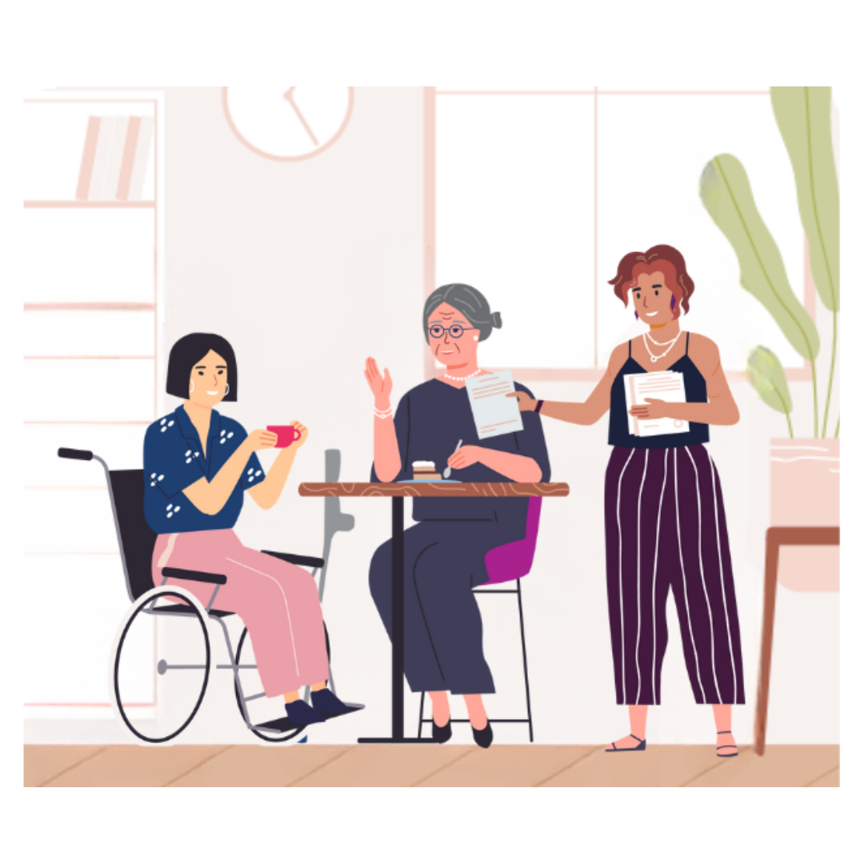Planning and measuring for a gender and disability equitable organisation

## 1. Commitment

### Indicator statements

Our organisation demonstrates ongoing prioritisation, commitment, resourcing, and action to achieving equality of all people and eliminating discriminatory stereotypes and barriers. Disability and gender equity and inclusion are embedded throughout our vision, mission, values, strategy, policy, and practice. We value the voices and expertise of those most impacted by discrimination and inequity in guiding our gender and disability equity action, and we positively acknowledge women and non-binary people with disabilities as part of our community.

Our leadership, board, and senior executive take responsibility to actively address harmful attitudes, beliefs and behaviours, and challenge intersectional barriers from policy to delivery, to prevent gender and disability based violence. Our strategies, policies, and procedures related to inclusion and equity are understood by all staff and promoted within our organisation, including our active, up-to-date Disability Action Plan (DAP) which we share with the public. Our staff understand gender and disability inequality and intersectionality and take action to facilitate primary prevention which is inclusive of the rights, needs and perspectives of women and non-binary people with disabilities. They are enabled to feel confident and empowered to champion, support, and include women and non-binary people with disabilities among our community. We are resourced to support accessibility requirements of participants across our services, activities, and events.

Our organisation is actively involved in industry networking, learning exchange, and advocacy for policy and practice reforms concerning prevention of disability and gender based violence. We have strong relationships across sectors and communities, with whom we collaborate and partner to centre lived experience and expertise of women and non-binary people with disabilities. This includes disability led organisations; disability and gender equality specialists; other organisations involved in primary prevention; and women and non-binary people with disabilities who are survivors of violence.

### Our plan for change in this area

* + - **Current strengths**:
    - **Current gaps**:
    - **Short term goals**:
    - **Medium term goals**:
    - **Long term goals**:
    - **Timeline**:
    - **Responsibility**:

## 2. Workplace culture

### Indicator statements

Our organisational culture fosters a safe, welcoming, and inclusive working environment that supports authentic inclusion of women and non-binary people with disabilities. We are committed to a fair and diverse workplace, through acknowledging and challenging intersectional discrimination and normalising equality across leadership, policy, and practice.

Our workplace celebrates disability pride, fosters personal identities, and affirms the equality of all. We recruit, retain, and promote women and non-binary people with a range of disabilities across the spectrum of positions. We value diverse skills and attributes, challenge traditional expectations of career paths, and our role design, recruitment and reasonable adjustment processes are inclusive for women and non-binary people with disabilities. We are resourced to support team members who disclose disability, and our managers and supervisors are flexible and knowledgeable about what to offer all staff. Staff can choose to disclose disability and exercise leadership according to their attributes and skills, and we support one another’s strengths, including those relating to disability.

Prevention of violence and staff safety and wellbeing are embedded in our organisational policies and procedures. We create supportive, culturally appropriate, trauma-informed spaces, and we listen to and value the experiences of our employees. We confidentially respond to and support employees who disclose experiences of violence. We support employees who are living and/or working regionally or remotely during extreme weather and climate emergency events. Remote and hybrid working employees are supported to maintain healthy work-life balance and are included in our workplace culture. We hold space for regular staff reflection, debriefing, and self-care, to manage physical, psychological, and emotional efforts required for work.

### Our plan for change in this area

* + - **Current strengths**:
    - **Current gaps**:
    - **Short term goals**:
    - **Medium term goals**:
    - **Long term goals**:
    - **Timeline**:
    - **Responsibility**:

## 3. Information and communications

### Indicator statements

Our organisation ensures that women and non-binary people with disabilities feel heard, accepted, and included to engage across our services, events, and activities. Women and non-binary people with disabilities can engage fully, safely and to an extent equal to that of people without disabilities, without worrying about meeting their disability related needs or relying on other participants to do so.

Women and non-binary people with disabilities can participate and engage where they may otherwise experience barriers. We use a range of formats and methods so that our information and communications are easy to access, use, and understand for everyone. Participants of our services and events receive support to prepare with clear information about what they can expect and how to locate and access facilities. Women and non-binary people with disabilities can optimise their independence and agency through nominating their accessibility needs, and we respect and protect privacy and rights by treating their experiences and requests as confidential.

Our organisation supports accurate, positive representation of diverse women and non-binary people with disabilities in our communication media. We foster affirmative personal identities and challenge gender stereotypes and roles. We promote equality between people of all genders and people with and without disabilities using a strengths-based model. We use person-first language to respect and refer to people how they wish.

Our organisation prioritises physical, psychological, and emotional safety for everyone who engages with our services, events, and activities. It is imperative that our in-person, online and hybrid activities and events are safe, inclusive, positive experiences for all participants. We value the experiences, expertise, time, and efforts of people with disabilities with whom we collaborate. Our consultations are respectful, accessible, and empowering, and we close the loop with those who have contributed.

### Our plan for change in this area

* + - **Current strengths**:
    - **Current gaps**:
    - **Short term goals**:
    - **Medium term goals**:
    - **Long term goals**:
    - **Timeline**:
    - **Responsibility**:

## 4. Premises and catering

### Indicator statements

Our organisation ensures that all physical spaces and catering arrangements we use for events, activities and services are safe, accessible, comfortable, and inclusive for women and non-binary people with disabilities. This applies to the building or other premises from which we operate and any off-site facilities - for visitors, participants, presenters, and employees. We consider accessibility from the beginning for longer term decisions and planning for workplace renovation or relocation; we employ short-term strategies to improve access in the meantime.

Our organisation considers the whole-of-journey experience for all participants when accessing our services, events, and activities. We work to counter assumptions that breaching the boundaries and privacy of women and non-binary people with disabilities is acceptable. Women and non-binary people with disabilities can access facilities autonomously, without undue anxiety, and with dignity. Women and non-binary people with disabilities can fulfil their roles as equal and valued – entering, exiting, and navigating all areas and facilities safely, conveniently, and according to their independent choices.

Our organisation works to counter gendered expectations of the status of women with disabilities as recipients of rescue. Women and non-binary people with disabilities can exercise agency and autonomy within the boundaries imposed by an emergency; we guarantee safe, respectful, and equal emergency evacuation. Employees with disabilities have personal emergency evacuation plans with our organisation.

### Our plan for change in this area

* + - **Current strengths**:
    - **Current gaps**:
    - **Short term goals**:
    - **Medium term goals**:
    - **Long term goals**:
    - **Timeline**:
    - **Responsibility**:

## 5. Decision making and continuous improvement

### Indicator statements

Our organisation has a continuous, coordinated, fit-for-purpose system for monitoring, evaluation, reporting and embedding learnings into decision making. We promote a supportive, open culture which values growth, reflection, reflexivity, and learning. Intersectionality and trauma-informed practice are reflected throughout our primary prevention and across our monitoring, evaluation, and learning. Accessibility and inclusion are standard requirements in our decision making and procurement, to enhance participation and engagement of women and non-binary people with disabilities and provide access for as many people as possible.

Our organisation effectively governs, monitors, evaluates, and reports to the community on our disability and gender inclusion goals and actions. Staff regularly reflect, provide feedback, and share knowledge, to embed and continuously improve inclusion in organisational, team, and individual practices across planning, policy, programs, and services. We consult, collect feedback from, and embed insights of, women and non-binary people with disabilities from our community; participants of our services, activities and events; and disability organisations.

Lived experience is a valued component of our evidence-based practice. We prioritise professional development opportunities which centre the experiences and expertise of women and non-binary people with disabilities, including survivors of violence. We actively share knowledge, build strengths in existing networks, and sustain collaborative partnerships, to build the evidence base, form a coordinated approach, and encourage everyone to play a role in the prevention of disability and gender based violence.

### Our plan for change in this area

* + - **Current strengths**:
    - **Current gaps**:
    - **Short term goals**:
    - **Medium term goals**:
    - **Long term goals**:
    - **Timeline**:
    - **Responsibility**:

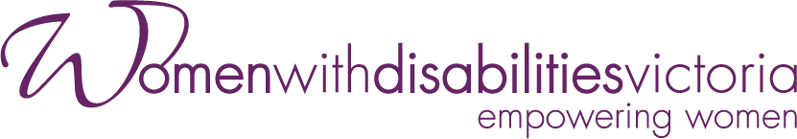

Wurundjeri Country

Postal: PO Box 18314, Collins Street East, VIC 8003

**Phone:** 03 9286 7800

**Email:** [wdv@wdv.org.au](mailto:wdv@wdv.org.au)

For more information visit <https://www.wdv.org.au/>