# **Foundational Support Survey**

Foundational Supports are a new plan from The Government to better include people with disabilities (under 65) in their community.

These supports may be things like; help with daily tasks, accessing your community or building skills.

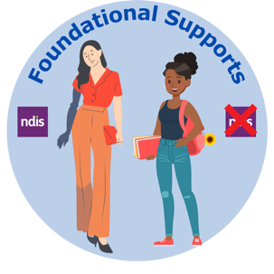

These supports will be for people who **have** and **don’t have** the NDIS.

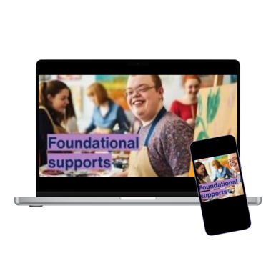

You can find out more about [Foundational Supports](https://www.ndisreview.gov.au/resources/fact-sheet/foundational-supports-all-people-disability) (link opens in new browser) on the NDIS website.

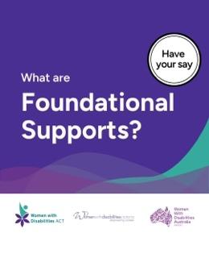

WDV has been working with other women with disabilities organisations on a survey.

This survey will be used to get feedback on what our community needs from ‘foundational supports.’

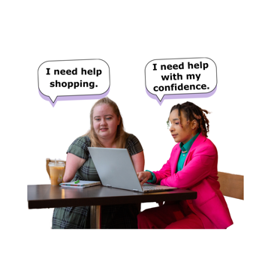In this survey we ask about the kinds of supports that would make a big difference in your life.

Feedback from the survey will help WDV advocate for foundational supports that meet the needs of women with disability.

Take the NDIS Foundational Supports Survey here:

[Survey Monkey](https://www.surveymonkey.com/r/CB8YFCW) (link opens in new browser)



[Accessible Surveys](https://accessiblesurveys.com/.../-O5k3E2FmRPTRwVnwD3e/intro) (link opens in new browser)