# Prevention of Gender and Disability Based Violence Audit Toolkit

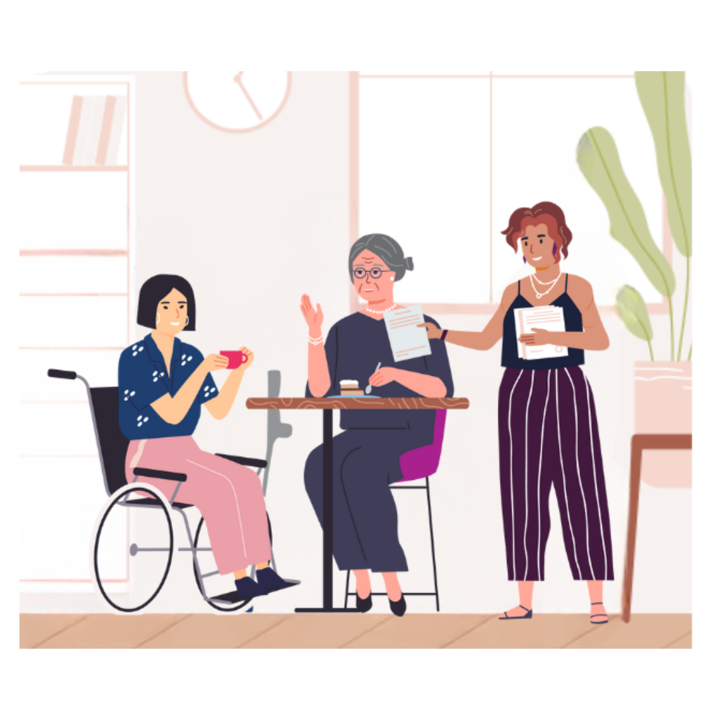Audit 3. Information and communications

# Information and communications

This audit tool supports your organisation to produce and provide information and communications that are inclusive for women and non-binary people with disabilities. These questions apply to the range of media in multiple contexts with which people may interact as visitors, volunteers, employees, consultants, and partners.

Through this audit, you will assess some of the most immediate barriers for women and non-binary people with disabilities who engage and participate across your services, events, and activities - be this once, or frequently. This audit is inclusive of your organisation’s internal information sharing, communication styles, and use of public communications.

Accessibility and inclusion occur when women and non-binary people with disabilities can engage and participate fully, safely and to an extent equal to that of others, without worrying about meeting their disability related needs or relying on other participants to do so. Meaningful engagement for women and non-binary people with disabilities means that they can feel heard, accepted, and included. This also enhances autonomy, agency and decision making of women and non-binary people with disabilities and strengthens their public perception as equal contributors to community life.

In addition to the advice and resources provided in this booklet, always follow your organisation’s policies and procedures around privacy, ethics, research, and consent where relevant for your services, activities, and events.

Reflection

**How accessible and inclusive are your organisation’s communications for women and non-binary people with disabilities?**

Example: You use a range of formats and methods in your communications and marketing and your language and imagery reflect gender and disability equitable attitudes and practice.

Formats, methods, and technologies

This part of the audit relates to how your organisation conveys information to others – both to staff and to the public. You might like to think about documentation, social media, the production of resources, or promotional communications when responding to these questions.

**1. What formats and methods do your organisation use to communicate information - internally and externally, online, and offline?**

When your organisation uses a range of formats and methods, the information produced and communicated will be easy to access and understood by everyone. This increases the likelihood of independent access to your services, activities, and events by all women and non-binary people, including those who are isolated due to violence and abuse, live in remote and rural areas, and/or cannot afford the cost of technology.

People with a range of neurological and sensory disabilities access information in a variety of formats such as: Plain English, Easy English, large print, audio online formats, and braille. Using a range of engagement and promotion methods, such as social media and community radio, can also widen the reach of your information and communications.

Further guidance is available at: <https://www.vic.gov.au/accessibility-guidelines-government-communications>.

* + - Current situation:
    - Action required:
    - Time frame for action:
    - Resources required:

**2. How does your organisation make visual material easy to use and understand for people who are blind or vision impaired?**

Visual material includes pictures, diagrams, graphics, and films/videos, including subtitled material. This includes online content, such as social media posts, and offline content, such as documents. Providing text-based or verbal representation of this material promotes independent access by women and non-binary people with disabilities, challenging gender norms of family or carer facilitated access.

Adding Alternative Text (Alt Text) to all social media posts containing an image provides a written description of the image and increases accessibility of those using screen readers. In addition to alt text, include more detailed Image Descriptions (IDs) in the caption of the post.

Provide captioning options for all video content. While auto-captions are regularly available and easy to add, it is imperative to check for correctness, spelling, and punctuation.

When using hashtags be sure to capitalise the first letter of each word to ensure accessibility for those using screen readers. Limit the use of emojis as the descriptions ascribed to them can be misaligned with the information you are trying to convey.

Use simple font, large font size, and high contrasting colours.

More information can be found at: <https://www.visionaustralia.org/business-consulting/digital-access/blog/how-to-make-social-media-accessible-our-top-three-tips>.

* + - Current situation:
    - Action required:
    - Time frame for action:
    - Resources required:

**3. How do you ensure accessibility for people who are deaf, deaf-blind, or have hearing impairments?**

People who experience difficulty hearing can more effectively access your services, activities and events via augmented communication systems. More details are available from: <https://www.health.gov.au/our-work/hearing-services-program>.

Auslan is the language of the Australian Deaf community. Find more information at: <http://www.auslan.org.au/>. It is good practice to use certified Auslan interpreters, available for booking through several commercial providers. When possible, book interpreters who are members of the community that you are representing, as dialects of Auslan vary because of region, gender, age, class, education, cultural background, social network, religion, or sexuality. Find more information here: <https://aslia.com.au/>.

More information about communication methods used by people who are deaf-blind can be found at: <https://www.deafblind.org.au/deafblind-information/communication/communication-methods/>.

* + - Current situation:
    - Action required:
    - Time frame for action:
    - Resources required:

**4. Does your organisation have access to a hearing loop? How is the hearing loop promoted to potential users?**

A hearing augmentation system, more commonly referred to as a hearing loop, allows for audio content broadcast through microphones or speaker systems to transmit directly to a person’s hearing aids. Different systems are available for hire or permanent installation and there are signage requirements to signify their availability within a public venue. Hiring or owning hearing augmentation facilities is another way of publicly promoting the independence and autonomy of women and non-binary people with disabilities.

Further information is available from: <https://www.deafnessforum.org.au/resources/signage-guide-for-hearing-augmentation-systems/>.

* + - Current situation:
    - Action required:
    - Time frame for action:
    - Resources required:

**5. Does your organisation’s website comply with WCAG2.2 Standards?**

These standards ensure the accessibility of online environments for people with diverse disabilities. Adhering to these standards benefits other internet users, particularly those accessing content via mobile devices or others who are connecting to the internet via low speeds of data.

A simple guide to the basic requirements of the standards in plain language can be found at: <https://accessible.org/wcag/#wcag-2-2-aa-checklist>. Find more technical advice for communicating with web designers at: <https://www.w3.org/WAI/tutorials/>.

* + - Current situation:
    - Action required:
    - Time frame for action:
    - Resources required:

**6. Does your organisation’s software comply with WCAG 2.2 Standards?**

Ensure that the software and systems for information management and retrieval, internal and external communication, project and stakeholder management and evaluation meets the WCAG 2.2.

For more information, visit: <https://accessible.org/wcag/#wcag-2-2-aa-checklist> and <https://www.w3.org/WAI/tutorials/>.

* + - Current situation:
    - Action required:
    - Time frame for action:
    - Resources required:

**7. How does your organisation ensure that written information is presented in a clear and simple way?**

Designing your written information with a clear structure supports people with disabilities to navigate your content and find the information they need. Visit: <https://www.stylemanual.gov.au/structuring-content/types-structure>.

Producing Plain and Easy English versions of written information ensures accessibility for more people and is another means of promoting independent engagement of women and non-binary people with a range of disabilities, or who have experienced barriers in gaining literacy.

Plain English, also known as plain language or Everyday English, is a direct style of writing that avoids jargon and complicated words and phrases. Plain language is accessible for people who can read at level 2 (Australian year 7 equivalent) or higher and helps people with higher literacy to read and understand information quickly. Further guidance is available at: <https://www.stylemanual.gov.au/writing-and-designing-content/clear-language-and-writing-style/plain-language-and-word-choice>.

Easy English, also known as easy-to-read or Easy Read, is a writing style that helps people who find it hard to read and understand English. It has a lower reading level than Plain English and uses short sentences and images. Further guidance is available at: <https://www.stylemanual.gov.au/content-types/easy-read>.

For more information about the differences between Plain and Easy English, visit (Word): <https://centreforinclusivedesign.org.au/wp-content/uploads/2020/04/Easy-English-vs-Plain-English_Final.docx>.

* + - Current situation:
    - Action required:
    - Time frame for action:
    - Resources required:

**8. How do you make sure that people with sensory disabilities can understand and access your organisation’s presentations and training content?**

Ensure that women and non-binary people with disabilities can access and engage with your presentations and training independently. For all delivery modes, simplify your slides and provide accessible copies to participants in advance. Make sure that you can describe any essential graphical or visual material so that everyone understands the same information. Plan and test sound, audio, camera, video, presentation sharing, assistive technology integration, and other accessibility features.

For in-person facilitation, ensure participants can access the presentation projector, screen, or other display. Make content large so that more participants can see it, for example, people who have low vision and those sitting in the back of the room. When you present online, make sure your presentation or screen is clear on different devices such as phones, tablets, and computers and how it presents with assistive technology.

For more tips on presentation accessibility visit: <https://www.disabilitygateway.gov.au/good-practice-guidelines>.

For guidance on developing accessible PowerPoint presentations visit: <https://support.office.com/en-us/article/make-your-powerpoint-presentations-accessible-to-people-with-disabilities-6f7772b2-2f33-4bd2-8ca7-dae3b2b3ef25>.

* + - Current situation:
    - Action required:
    - Time frame for action:
    - Resources required:

**9. What flexibility do you offer participants in your activities and events, in terms of location and time?**

Consider the time and place when you hold events and activities to support women and non-binary people with disabilities to participate when they may otherwise find certain periods, venues, or other settings inaccessible.Some women and non-binary people with disabilities experience barriers participating online, such as cost of technology. Some women and non-binary people experience stalking and/or online monitoring by a current or former partner, family member, or someone else they know.

Where feasible, identify convenient times and locations for participants and provide options for hybrid participation. Consider the whole-of-journey experience of participating in an in-person event or activity. Travel times to and from the venue, time zones, or other obligations may impact an individual’s access, availability, or interest in participating.

It may also be feasible to offer other means of remote participation, including via phone, email, or post, for some activities.

* + - Current situation:
    - Action required:
    - Time frame for action:
    - Resources required:

Participation information

This part of the audit relates to how your organisation collects and communicates information about participation, to contribute towards inclusive meetings, events, and activities across your organisational practice. You might like to think about the processes and systems your organisation has in place to acquire and use logistical information and communicate what needs to be known to staff and participants, so that everyone receives the same information with enough time.

**1. How does your organisation support participants to prepare for the content of your activities and events?**

When inviting people to participate in your activity or event, provide them with clear information about what they can expect from their involvement. Send an accessible copy of meeting and training agendas to participants ahead of time, and where possible, accessible copies of presentations and other supporting materials. This enables participants to review content and begin to absorb information if they choose to, acknowledging different learning styles.

When engaging people with disabilities to contribute to your work, for example in consultant or advisory roles, provide background information on your organisation and the details of the activity, so they have enough time to arrange logistics and any accommodations they need. Discuss expectations early on to frame what the intended objectives are, provide questions or discussion points in advance, and advise how you will use the information they provide.

For more information, visit: <https://www.disabilitygateway.gov.au/good-practice-guidelines>.

* + - Current situation:
    - Action required:
    - Time frame for action:
    - Resources required:

**2. How do you support participants to access your online activities and events?**

Prior to your online activities and events, provide participants with clear information about how to locate, access and engage via your chosen platform. Produce and provide an access guide with written instructions, screenshots of what they might see via a device, and image descriptions to describe the content of the screenshots. Include details about how to use the range of accessibility features, such as live captions, audio descriptions, and keyboard navigation such as key functions if using a screen reader and keyboard shortcuts.

When engaging people with disabilities to contribute to your work, for example in consultant or advisory roles, plan for any methods, approaches, and technologies both parties will use.

For more information, visit: <https://www.disabilitygateway.gov.au/good-practice-guidelines>.

* + - Current situation:
    - Action required:
    - Time frame for action:
    - Resources required:

**3. How do you support participants to locate and access the premises in which you hold your in-person activities and events?**

Prior to your in-person activities and events, provide participants with clear information about how to locate and access the premises. This supports people with disabilities to plan how they will travel. Produce and provide an ‘access guide’ with clear photos and maps alongside instructions and descriptions, including:

* the route from the closest main road
* the route from the closest parking options and accessible parking bays, and any associated cost
* the line numbers/names of and route from the closest public transport stops
* the nature and location of the main entrance and any alternative entrances, e.g., ramps.

It is valuable to express proximity in metres rather than estimates of walking time, as these will vary for everyone.

Consider undertaking the *Premises and catering* audit within this toolkit and refer to the “Approach and access” section for other points to include in your access guides.

* + - Current situation:
    - Action required:
    - Time frame for action:
    - Resources required:

**4. How do you support participants to navigate the premises, spaces, and facilities of your internal and external in-person activities, events, and staff meetings?**

Your buildings or venues are accessible when people with disabilities can independently navigate the interior and access all spaces and facilities. Provide clear photos, instructions, descriptions, and floorplans in your access guides, including:

* accessibility of hygiene facilities, including the route from the main area
* quiet spaces, including the route from the main area
* facilities for the care of assistance animals, including the route from the main area
* seating arrangements and plan
* food and drink catering arrangements, including the route from or within the main area, and facilities available
* any other sensory information, e.g., lighting, sound, smells, floor texture.

It is valuable to express proximity in metres rather than estimates of walking time, as these will vary for everyone.

For other points to include in your access guides, refer to the “Navigation”, “Hygiene facilities” and “Food and drink” sections in the *Premises and catering* audit booklet.

For more guidance, visit: <https://www.disabilitygateway.gov.au/good-practice-guidelines>.

* + - Current situation:
    - Action required:
    - Time frame for action:
    - Resources required:

Access requirements

This part of the audit relates to how responsive your organisation is to support the access requirements of participants, community, and staff. Making sure this information is accessible and ensuring that all staff know how to support accessibility across activities means that your organisation can learn from past experiences and support equal opportunities for all members of your community.

**1. Where not readily available, does your organisation clearly indicate to the community how they can contact you to request alternative formats and methods of media?**

It is good practice to include a direct method for community members to contact your organisation if they wish to request information in formats not readily available. A link to a social media site or email address on its own is not an adequate means of direct contact. Provide a telephone number which is responded to by the appropriate staff member/s.

* + - Current situation:
    - Action required:
    - Time frame for action:
    - Resources required:

**2. How do you let participants know what accommodations are available to them, for your activities and events?**

It is good practice to offer participants the choice to nominate accessibility requirements as part of event registration processes, or upon inviting people to contribute as consultants or advisors. This not only conveys your organisation’s commitment to inclusion but offers autonomy and choice for participants and facilitates planning for accessibility, e.g. Auslan interpretation, catering and dietary requirements.

* + - Current situation:
    - Action required:
    - Time frame for action:
    - Resources required:

**3. How can participants contact your organisation if they wish to request accommodations or assistance before or during events and activities?**

Participants with disabilities may wish to optimise their independence and agency by discussing access needs or requesting assistance, before or during your events and activities. It is good practice to include a direct method for contacting event organisers, operational prior to and during the event, such as a telephone number that the appropriate staff member/s can respond. A link to a social media site or email address on its own is not an adequate means of direct contact.

* + - Current situation:
    - Action required:
    - Time frame for action:
    - Resources required:

**4. How does your organisation record the access requirements of participants?**

Documenting and collating participants’ requirements assists staff to ensure delivering activities and events according to their needs, recognising their equality and value as participants. However, ensure you protect the privacy and rights of people with disabilities by storing their information confidentially and safely.

Follow your organisation’s and industry’s processes to manage privacy, encryption, and other concerns. Tell people where their information will be kept, who will have access to it, and how long you will keep it. Always respect participant privacy in group settings by not disclosing accessibility needs.

For more guidance, visit: <https://www.disabilitygateway.gov.au/good-practice-guidelines>.

* + - Current situation:
    - Action required:
    - Time frame for action:
    - Resources required:

Respect and safety

This part of the audit relates to the way that your organisation uses information and communications to represent members of your community in a manner that is strengths-based, and representational, while promoting safety and respect. Again, this includes how your organisation uses the internal and external facing communication and engagement methods to build trust and understanding with your community.

**1. How does your organisation include accurate, positive representation of diverse women and non-binary people with disabilities in your communication media?**

An organisation reflects their values and attitudes concerning women and non-binary people with disabilities in their portrayal in media through language and visual imagery. This can range from invisibility, a limited range of disabilities, or in poses or language signifying a spectrum of dependence and power relationships, e.g., people with disabilities always being photographed with a carer.

Positive portrayals of women and non-binary people with disabilities (obtained with informed consent) assist in fostering affirmative personal identities and challenge gender stereotypes and roles. It is also important to use “person-first” language, respect and refer to people how they wish to be identified. A person with a disability should not be used to make people without a disability feel better and referred to as “inspiration porn”. It is important to celebrate the achievements of people with disabilities, but not just because they have a disability.

For more information, visit: <https://www.vic.gov.au/state-disability-plan/our-language/person-first-and-identity-first-language>.

* + - Current situation:
    - Action required:
    - Time frame for action:
    - Resources required:

**2. How do you ensure that the language used in your media is inclusive for women and non-binary people with disabilities?**

Avoid ableist and deficit language. Instead, promote equality between people of all genders and people with and without disabilities by framing disability using a strengths-based model. Use factual language that does not reinforce stereotypes, imply weakness, alienate people, or suggest disability is a reason for violence. To ensure your use of language meets good practice for inclusion, you might need to create or update a style guide that reflects the standards you expect across all organisational communications.

For more information, visit: <https://www.adcet.edu.au/resources/cdl-hub/advice-tips-and-student-stories/guide-to-language-about-disability>.

* + - Current situation:
    - Action required:
    - Time frame for action:
    - Resources required:

**3. How do you prioritise psychological and emotional safety for the community when accessing your media?**

Use content warnings for content that may trigger negative memories or emotions in people. Content warnings are common when content includes topics such as violence, abuse, and discrimination, but other warnings that are important to consider for people with disabilities are graphic medical content, content containing flashing lights, fast moving imagery and loud noises/change in volume or tone.

More information on content warnings can be found here: <https://www.diversityaustralia.com.au/the-use-of-trigger-warnings-in-educational-materials-media-content-and-training-programs/>.

Provide a list on your website and within your documents of available support services, to guide people as needed. For an example, visit WDV’s directory here (Word): <https://www.wdv.org.au/wp-content/uploads/2022/12/Service-Referral-Options-UPDATE-Dec22.docx>.

* + - Current situation:
    - Action required:
    - Time frame for action:
    - Resources required:

**4. How do you reduce the risk of fatigue and prioritise psychological and emotional safety for participants in your events and activities?**

It is important to create safe, supportive, culturally appropriate, trauma-informed spaces for all participants. Provide participants with content warnings and referral to support services, as described in the previous question.

The duration of your activity or event can impact who is interested and available, and whether there is enough time to meet the expected level of participation. Factor in time for sufficient breaks, reflection, and debriefing, so that participants can take time and space away when needed to manage physical, psychological, and emotional efforts required. This can minimise risk of fatigue from accessing, absorbing, and sometimes contributing too much content or content of sensitive or complex nature, as well as from constant screen time when there is a requirement of digital access. Fatigue can have compounding impacts on the specific experiences of people with disabilities.

For online events and activities, reassure participants that it is okay to switch off their cameras if needed, and remind them that they can use headphones if they have someone nearby who could potentially overhear the content.

For more information on trauma-informed practice, visit: <https://www.dffh.vic.gov.au/publications/framework-trauma-informed-practice>.

We cover prioritising safety within physical spaces further in the *Premises and catering* audit booklet; and trauma-informed research and evaluation practice in the *Decision making and continuous improvement* audit booklet.

* + - Current situation:
    - Action required:
    - Time frame for action:
    - Resources required:

**5. How do you prioritise privacy for participants of online events and activities?**

Some people prefer to go by a pseudonym during online events and activities, especially if the content relates to lived experience of violence, abuse, and discrimination. Ask participants how they want to display their name and provide instructions for those who wish to edit their own name on the day. Advise participants that they are welcome to turn their camera off as needed and provide instructions on how to do so. If you must record an event or activity, make sure you inform participants ahead of time, so that they can choose to change their name and/or have their camera switched off.

Some women and non-binary people with disabilities may experience monitoring by a partner, family member, carer, or someone else who could potentially overhear the event or activity. Remind participants that they may also use headphones for greater privacy.

* + - Current situation:
    - Action required:
    - Time frame for action:
    - Resources required:

**6. How does your organisation support the inclusion of remote participants during hybrid activities and events?**

Plan ahead to support an accessible and positive experience for remote participants of a hybrid event or activity. To make sure not to forget anyone, you will need multiple facilitators, accessible materials in multiple formats, and technologies such as microphones and cameras.

Where appropriate, create spaces to encourage participants to build rapport and network, such as breakout rooms, replicating face-to-face participation.

* + - Current situation:
    - Action required:
    - Time frame for action:
    - Resources required:

**7. How does your organisation follow up or “close the loop” with participants?**

Follow up with activity and event participants afterwards, by providing accessible copies of minutes, presentations, and other supporting materials.

When you engage people with disabilities to contribute to your work, for example in consultant or advisory roles, inform them of the next steps during and directly after engagement, and continue to provide updates and materials for ongoing activities.

It is common that people with disabilities will not receive communication about the outcomes of the work they contribute to. This makes them feel that their time and effort is a waste or that their experience and expertise was not valued. “Closing the loop” by sharing outputs and outcomes will demonstrate that you value them. If their engagement leads to no product or change, explain why.

For more information, visit: <https://www.disabilitygateway.gov.au/good-practice-guidelines>.

* + - Current situation:
    - Action required:
    - Time frame for action:
    - Resources required: