# Prevention of Gender and Disability Based Violence Audit Toolkit

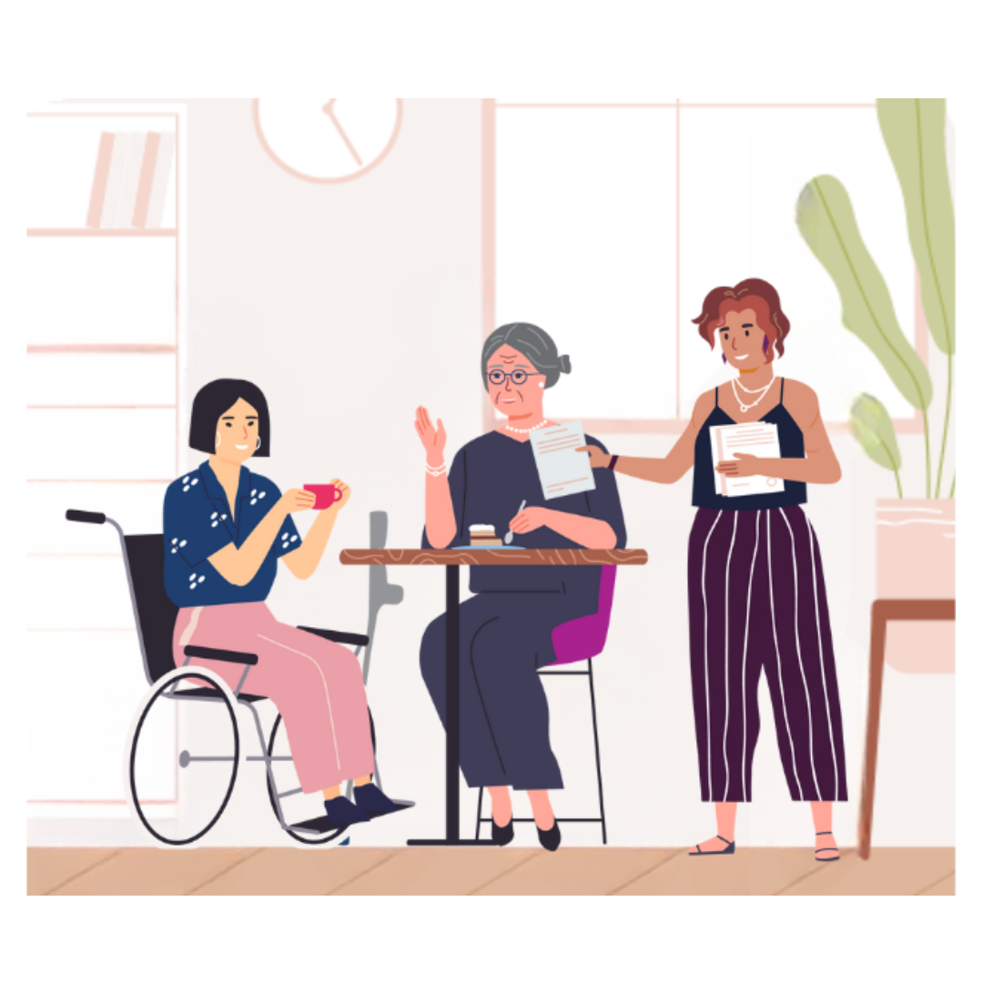Audit 1. Commitment

# Commitment

This audit tool supports your organisation to demonstrate an ongoing, authentic commitment to inclusion for women and non-binary people with disabilities.

These questions relate to how your leadership, board, and senior executive take responsibility to promote, resource, and embed disability and gender inclusion throughout strategy, policy, and practice. This includes being consistent and transparent with your approach; strengthening staff capacity in creating safe spaces for people with lived experience of disabilities and victims/survivors of violence; and building genuine relationships within the disability and prevention of violence against women (PVAW) sectors and with other organisations working to prevent gender-based violence.

Auditing commitment can lead to greater accountability and action to challenge the drivers of ableism and inequality, centre lived experience and prevent violence against women and non-binary people with disabilities.

## Reflection

**How do leadership in your organisation model a gender and disability inclusive workplace culture?**

Example: Leadership role model behaviour that is inclusive and proactively engage in actions to challenge negative ableist and sexist stereotypes.

## Plans, policies, and programs

The following questions relate to how your organisation includes experience of gender and disability across processes of planning, policy, and programs to ensure a systemic approach to inclusive and accessible practice for women and non-binary people with disabilities.

**1. How are gender and disability inclusion promoted in your organisation’s vision, mission, values, and strategic goals?**

The promotion of gender and disability inclusion in your vision, mission, values, and strategic goals can be an effective way to ensure that staff, partners, and the community are aware of your organisation’s commitments and requires minimal resources to undertake. You will demonstrate organisational commitment to equality of all people, elimination of discriminatory stereotypes and barriers, and positive acknowledgement of women and non-binary people with disabilities as part of your community.

* + - Current situation:
    - Action required:
    - Time frame for action:
    - Resources required:

**2. How are gender and disability inclusion embedded in policies and procedures?**

Your organisation can further indicate and promote your commitment to preventing violence against women and non-binary people with disabilities through embedding gender and disability inclusion in policies and procedures.

These fact sheets can help inform your policies and procedures: <https://humanrights.gov.au/our-work/employers/good-practice-good-business-factsheets>.

For guidance on embedding gender equality in policies and procedures, download this tool (PDF): <https://www.vichealth.vic.gov.au/sites/default/files/VH_Tool-Kit_Manual_State-Gov-Edtion_WEB.pdf>.

For further ideas on expressing your commitment to disability inclusion, visit: <https://askearn.org/page/expressing-a-commitment-to-disability-inclusion>.

* + - Current situation:
    - Action required:
    - Time frame for action:
    - Resources required:

**3. Does your organisation have a Disability Action Plan (DAP) – otherwise known as an Accessibility Action Plan (AAP)? What is the status of the plan?**

A DAP is a document stating to the public how an organisation will identify and address barriers to access and inclusion in their community. Documenting your approach, actions and measures will demonstrate commitment to the promotion of equality and strengthening of positive, equal, and respectful relationships.

DAPs are not compulsory for non-government organisations but can be a useful means of actively committing and demonstrating accountability. Ensure your organisation allocates the time, resources, and managerial support within your plan to effectively engage staff throughout the organisation and remain current. Your organisation may also engage in joint activities with partners, such as local governments, as part of their DAP.

Further information is available at: <https://providers.dffh.vic.gov.au/disability-action-plans>.

* + - Current situation:
    - Action required:
    - Time frame for action:
    - Resources required:

**4. What budget is allocated across services, activities, and events to support access requirements of participants?**

Take active steps to ensure your work is inclusive and allows a range of diverse people to participate and engage in a safe, respectful way that meets their needs. Ensuring that budget is allocated to support access requirements of participants challenges intersectional barriers from policy to delivery. Senior managers with influence in budgeting and resourcing should ensure this is standard and embedded in funding applications, and your CEO should reinforce these expectations. This includes ensuring staff are available and resourced for offering assistance to participants at events, where necessary. Doing this can enable staff to feel empowered to champion women and non-binary people with disabilities among your community; and contribute to the prevention of gender and disability based violence by reaching more women and non-binary people with disabilities.

* + - Current situation:
    - Action required:
    - Time frame for action:
    - Resources required:

**5. How does your organisation get involved in advocacy for policy and practice reforms concerning prevention of violence against women and non-binary people with disabilities?**

Engage in advocacy for federal and state legislative and policy change to address structural discrimination and inequity that disadvantages people based on gender and disability. This may include supporting public campaigns and writing or contributing to submissions to parliamentary inquiries, Royal Commissions and plans.

* + - Current situation:
    - Action required:
    - Time frame for action:
    - Resources required:

## Employee capacity building

These questions reflect on how your organisation supports staff to understand and build strength in gender and disability inclusive practice. Ongoing action and staff engagement are necessary to embed and sustain progress towards a gender and disability equitable organisation.

**1. How are organisational documents disseminated internally, to employees?**

This relates to the availability and promotion within your organisation of the plans, policies and procedures considered in the first section of this booklet. It is best to store documents in the same place, always available and easily accessible to all staff, e.g., in accessible formats on your organisation’s intranet. New staff should be directed to access key plans, policies and procedures during induction, and dissemination of new and updated documents should occur via usual channels of internal communication to ensure their use by staff, e.g., newsletter, staff meetings, or emails.

For guidance on how to implement policies and procedures, visit: <https://www.healthandsafetyhandbook.com.au/bulletin/step-by-step-how-to-implement-effective-policies-and-procedures/>.

* + - Current situation:
    - Action required:
    - Time frame for action:
    - Resources required:

**2. How do staff in your organisation acquire knowledge on disability and intersectionality? How often?**

Taking an intersectional approach will help you ensure your work understands and addresses the ways that other forms of privilege and oppression intersect with gender to result in violence against women and non-binary people.

Disability organisations deliver considerable information and training regarding disability, human rights, and inclusion, and exist online. Free e-learning resources are available from: <https://disabilityawareness.com.au/elearning/>.

WDV develops training and shares resources to inform partners, organisations, and the community about the experiences, rights and needs of diverse women with disabilities, especially relating to violence against women, sexual and reproductive health, human rights, and the impact of government policy on the lives of women and non-binary people. For more information, visit: <https://www.wdv.org.au/resources-v2/>.

For resources and training on working with Aboriginal and Torres Strait Islander people and communities, visit: <https://aifs.gov.au/resources/resource-sheets/resources-support-culturally-safe-service-delivery-aboriginal-and-torres>.

For resources and training on working with migrant and refugee people and communities, visit: <https://www.mcwh.com.au/>.

For resources and training on working with LGBTIQA+ (lesbian, gay, bisexual, trans and gender diverse, intersex, queer and asexual) people and communities, visit: <https://rainbowhealthaustralia.org.au/>.

* + - Current situation:
    - Action required:
    - Time frame for action:
    - Resources required:

**3. How do staff acquire knowledge on violence against women and non-binary people with disabilities and evidence-based inclusive prevention initiatives? How often?**

Good practice to acquire this knowledge includes building genuine relationships with disability led organisations to learn from their expertise in gender and disability based violence; working with women and non-binary people with disabilities who are survivors of violence; participating in industry networking and learning exchange; and participating in WDV’s training and subscribing to our publications.

Ensure you tailor professional development to the specific needs of your workforce in a way that allows all staff to engage and participate fully. It needs to stay current and should be part of your annual training calendar to refresh staff knowledge and ensure the engagement of new staff.

You can browse our prevention of violence resources here: <https://www.wdv.org.au/family-violence-resources/>. Contact us to find out more about our training here: <https://www.wdv.org.au/contact-us/>.

* + - Current situation:
    - Action required:
    - Time frame for action:
    - Resources required:

**4. Does everyone in your organisation have (at least) a foundational understanding of:**

* **Prevalence of violence against women and non-binary people with disabilities**
* **Forms of violence that women and non-binary people with disabilities experience**
* **Drivers and risk factors of gender and disability based violence**
* **Essential actions to prevent gender and disability based violence?**

All staff should be aware of how gender and disability inequality can occur and what they can do to prevent and respond to this discrimination and violence. This includes all staff having at least a foundational understanding of gender-based violence and family violence prevention and response, and how to challenge attitudes, beliefs, behaviours, systems, and practices that condone violence against women and non-binary people with disabilities. A great starting point for professionals to strengthen their knowledge can be found here: <https://www.ourwatch.org.au/change-the-story/changing-the-landscape>.

Support staff to identify, acknowledge and understand any unconscious biases and beliefs they hold. To put learnings into practice, your leadership must provide a supportive, open, and safe culture for staff to reflect and take action.

* + - Current situation:
    - Action required:
    - Time frame for action:
    - Resources required:

**5. How do staff manage risk and prioritise the safety of victims/ survivors of violence with lived experience of disability whom they encounter?**

It is essential to equip staff to create safe, supportive, culturally appropriate, trauma-informed spaces when engaging women and non-binary people with lived experience of disability, including victims/survivors of violence. Good practice includes having policies and procedures in place to respond to disclosures by active listening, affirming the right to safety, offering initial support, accessible external referral and follow up. During design and planning for activities and events, staff need to consider intended and unintended impacts on victims/survivors, to identify and reduce potential harms and support positive experiences.

Provide training to your leadership staff on how to appropriately manage disclosures that occur in the workplace, including understanding how violence impacts different population groups, such as women with disabilities, people from LGBTIQA+ communities, or people on temporary visas.

We cover workplace safety, policies, and procedures further in the *Workplace culture* audit booklet. We also consider safe, respectful engagement further in the *Information and communications* audit booklet.

For more information on trauma-informed practice, visit: <https://www.dffh.vic.gov.au/publications/framework-trauma-informed-practice>.

For further resources, including training opportunities, visit: <https://professionals.blueknot.org.au/>.

* + - Current situation:
    - Action required:
    - Time frame for action:
    - Resources required:

## Relationships and partnerships

These questions relate to the recognition and maintenance of relationships with your community and across sectors in your local region, including violence prevention, disability, and gender equality specialists. Building genuine relationships and partnerships enables consolidated action to prevent disability and gender based violence.

**1. How does your organisation involve community members on organisational matters, to include the rights, needs and experiences of women and non-binary people with disabilities?**

The voices of those most impacted by discrimination and inequity need to be represented at all levels and have an active role shaping how your organisation takes action. Consulting and involving women and non-binary people with disabilities from your community in organisational matters promotes decision making, inclusion and leadership. Organisations can seek input from community on the rights of women and non-binary people with disabilities through meaningful consultation, providing accessible forms of information and points of contact, and building inclusive relationships with members of your community. Disability specialists and organisations can help you find the right person or group to consult with and prepare you to work together.

* + - Current situation:
    - Action required:
    - Time frame for action:
    - Resources required:

**2. What remuneration is available to community members consulted on organisational matters?**

Providing meaningful remuneration when consulting with women and non-binary people with disabilities indicates acknowledgement of the value of their expertise. Doing so can also challenge gendered and ableist stereotypes of the perpetual voluntarism of women with disabilities. Forms of remuneration can vary depending on personal circumstance. It is important to remain flexible in designing your consultation method with this in mind. We cover inclusive, accessible consultation further in the *Information and communications* audit booklet.

* + - Current situation:
    - Action required:
    - Time frame for action:
    - Resources required:

**3. How does your organisation disseminate plans and policies externally, to the community?**

This relates to public dissemination of documents considered in the first section of this booklet, in accessible formats, where relevant and appropriate. This supports your organisation to be accountable and transparent and signals your stance on the equality of all people.

* + - Current situation:
    - Action required:
    - Time frame for action:
    - Resources required:

**4. What resources (financial, human, physical) are you aware of within your local community or region for disability inclusive prevention of gender-based violence?**

This relates to identifying the financial, human, and physical resources available in your local community or region to support disability inclusive prevention practice. This may include local government inclusion grants; expertise within disability advisory committees; regional strategies and plans; coalitions and alliances; and infrastructure and facilities in shared spaces.

* + - Current situation:
    - Action required:
    - Time frame for action:
    - Resources required:

**5. With whom is your organisation partnering to deliver disability inclusive prevention of violence against women and prevention of gender-based violence initiatives?**

Consider partners you have formal agreements with for collaboration as well as those whose initiatives you participate in. This may include community services, Aboriginal Community Controlled Organisations, multicultural services, National Disability Insurance Scheme (NDIS) providers, local government, sporting clubs, education and training services, health care services, and disabled people’s organisations.

* + - Current situation:
    - Action required:
    - Time frame for action:
    - Resources required: