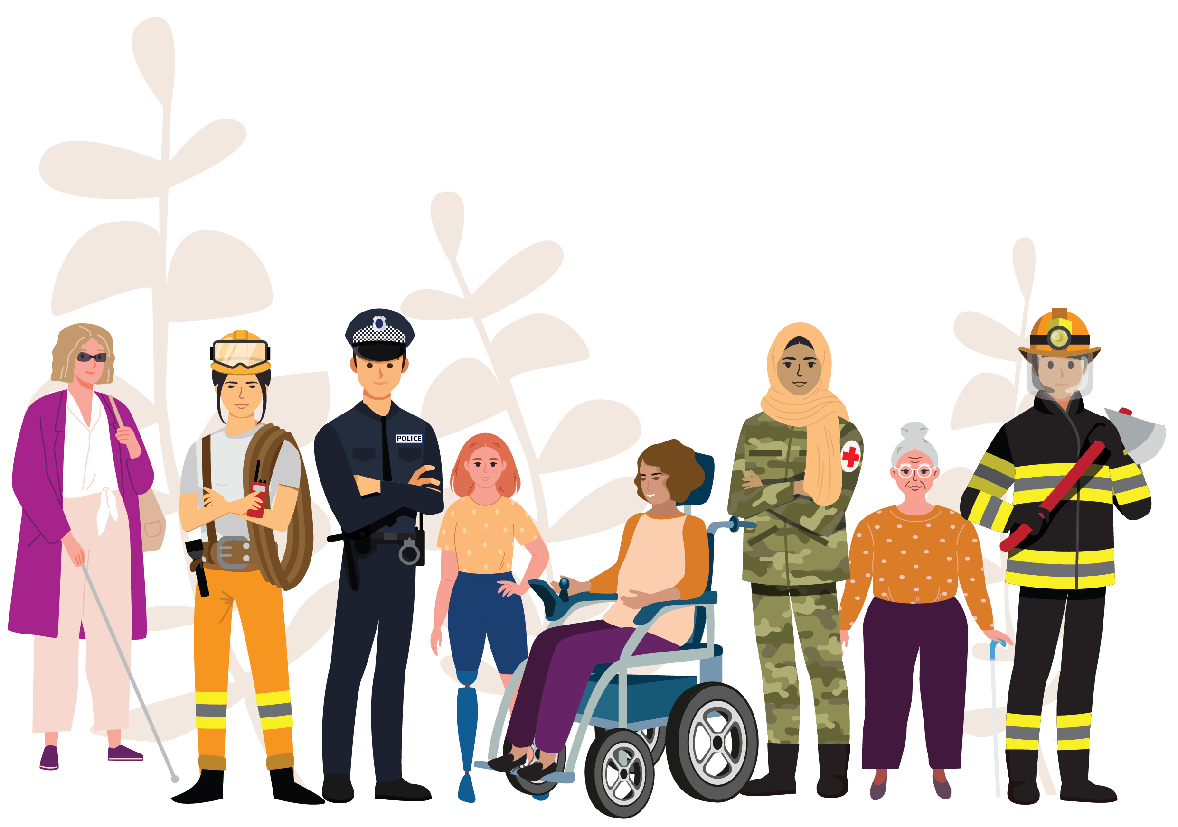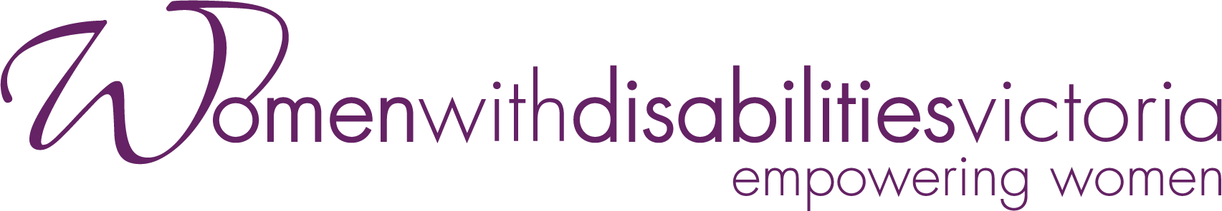





Women with Disabilities  
and climate emergencies

EMERGENCY MANAGEMENT  
BEST PRACTICE GUIDE

AUGUST 2024

|  |
| --- |
| Women with Disabilities Victoria logo  Women with Disabilities Victoria acknowledges the Australian Aboriginal and Torres Strait Islander peoples as the first inhabitants and traditional custodians of the lands on which we live and work. We pay our respects to ancestors and Elders, past and present. The WDV community is committed to honouring the unique cultural and spiritual relationship Aboriginal and Torres Strait Islander peoples have with the land and waters, and their rich contribution to society. |
| Golden Plains Shire Council logo  Golden Plains Shire spans the Traditional lands of the Wadawurrung and Eastern Maar Peoples. Council acknowledges them as the Traditional Owners and Custodians and pays its respects to both Wadawurrung and Eastern Maar Elders past, present and emerging. Council extends that respect to all Aboriginal and Torres Strait Islander People who are part of Golden Plains Shire. |

# About this resource

This booklet, developed by Women with Disabilities Victoria (WDV) and Golden Plains Shire Council (GPSC), as an emergency management best practice guide for all emergency service workers who are directly involved in the planning and preparation for climate emergencies in their communities. National disaster risk reduction (DRR) and emergency management plans frequently overlook the diversity of disabilities.[1] When emergency plans are prepared properly and practiced in a way that is inclusive of all, whole communities will benefit.

This resource aims to build knowledge on gender and disability inclusive practice, and how our communities and organisations can work to prevent the higher rates of violence that women with disabilities report during climate-based emergencies.

This resource has been co-designed with women with disabilities, whose lived experience has informed the content of this resource.

# Women with Disabilities Victoria (WDV)

Women with Disabilities Victoria is an organisation of women with disabilities with a diverse and growing membership which aims to build partnerships, lead the way for Victorian women with disabilities, and improve women’s choices by providing a voice for women with disabilities.

Our Vision

A world where all women are respected and can fully experience life.

Women with Disabilities Victoria Goals:

Influence Policy: Influence government and the community to recognise and remove barriers to full participation by women with disabilities.

Empower Women: Engage and empower women with disabilities to lead and influence their communities.

Influence Services: Educate and guild the capacity of service systems and organisations to be accessible to women with disabilities.

|  |  |
| --- | --- |
| Our Values |  |
| * Uphold human rights and social justice * Equal opportunity * Accessibility * Respect * Collaboration | * Effectiveness * Creativity * Diversity * Accountability |

# Golden Plains Shire Council (GPSC)

Golden Plains Shire Council has seven elected Councillors, which includes a peer elected Mayor, this groups holds the governance responsibility of the Shire. There are over 200 Council staff that assist in the delivery of Council's Legislative functions under the Local Government Act 2020.

As a part of Local Government, Council provides a wide variety of services to our municipality and enforces various federal, state and local laws for our communities outlined under the Local Government Act.

Golden Plains Shire Council Vision and Values Graphic:

Where people matter
Communities are connected
And the future is bright.

Pride - We know that our work is important, and we take pride in doing the best job we can.

Respect - We treat each other with courtesy and respect, and are committed to keeping our environment safe, and free from judgement.

Integrity - We are committed to being authentic, honest and ethical in our work.

Collaboration - We partner together to achieve shared goals and deliver community focussed outcomes.

Excellence - We are committed to delivering the best community experience and outcome that we are capable of providing.

# Women with Disability in Australia

About one in five women in Australia have a disability.[2] Women and girls with disabilities are more likely to experience gender-based violence during and after climate emergencies due to multiple and intersecting forms of discrimination that heighten their exclusion and risks.[3]

A range of factors including **increased poverty** and **social isolation**, **a loss of assistive devices, a lack support people** and **other protective networks, limited mobility**, and **communication barriers** can contribute to a heightened risk of gender-based violence.[4] Women with disabilities in a rural setting experience an even higher risk of social isolation and have less access to support services.[5]

Australia is witnessing a significant increase in both the severity and frequency of natural disasters. This means accessible and inclusive planning and safeguarding for the needs of women and girls with disabilities are critical in preventing gender-based violence in this context.

Older woman with walking stick
Young Asian woman with shortened right arm.
Young woman in a wheelchair

# 2019–20 Black Summer and 2022 Floods in Australia

Australia drew worldwide attention for its 2019–20 bushfires and 2022 floods. Recent government reports have highlighted that Australia’s lack of inclusive emergency preparedness disproportionately harms people with disabilities.[6]

In previous years:

* Emergency information is not available in multiple formats accessible for women with disabilities
* Evacuation centres remain inaccessible for people with physical disabilities
* Disruptions to essential services for people with disabilities involving health, social care, transportation, and food were disproportionately experienced
* People with disabilities are more likely to experience homelessness when living in disaster-prone areas
* Women with disabilities experienced much higher levels of family violence.[7]

These exclusionary practices highlight the need to set up stronger safeguards to protect women with disabilities at all levels of emergency planning and response.

Important steps to prevent family violence occurring against women with disabilities in emergencies:

1. Include women with disabilities across all levels of emergency planning and response
2. Remove physical barriers to safety
3. Make emergency information and messaging accessible, in a variety of formats
4. Support women with disabilities to plan and create household evacuation plans with their community
5. Maintain community connections between women with disabilities.

1. Include women with disabilities across all levels of emergency planning and response

“Lift your game – disability is thought of a group over there, not a part of the community. We’re not separate.” – Alice*

To understand the specific experiences of women with disabilities, include us in all stages of planning and implementation. For example, you can provide opportunities for meaningful consultation and inclusion with women with disabilities in your community throughout all stages of emergency planning and response. This is crucial so that responses and recovery efforts are disability-inclusive and uphold the human rights of women with disabilities.

"Lived experience is expertise."

Strengthening the role of women with disabilities in the communities where they live, and work promotes independence, agency and participation in leadership and decision-making. This builds community resilience for everyone. Women and girls with disabilities must play a key role in planning for disasters long before they occur as they know their own needs best.

Women and disabilities can be engaged in emergency planning and response efforts as staff, volunteers, advisors, and partners.

Your organisation can facilitate greater inclusion for women with disabilities for climate emergency planning using these resources:

* **Collaboration 4 Inclusion Disability Inclusive Disaster Risk Reduction (DIDRR) Framework and Toolkit:** <https://collaborating4inclusion.org/disability-inclusive-disaster-risk-reduction/>
* **Collaboration 4 Inclusion Person-Centred Emergency Preparedness (PCEP) Toolkit:** <https://collaborating4inclusion.org/home/pcep/>

These resources assist women with disabilities in planning for and responding to their specific needs during emergencies. It’s important that women with disabilities have tools that provide them with accessible means to support their independence. Doing so empowers women and girls with disabilities to maintain their health, safety, independence, as well as the dignity of all women and the community at large.

2. Remove physical barriers to safety

“The ‘normal’ way isn’t always a possibility.” – Lucy*

Shelters and emergency accommodations are often not accessible for many people with disabilities who require assistive technologies, equipment, carers/support workers, and other vital supports. When women with disabilities can not access safe shelter or transport, they are more likely to rely on people who may choose to use violence against them or be isolated and unable to participate in the recovery effort in your community.

Emergency response plans should adhere to universal accessible design principles as much as possible, as women and girls with disabilities may have accessibility requirements that are more specific than the general population. This means factoring in extra time, and costs to support access and safety, and to ensure that we aren’t at risk of further harm when escaping a climate emergency. To prevent gender-based violence from occurring during these events, physical accessibility is essential for all women to have a safe location to access counselling, medical support, food and water that everyone deserves.

It is important to advocate for the designing and modification to sheltering. Some examples include:

* Accessible toilets
* Ramps
* Handrails
* Hoists
* Doors that are at least 90cm in width to allow the easy passage of wheelchairs
* Doors are easy to open and close for persons with disabilities
* Space inside the shelter is wide enough to allow a wheelchair user to circulate and complete a full turn
* Use clear, large-font, easy-to-read wayfinding signs with high visual contrast and images to make it easy for people to navigate through spaces without needing to ask for assistance.

3. Make emergency information and messaging accessible, in a variety of formats

Communicate essential public broadcasts and information with all disabilities and access needs in mind. During emergencies, access to real-time information can be the difference between life or death.

Information should be consistent, accurate, short, and sharp. It’s important to use plain language that can be repeated for clarity.

Information, evacuation procedures, and protocols for sheltering must be available in multiple accessible formats such as:

* Auslan
* Easy Read
* Plain English
* Information in commonly spoken languages other than English
* Accessible digital formats
  + E.g. large print, fonts that are clear and easy to read, using stronger colour contrasts between essential information and the background, and audio descriptions.
* Inclusive alerts and warnings via multiple communication channels
  + E.g. SMS alerts sent directly to users’ phones, phone calls, sirens, flashing lights.
* Provide emergency contact lists to all households
  + Including 24-hour communication lines for people who require a greater level of support.

For more information on accessible messaging:

[www.stylemanual.gov.au/accessible-and-inclusive-content](http://www.stylemanual.gov.au/accessible-and-inclusive-content)

[www.visionaustralia.org](http://www.visionaustralia.org)

4. Support women with disabilities to plan and create household evacuation plans with their community

Planning in advance can better protect women with disabilities during climate emergencies and may minimise their risk of gender-based violence by providing them with knowledge and tools to find and access appropriate services.

Women with disabilities need to know their evacuation plan well before disaster strikes. Promote the importance for women with disabilities to have a plan in place to your community, and urge your community to consider the following:

**1. Vulnerable Persons Register (VPR)**

* Support members of the community to register with the VPR. The VPR is a local list of people who may need consideration in an emergency.

**2. Transport**

* Plan if you would require support from family members, support workers, carers, or assistive technologies to travel, and who you would contact
* Share your plan with the people in your support network and ensure they understand their role and responsibilities
* Plan evacuations route out of your home or neighbourhood that are accessible.

**3. Assistive Technologies**

* Plan which assistive technology you will need and its transportation
* Plan for how you will manage your equipment in an emergency, e.g. power supply.

**4. Assistance Animals**

* Plan for their food, water, leash, bedding, medicines, registration records.

**5. Health Management**

* Keep copies of concession and health insurance cards, and prescriptions together
* Keep your medication together and in an easily accessible place
* Plan for any medical devices you need such as insulin, glasses, hearing aids
* Prepare a detailed record of everything you need to manage your health
* Seek support from your health practitioners to provide you with any information you need to manage your health in emergencies if you need to delay a treatment or are unable to access medications.

**6. Support Systems**

* Know who your circle of support is such as family or carers and have their contact details in an easily accessible place
* Know your neighbours.

**7. Living Situation**

* Keep your mobility device by your bed if you need to evacuate
* Ensure devices are fully charged, including portable charging banks
* Install an accessible smoke alarm system, e.g. an alarm that uses lights and a vibrating pillow if you are hearing impaired
* Set reminders to check smoke alarms at regular intervals. There are multiple alarm inspection services available for people who require assistance

◊ Tip: A useful way to remember to check your smoke alarm is to get it checked when daylight savings starts/ends.

* Keep your telephone nearby with emergency contacts
* Inform your power company that you or someone in your household relies on power for life-sustaining equipment.

**8. Communication**

* Create a record to have on hand so others know the best way to communicate with you
* Find translation or interpretation services at: [tisnational.gov.au](https://www.tisnational.gov.au)

**9. Personal Support**

* Ask service providers about the plans they have in place for service continuity during emergencies.
* Have a record of your support needs to assist others in helping you make effective decisions when under pressure. Share this information with those who support you.

Adapted from Person-Centred Emergency Preparedness (P-CEP) Toolkit:

<https://collaborating4inclusion.org/home/pcep/>

5. Maintain community connections between women with disabilities

During emergencies, community connections and active outreach for women with disabilities provide safeguards to prevent violence, neglect, and exploitation. Online platforms such as social media can be useful to maintain community connections and provide access to essential services for those able to navigate such methods.

Community engagement initiatives by local councils can also be an effective way for both workers and community members to meet each other and become informed about individual needs.

Get a neighbourhood conversation going – put together a BBQ for people in the community to get together and meet. This can help to create a sense of community to look out for one another.

Councils can also better understand the disability demographic of their jurisdictions and their access needs by sending out a survey via e-mail, letterbox, or via phone call to find out access needs of the community. Maintaining and regularly updating a list of residents who are at heightened risk during emergencies can be extremely beneficial.

Community surveys should be both gender and disability inclusive, and trauma informed to ensure safety of women with disabilities in the community who may be experiencing family violence.

Examples may include:

*‘Do you feel safe in your home?’*

*‘Are you in a relationship that sometimes becomes violent?'*

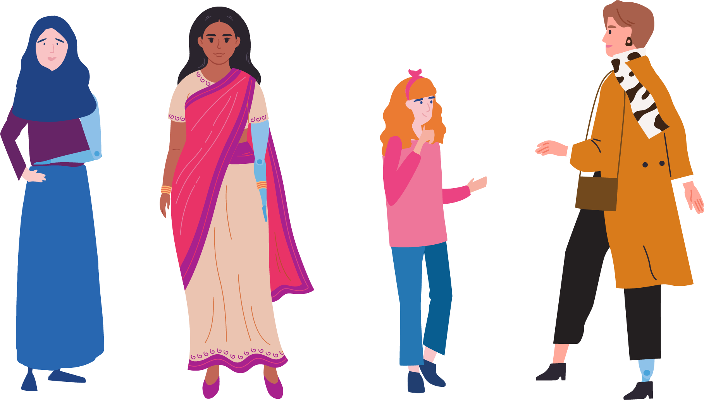

# Ableism in Victoria

Ableism is discrimination or prejudice towards people with disability.

When working towards protecting the health and wellbeing of women with disabilities, it is important that emergency services are committed to and taking the steps necessary to become disability inclusive, both internally as an organisation and when working in the community.

Below are some steps your organisation can make towards disability inclusive prevention of violence against women (PVAW).

1. Create inclusive attitudes and build staff capacity

You can achieve this by:

* Ensuring access to periodic training on disability and intersectionality
* Including accessibility in your organisation’s policies and plans
* Creating and implementing a Disability Action Plan (DAP) through paid consultation with women with disabilities in your community.

2. Build your organisation’s knowledge and capacity of the intersectional impact of violence against women with disabilities

You can achieve this by:

* Evaluating the level of staff awareness on the causes, consequences, and primary prevention measures of violence against women with disabilities, as well as its frequency and forms
* Evaluating the staff's awareness of warning signs of abuse directed towards women with disabilities and suitable ways to handle disclosures
* Evaluating the way in which employees prioritise the safety of victims and survivors of violence who have a lived experience of disability and manage risk
* Incorporating disability and intersectionality into the design, implementation, and monitoring of PVAW activities within your organisation
* Taking part in advocacy for policy and practice reforms concerning prevention of violence against women with disabilities
* Building gender equality and safety of women from violence into your organisation’s HR and wellbeing policies and procedures.

3. Build inclusion in your organisation’s internal and external communication practices

You can achieve this by:

* Providing training and information to staff concerning methods of accessible communication and the organisation’s expectations about their use
* Ensuring website compliance and accessibility with Web Content Accessibility Guidelines (WCAG) 2.1, which is a set of guidelines designed to make web content accessible to everyone
* Providing access to a hearing loop when holding public meetings or events, or at other times upon request
* Producing your organisation’s communication material in a variety of accessible formats, and monitoring and reviewing document accessibility
* Promoting the use of accessible communication in your organisation’s policies and procedure, including visual cues which help visual learners understand activities, discussions, and directions
* Provide verbal descriptions of visual material produced or displayed by your organisation, including PowerPoint slides, pictures, graphics, videos, and subtitled content
* Include positive portrayals of women with diverse disabilities in your visual media.

4. Allocate resources to ensure inclusion occurs

You can achieve this by:

* Connecting with women with disabilities in your community
* Allocating specific human and financial resources by executive and senior leaders to address disability inclusion in operations, programs, and strategy
* Identify physical, financial, and human resources available in your local community to support disability inclusive PVAW practice
* Ensuring staff have access to evidence-based knowledge concerning violence against women with disabilities and programming strategies for its prevention
* Evaluating the effectiveness of your disability inclusive PVAW activities and building on the evidence generated
* Connecting with Women with Disabilities Victoria at wdv@wdv.org.au or call  
  (03) 9286 7800
* Connecting with the Golden Plains Shire Council Disability Advisory Committee and Access and Inclusion Officer at enquiries@gplains.vic.gov.au or call (03) 5220 7111.

5. Frame your organisation’s strategy and partnerships within an intersectional disability inclusive perspective

You can achieve this by:

* Collaborating with women with disabilities and their organisations when planning, implementing, and evaluating PVAW activities
* Including the rights, needs and experiences of women with disabilities in your PVAW activities
* Participating in disability inclusive PVAW activities within your region
* Collaborating with other regional partners to undertake inclusive PVAW activities
* Expressing your commitment to inclusive practice in your organisational strategy.

Adapted from WDV’s ‘Steps to Disability Inclusive Prevention of Violence Against Women – A Brief Guide’

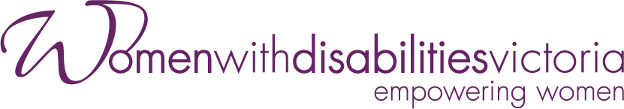

Wurundjeri Country

Postal: PO Box 18314, Collins Street East, VIC 8003

**Phone: 03 9286 7800**

**Email:** [wdv@wdv.org.au](mailto:wdv@wdv.org.au)

For more information visit <https://www.wdv.org.au/>

Golden Plains Shire Council

2 Pope Street, Bannockburn, Victoria 3331

19 Heales Street, Smythedale, Victoria 3351

**Ph: (03) 5220 7111**

**Fax: (03) 4206 7011**

**Email:** [enquiries@gplains.vic.gov.au](mailto:enquiries@gplains.vic.gov.au)



1. Villeneuve, M. (2021). Building a roadmap for inclusive disaster risk reduction in Australian communities. *Progress in Disaster Science,* 10. <https://doi.org/10.1016/j.pdisas.2021.100166>.
2. Disabled People’s Organisations Australia & National Women’s Alliances. (2019). *The Status of Women and Girls with Disability in Australia. Position Statement to the Commission on the Status of Women (CSW) Twenty-Fifth Anniversary of The Fourth World Conference on Women and The Beijing Declaration and Platform for Action (1995).*
3. Le Masson, V. (2022). *Disasters, Climate Change, and Violence Against Women and Girls*. Oxford Research Encyclopedia of Natural Hazard Science, (June), 1–26. <https://doi.org/10.1093/acrefore/9780199389407.013.393>
4. UK Department for International Development. (2017). *Women and girls with disabilities in conflict and crises: K4D Helpdesk Report*.
5. Camilleri, M. (2019). *Disabled in rural Victoria: Exploring the intersection of victimisation, disability, and rurality on access to justice*. International Journal of Rural Criminology, (5)1. 88-112.
6. Royal Commission into Violence, Abuse, Neglect and Exploitation of People with Disability. (2021). *People with disability at much greater risk of neglect during emergencies.*
7. Engelman, A., Craig, L., & Iles, A. (2022). *Global Disability Justice in Climate Disasters: Mobilizing People with Disabilities as Change Agents*. Health Affairs, 41(10). 1496-1504. <https://doi.org/10.1377/hlthaff.2022.00474>