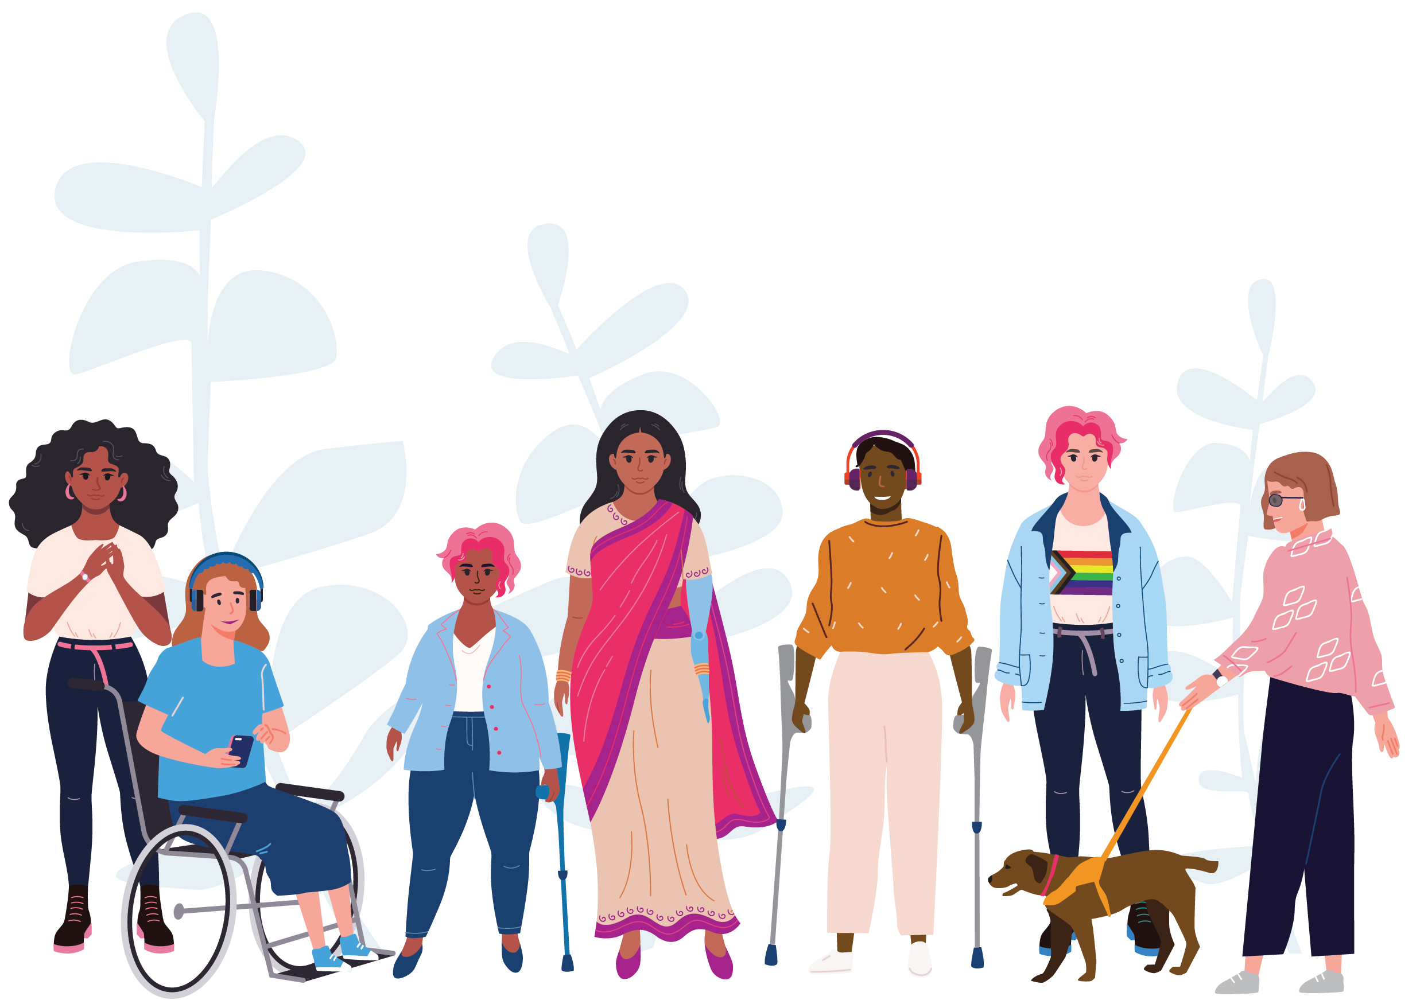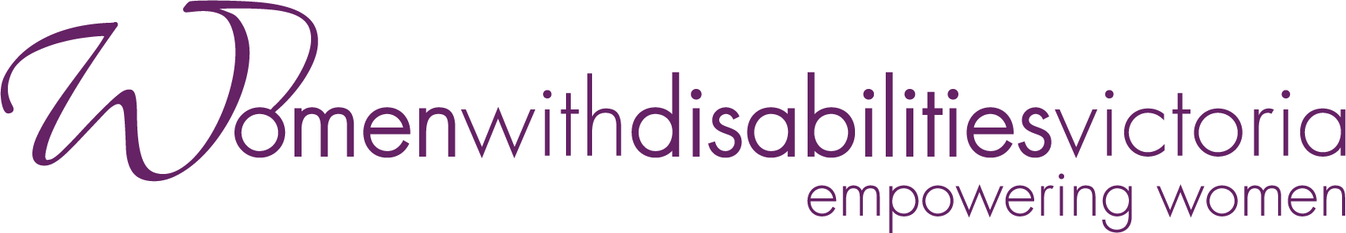



How can we prevent violence against women with disabilities during climate emergencies?

COMMUNITY RESOURCE

AUGUST 2024



|  |
| --- |
| Women with Disabilities Victoria logo  Women with Disabilities Victoria acknowledges the Australian Aboriginal and Torres Strait Islander peoples as the first inhabitants and traditional custodians of the lands on which we live and work. We pay our respects to ancestors and Elders, past and present. The WDV community is committed to honouring the unique cultural and spiritual relationship Aboriginal and Torres Strait Islander peoples have with the land and waters, and their rich contribution to society. |
| Golden Plains Shire Council logo  Golden Plains Shire spans the Traditional lands of the Wadawurrung and Eastern Maar Peoples. Council acknowledges them as the Traditional Owners and Custodians and pays its respects to both Wadawurrung and Eastern Maar Elders past, present and emerging. Council extends that respect to all Aboriginal and Torres Strait Islander People who are part of Golden Plains Shire. |

Background image: 2022 flood at Inverleigh by James Patterson

# About this resource

This booklet, developed by Women with Disabilities Victoria (WDV) and Golden Plains Shire Council (GPSC), is a prevention and early intervention resource for family violence support agencies and community members. It offers guidance for the prevention of violence against women with disabilities during climate emergencies, and for effective evacuation planning.

In this resource, we have prioritised women with disabilities and accessibility as we know the ‘normal’ way of evacuation planning is not always a possibility for some.

This resource has been co-designed with women with disabilities, whose lived experience has informed the content of this resource.

About one in five women in Australia have a disability.[1] Women and girls with disabilities are more likely to experience gender-based violence during and after climate emergencies due to multiple and intersecting forms of discrimination that heighten their exclusion and risks.[2] Women with disabilities in rural settings experience an even higher risk of social isolation and have less access to support services.[3]

Australia is witnessing a significant increase in both the severity and frequency of natural disasters. This means accessible and inclusive planning and safeguarding for the needs of women and girls with disabilities are critical in preventing gender-based violence during these times.

# Women with Disabilities Victoria (WDV)

Women with Disabilities Victoria is an organisation of women with disabilities with a diverse and growing membership which aims to build partnerships, lead the way for Victorian women with disabilities, and improve women’s choices by providing a voice for women with disabilities.

Our Vision

A world where all women are respected and can fully experience life.

Women with Disabilities Victoria Goals:

Influence Policy: Influence government and the community to recognise and remove barriers to full participation by women with disabilities.

Empower Women: Engage and empower women with disabilities to lead and influence their communities.

Influence Services: Educate and guild the capacity of service systems and organisations to be accessible to women with disabilities.

|  |  |
| --- | --- |
| Our Values |  |
| * Uphold human rights and social justice * Equal opportunity * Accessibility * Respect * Collaboration | * Effectiveness * Creativity * Diversity * Accountability |

# Golden Plains Shire Council (GPSC)

Golden Plains Shire Council has seven elected Councillors, which includes a peer elected Mayor, this groups holds the governance responsibility of the Shire. There are over 200 Council staff that assist in the delivery of Council's Legislative functions under the Local Government Act 2020.

As a part of Local Government, Council provides a wide variety of services to our municipality and enforces various federal, state and local laws for our communities outlined under the Local Government Act.

Golden Plains Shire Council Vision and Values Graphic:

Where people matter
Communities are connected
And the future is bright.

Pride - We know that our work is important, and we take pride in doing the best job we can.

Respect - We treat each other with courtesy and respect, and are committed to keeping our environment safe, and free from judgement.

Integrity - We are committed to being authentic, honest and ethical in our work.

Collaboration - We partner together to achieve shared goals and deliver community focussed outcomes.

Excellence - We are committed to delivering the best community experience and outcome that we are capable of providing.

# Disaster is no excuse for family violence

Family violence is against the law in Australia, and rates of violence often increases during disasters and emergencies.[4] However, violence is always a choice, and we all have a role in identifying and responding to family violence in our communities. Family violence can happen with a current or former partner, in same sex, gender diverse relationships, between a parent, carer, child, sibling or extended family. Women with disabilities face specific risks of family violence during climate emergencies, as they may be:

* Unable to evacuate due to physical barriers.
* Unable to access shelters and assistance if they are not inclusive and accessible for women with disabilities.
* Subjected to neglect, by being deprived of necessities such as food, water, shelter, clothing, support services or medical care.
* Subjected to restrictive practices that restrict the rights or freedom of movement including:
  + Seclusion– being placed in a space they cannot leave either because the exit is locked, or because there are real or perceived consequences for leaving.
  + Environmental restraint– being prevented from accessing the community, areas of their homes, or personal possessions such as disability aids.
* Experiencing increased vulnerability due to the limitations and pressures created by sudden homelessness brought on by the disaster.[5]

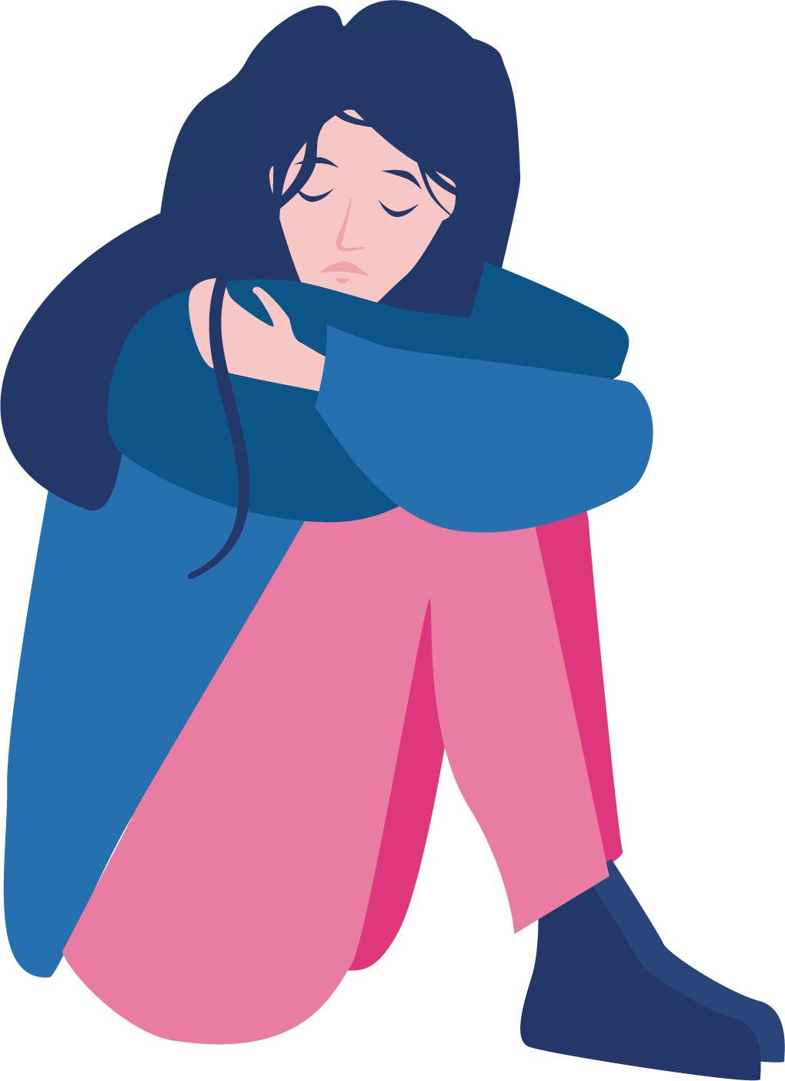

# How to recognise violence against women with disabilities

Women with disabilities experience greater levels of violence compared to people without disabilities and men with disabilities.[6] Family violence can involve any form of violence, including physical, sexual, psychological / emotional, financial abuse as well as restrictive practices and neglect. Family violence often escalates over time, and even more so during climate emergencies.

Therefore, it is important to know the early signs so you can recognise violence against women with disabilities or in your own relationships. Early signs of family violence against women with disabilities may include but are not limited to:

* Verbal abuse such as name calling, manipulation or using disrespectful/degrading language
* Humiliation (regularly putting someone down to damage their self-worth)
* Withdrawing care
* Withholding medication/aids
* Harming pets or assistance animals
* Denying or trivialising the experience of disability
* Monitoring whereabouts
* Isolating a person or preventing them from seeing certain people.
* Financial abuse such as controlling finances or limiting access to money (including government pensions).[7]

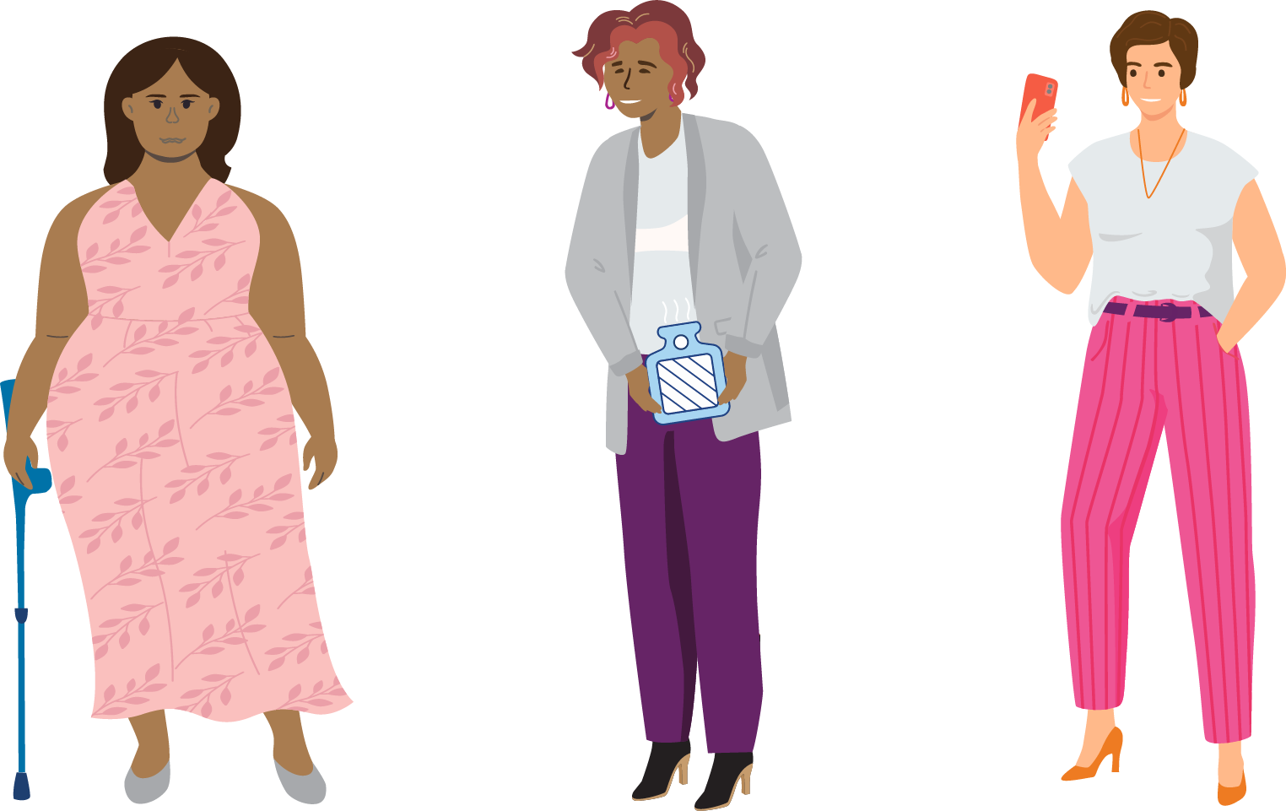

# What you can do to prevent violence against women with disabilities during climate emergencies

On their own, these supporting actions are not sufficient, however, they can make an important contribution to the prevention of violence against women and girls with disabilities.

1. Understand the increased risk of family violence before, during and after climate emergencies:

* Be aware of power differentials in caring relationships and how these can grow during emergencies.
* Be aware of the risk of women with disabilities becoming isolated in rural communities.
* Know the different types of abuse to look out for and check in on people if you are concerned, they are experiencing family violence.

1. Know the relevant support services available to help victims.
2. Undergo ‘responding to disclosures training’ by specialist sexual and family violence services in your area.
3. Build a sense of community by engaging with and including women with disabilities in political, public and community life.

* Support opportunities for women and girls with disabilities to develop social and peer connections.
* Encourage and support political participation by women with disabilities.
* Advocate for the right of women and girls with disabilities to participate equally in the community.[8]

“Council needs to ensure that there is disability representation on any committee about this and make this committee accessible.”  
–Jordy

# How to respond effectively to family violence during times of emergency

It is important during times of emergency not to minimise the impacts of family violence or reinforce unsupportive messages for victims/survivors.

Providing a sensitive and supportive response to a disclosure validates the person’s experience and can impact their willingness to seek further help.

The **most important things** you can do are:

* Actively listen, without interruption or judgement.
* Believe and validate their experiences.
* Emphasise that they are not to blame for what has happened. Violence is always a choice.
* Be clear about the limits (if any) to confidentiality. For example, you may have a legal obligation to share some of this information with other people if you believe that there is an immediate risk of harm.
* Provide information of available support services.[9]

Important **things to avoid** include:

* Trying to fix the situation or provide solutions/counselling.
* Talking about your own experience of violence.
* Talking negatively about the perpetrator – often these are people who the victim may still care about.
* Asking lots of questions/pushing for information.
* Criticising their choices or telling them what to do.[10]

Some examples of unsupportive messages may include:

* Making excuses for the behaviour of the abusive person (e.g. “they were stressed” or “they were drunk”).
* Excusing the behaviour by mentioning unrelated aspects of their identity/behaviour (e.g. “they are such a great dad/community leader”).
* Suggesting that there are bigger problems to deal with (e.g. “now is not the time as people are too busy to help” or “other people have it worse”).
* Discouraging making a complaint due to how it may affect the abusive person.[11]

Collecting evidence

Keeping a record of abusive or frightening things that happen can help with protection orders or child custody cases. Keep these records and documents in a safe place where it won’t be found by the abusive person and share this evidence with a **trusted** family member/friend.

**Evidence of violence or abuse** might include:

* A personal diary or calendar in which documents the abuse.
* Photos of physical injuries or signs of violence (e.g. torn clothing, bloodstains, damaged property).
* Screenshots of abusive social media messages, text messages or emails.
* Saved voicemails.
* Video and audio recordings.
* Bank statements, particularly if you are experiencing financial abuse.
* Evidence of contact made when there is a protection order in place.[12]

Evacuation Essentials checklist

In emergencies, there may not be time to pack a complete list. Below are suggestions of items to prioritise:



**Essential documents including:**

* Photo ID
* Medicare card
* Birth certificates
* Visa documentation
* Court/protection orders
* Family violence provision supporting documents
* Marriage/divorce papers
* Police records
* Child support information
* Any evidence of abuse in a diary/folder (ideally save this information in your email so you can access it anywhere).

**Assistive technologies, important documents and other health management essentials including:**

* Phone and chargers (including  
  phone numbers of support people and support services)
* Copies of concession/health insurance cards
* Prescriptions
* Medications
* Medical devices, e.g. glasses, hearing aids
* Your most utilised assistive technologies and extra power banks
* Assistance animals, plus their food, water, leash, bedding, medicines, and registration records.

# Who is in your community?

# Who are our support systems?

Living in a rural or remote area can pose challenges when evacuating during a climate emergency. Strong community systems that are accessible and inclusive to experiences of women with disabilities means we can challenge violence during times of uncertainty, such as a climate emergency.

When we plan alongside the women with disabilities in the community during those times, we can ensure a more quick and easy evacuation, and mitigate the drivers of ableist and gender-based violence.

**Some things to consider:**

1. Talk with your community about how to plan support from family members, support workers, carers, or assistive technologies to travel. Have their contact details in an easily accessible place.
2. Plan who you would contact for transportation if you or someone that you are in contact with cannot travel independently.
3. Plan accessible evacuation routes out of your home.
4. Know your neighbours.

◊ Tip: Red Cross RediPlan offers postcards that you can use to introduce yourself to your neighbours and find different ways to support each other before, during, and after emergencies.

“Get a neighbourhood conversation going. Put together a BBQ for people in the community or on your street to get together and meet. Very rarely do you see your neighbours. Create a sense of community to look out for one another.” – Emmy

# Support services

If you are experiencing family violence, help is available.

**1800RESPECT:** 24/7 sexual assault and family violence information, support and counselling.

T: 1800 737 732

T: 1800 555 677 (National Relay System)

T: 13 14 50 (Interpreter)

**Safe Steps**: Victoria’s 24/7 Family Violence Response Centre

T: 1800 015 188

E: safesteps@safesteps.org.au

W: safesteps.org.au/chat (Chat Monday to Friday, 9am to midnight)

**The Orange Door:** free service for adults, children & young people experiencing or who have experienced family violence.

T: 1800 312 820 (Central Highlands)

T: 1800 219 819 (Barwon)

**Victorian Sexual Assault Crisis Line:** counselling services for people who have experienced sexual assault.

T: 1800 806 292

**InTouch Multicultural Centre against Family Violence**: supports women from migrant and refugee backgrounds. (Monday to Friday 9am-5pm)

T: 1800 755 988

W: intouch.org.au

**Djirra:** legal and non-legal support to Aboriginal and Torres Strait Islander people. (Monday to Friday 9am-7pm).

T: 1800 105 303

**With Respect:** LGBTIQA+ family violence service.

T: 1800 542 847

**The Sexual Assault and Family Violence Centre**: free, sexual assault and family violence services.

T: 03 5222 4318 (Geelong Service)

**Emergency Accommodation:**24/7 state-wide support, speak with a housing and support worker.

T: 1800 825 955

**VicEmergency:** website and app provides Victorians with access to information and warnings about incidents including:

* fires
* storms
* floods
* earthquakes
* tsunamis and more.

You can download the app from the Apple App Store or Google Play.

VicEmergency also publishes warnings and incident information via social media, including on Facebook or X (formerly known as Twitter) channels.

VicEmergency Hotline provides information during and after major incidents in Victoria. It also offers information to help householders, landowners, and small businesses plan for and recover from emergencies.

T: 1800 226 226

T: 1800 555 660 (National Relay Service)

T: 13 14 50 (Translating and Interpreting Service)

# Other Safety Apps

|  |  |
| --- | --- |
| Daisy app logo | Daisy app  (developed by 1800RESPECT)  A free app (downloadable from iTunes or Google Play) that you can use to search for support services in your local area and is available across Australia. You can visit service websites from within the app which means the sites won’t show up in your browser history, which can help protect your privacy if the abusive person can access your device. |
| Sunny app logo | S**unny app**  (developed by 1800RESPECT and Women with Disabilities Australia)  A free accessible app for people with a disability who have experience violence or abuse. It can support people with a disability to tell their story, understand what has happened, know their rights, and find people who can help and learn about the different types of abuse. |
| Arc app logo | Arc  (developed by Safe and Equal)  Arc can assist people with documenting abusive behaviour and recording their experiences. Its functions include being able to upload photos, videos, audio and diary entries to keep a log of events. The Arc App is available on IOS or Android and can also accessed via internet browser. |
| Positive Pathways app logo | Positive Pathways  (developed by Zonta House Refugee Association)  A free safety and wellbeing app for use in emergencies with audio recording, automatic help messages, GPS location and a one touch 000 call function. This app is accessible anywhere in Australia via the Apple App store. |
|  |  |
| Emergency+ app logo | Emergency +  (developed by Australia’s emergency services, and their government and industry partners)  Helps to call Triple Zero quickly and communicate your location to emergency call-takers. It also includes SES and Police Assistance Line numbers as options prioritise emergency and non-emergency calls with the appropriate number. You can download this free app from the Apple App store or Google Play store. |
| Help Me app logo | Help Me  (developed by the Daniel Morcombe Foundation)  Designed to help keep children safe, however this app can help people of all ages, covering all personal emergencies. It contains resources that help educate kids and parents on how to stay safe. It also includes a ‘help me’ button that sounds like a warning and sends an SMS to those on your safety network. This free app is available from the Google Play store. |



Wurundjeri Country

Postal: PO Box 18314, Collins Street East, VIC 8003

**Phone: 03 9286 7800**

**Email:** [wdv@wdv.org.au](mailto:wdv@wdv.org.au)

For more information visit <https://www.wdv.org.au/>

Golden Plains Shire Council

2 Pope Street, Bannockburn, Victoria 3331

19 Heales Street, Smythedale, Victoria 3351

**Ph: (03) 5220 7111**

**Fax: (03) 4206 7011**

**Email:** [enquiries@gplains.vic.gov.au](mailto:enquiries@gplains.vic.gov.au)



1. Disabled People’s Organisations Australia & National Women’s Alliances. (2019). *The Status of Women and Girls with Disability in Australia. Position Statement to the Commission on the Status of Women (CSW) Twenty-Fifth Anniversary of The Fourth World Conference on Women and The Beijing Declaration and Platform for Action (1995).*
2. Le Masson, V. (2022). *Disasters, Climate Change, and Violence Against Women and Girls.* Oxford Research Encyclopedia of Natural Hazard Science, (June), 1–26. https://doi.org/10.1093/acrefore/9780199389407.013.393.
3. Camilleri, M. (2019). *Disabled in rural Victoria: Exploring the intersection of victimisation, disability, and rurality on access to justice.* International Journal of Rural Criminology, (5)1. 88-112.
4. UN Women. (2022). *Domestic violence increase during natural disasters.* <https://wrd.unwomen.org/explore/insights/australia-domestic-violence-increase-during-disasters>
5. Our Watch (2022). *Changing the Landscape. A national resource to prevent violence against women and girls with disabilities.*
6. Our Watch (2022). *Changing the Landscape. A national resource to prevent violence against women and girls with disabilities.*
7. Women with Disabilities Victoria (WDV). (2023). *Taking Action Guide*
8. Ibid.
9. Safe and Equal. (2024). Practical tips for responding to disclosures. <https://safeandequal.org.au/working-in-family-violence/prevention/disclosures/>
10. Ibid.
11. 1800RESPECT. (2024). Responding effectively. https://www.1800respect.org.au/inclusive-practice/violence-in-times-of-disaster/responding.
12. Ibid.