1 August 2024 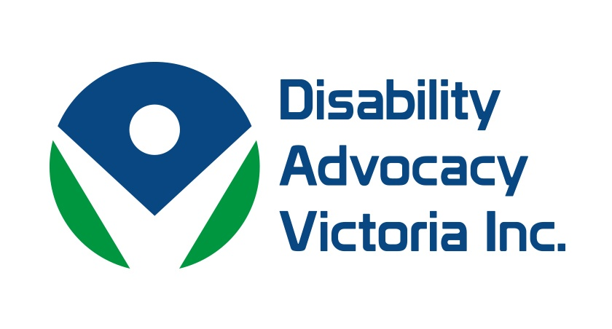

**DPO Victoria**

**MEDIA RELEASE**

Missed opportunity to ensure Victorians with disabilities are free from violence abuse and neglect.

The Victorian government’s failure to adopt in full the vast majority of the recommendations made by the Disability Royal Commission ensures the continued mistreatment of Victorians with disability, according to Victorian peak disability organisations.

In a joint statement, Disability Advocacy Victoria (DAV) and Disabled Persons Organisations (DPO) Victoria expressed their disappointment and frustration with Victorian and Federal government responses to the Royal Commission released yesterday

Julie Phillips, Chairperson of DAV, said: “With under 20 of over 220 recommendations accepted nationally and at the state level, both state and federal governments have failed to show the vision and commitment needed to end the abuse and neglect of people with disabilities.”

“The refusal to address the segregation of people with disabilities, given the Commission’s findings that link these settings with increased abuse, is particularly disappointing. People living in group homes will continue to be at particular risk,” said Ms Phillips.

Thousands of people with disabilities, their advocates and families, provided the Disability Royal Commission with a shocking picture of high levels of violence, abuse and neglect against them in numerous areas of daily life including education, employment and housing.

The Victorian government’s failure to act quickly and decisively to increase protections against such violence, mirrored in its lacklustre response to the Commission’s recommendations, is deeply disappointing to Victorians living with disability, who yet again feel let down by their governments.

Nadia Mattiazo, speaking on behalf of DPO Victoria, said “The Disability Royal Commission saw thousands of detailed and compelling testimonies delivered over nearly four and a half years. A few months down the track and these expert perspectives are simply being overruled. There must be a better way forward, we can’t accept that this is the best Victoria can do.”

“The current state of emergency for Victorian disability advocacy agencies, who are cutting staff and not even sure if they will still be operating in the next two years due to lack of funding, will impact directly on people with disability” said Ms Mattiazo. “The crumbling of disability advocacy infrastructure in Victoria is a sad reflection on the government’s views on the value of the disability community, and their rights to be free of abuse.”

DAV and DPO Victoria called on the Victorian Government to establish a Victorian Disability Reform Implementation Council to work in parallel with a proposed Federal Disability Reform Implementation Council, ensuring the direct involvement of people with disabilities and their representatives in the meaningful adoption and implementation of the full suite of Royal Commission recommendations at the State level.

Nadia Mattiazzo - DPO Victoria 0497 538 528

Julie Phillips - Disability Advocacy Victoria 0417 570 197

DPO Victoria - collective of disabled persons organisations

Disability Advocacy Victoria - peak body for independent disability advocacy agencies