FACT SHEET 03

Take an active approach to understanding gender, health and disability

This fact sheet is for healthcare staff. Healthcare staff includes administrative staff, clinical and allied health professionals.
A holistic approach to understanding the relationship between gender, health and disability can support positive healthcare experiences for Women with Disability (WWD).
These often complex and interrelated factors can influence the health and healthcare needs of WWD.
Here is how you can take an active approach to understanding gender, health and disability:

Social model of disability
You should learn about the social model of disability and understand that:
Inequality is a result of social environments that are created in ways that exclude WWD from taking part.
- Attitudes and environmental barriers need to change so WWD can participate and have equal opportunities.
WWD often encounter barriers and exclusion, this can be exhausting and stressful. These environmental and system barriers will contribute to how WWD can engage with your healthcare services.
To further support and be an ally of WWD you can:
Ask what you can do to remove or reduce specific barriers that your clients are facing.
Aim to eliminate physical, attitudinal, and other barriers to effective healthcare. Barriers can be:
- Physical, such as stairs
- Attitudinal, such as believing that WWD don’t have sex or need to know about sex
- Other such as communicating with WWD in ways that do not work for them.
Offer services, facilities and information that is accessible and inclusive of each client’s needs.
Use inclusive, respectful language
- Do not use ableist language and slurs.
Ableist language and slurs are words or phrases that may be hurtful, upsetting, retraumatising or offensive to many disabled people. Follow each person’s lead on which language to use. For example, if a client uses the term ‘disabled person' or 'person with disability' then you should use those terms when talking to them.

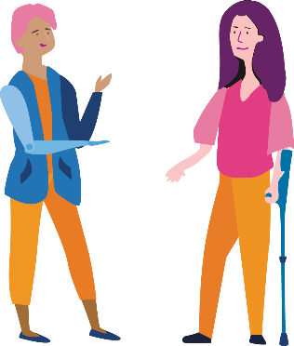
Consider disadvantage
Consider the implications of disadvantage and social systems on your clients’ health and access needs, including:
Aboriginal or Torres Strait Islander identity.
LGBTIQA+ identity.
Gender.
Age.
Cultural background.
Immigration or visa status.
- Socio-economic status.
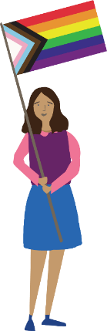
WD who are members of multiple disadvantaged groups experience unique barriers to healthcare. You should consider that:
Immigrant women may not have access to Medicare.
- First Nations women may experience intergenerational trauma and may not have access to culturally safe and appropriate health services.
Learn about safe and holistic healthcare for WWD to:
Recognise that WWD are more likely to experience family violence.
Know how to identify potential violence and/or coercive control from support people of WWD.
- Know how to respond to disclosures of violence and abuse from WWD.

Social determinants of health
Healthcare staff should:
Use a holistic approach based on the social determinants of health for WWD.
Be involved in finding and engaging with appropriate and broad supports such as:
- Housing
- Emotional support
- Disability support
- Employment
- Transport
- Finances.
Learn about services that WWD might be eligible for and proactively inform them.
Understand your role as potential ‘gatekeepers’ of services and provide continuous support to increase access for WWD.
Ask about disability and how you or other service providers can be of assistance.
- Ask about both physical and mental health, as these are interrelated.

Accessible information
Healthcare staff should promote and provide accessible information to support clients' participation in their healthcare.
You should proactively:
Find out about your clients' health literacy levels.
Tailor health information to your clients' needs.
Provide health information in accessible formats and alternate languages.
Support WWD to develop their health literacy to maximise their healthcare participation.
- Research and provide information about available supports.

More information
You can learn more at: www.wdv.org.au
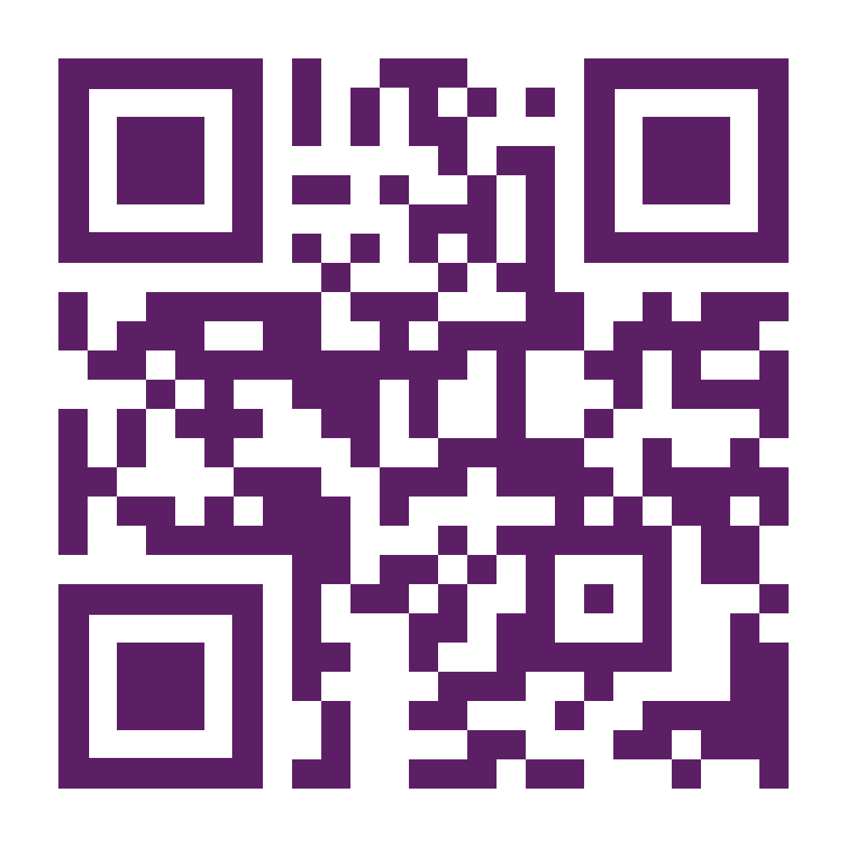
The development of this resource was supported by the Australian Government Department of Social Services. Go to www.dss.gov.au for more information.
The Australian Government Department of Social Services funding is gratefully acknowledged.
Women with Disabilities Victoria would also like to acknowledge the ongoing support from our partner organisations – Multicultural Centre for Women’s Health, Women’s Health Loddon Mallee and Women’s Health in the North as well as members of the Project Advisory Group.
Our particular thanks to Women with Disabilities Victoria’s twelve Health Experts, who contributed their expertise to this resource as part of our co-design process.
This resource was prepared by Women with Disabilities Victoria.
Published by Women with Disabilities Victoria: PO Box 18314, Collins Street East. VIC 8003
© Women with Disabilities Victoria 2022

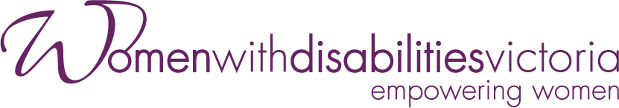
Wurundjeri Country
Postal: PO Box 18314, Collins Street East.
VIC 8003
Phone: 03 9286 7800
Email: wdv@wdv.org.au

