A Right to Respect: Preventing Violence against Women with Disabilities Training

Women and girls with disabilities are twice as likely to experience violence as those without disabilities.
This online workshop, aimed towards disability and social services workforces, will show how gender and disability inequality drives violence, and how you can prevent it.
The training will be delivered over three sessions:
- Session 1:
Introduction to Prevention of Violence against Women with Disabilities
- Session 2:
Drivers of Violence and Essential Actions
- Session 3:
Managing Disclosures in a Prevention Context
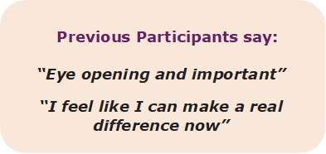

Details
Date: Session 1:
Tuesday 8th September
OR Thursday 10th September
Session 2: Tuesday 15th September
Session 3: Tuesday 22nd September
Time: 10am–1pm
Location: Online via Zoom
Register:
by Wednesday 2nd September: https://arighttorespecttraining.eventbrite.com.au
For more information: contact Olivia Franklin on 0433 691 548.

What you will learn
Session 1: Introduction to Prevention of Violence against Women with Disabilities
- How gender and disability inequality intersect to create disadvantage for women with disability
- Impacts of violence against women with disability
- Why gender inequity is a key driver of violence against women with disability
Session 2: Drivers of Violence and Essential Actions
- How our everyday actions and practice can contribute to violence against women with disability
- How gender and disability equitable practice can create change to end violence
- Strategies and tools to prevent violence against women with disability
Session 3: Managing Disclosures in a Prevention Context
- How primary prevention can inform the safe management of disclosures of violence against women with disability
- Referral services which can assist in responding to women with disability who experience violence.
The training is co-facilitated with an expert in violence prevention and a woman with a lived experience of disabilities. It is evidence-based, aligning with the latest research on disability, Our Watch’s Change the Story, and the Preventing Family Violence & Violence against Women Capability Framework.

Pricing
(per participant, including GST)

Organisation (cost per person)
- 1 x session delivery $150
- 2 x session delivery $200
- 3 x session delivery $250

Individual/sole trader
- 1 x session delivery $80
- 2 x session delivery $100
- 3 x session delivery $120
It is not essential to attend all three sessions, but please note that Session 1 is a prerequisite for Sessions 2 and 3.

