

**Women with Disabilities Victoria**

**Advocacy and Linkage Forum**

Are you a woman with a disability living in, or near, Traralgon?

Do you want to learn more about your rights or how to vote?

Do you want to meet with local advocacy organisations and services?

Do you want to add your voice to Women with Disabilities Victoria’s advocacy work?

Women with Disabilities Victoria, in partnership with Gippsland Disability Advocacy Inc., is organising an advocacy and linkage event in Traralgon.

**Details:**

Wednesday 11th April 2018

12:30pm – 4pm

Traralgon Service Centre

34-38 Kay Street, Traralgon, VIC, 3844

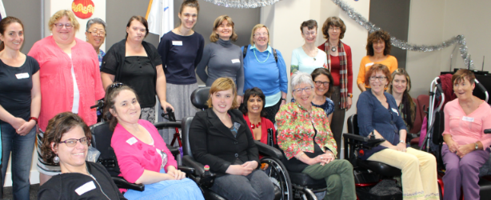There will be opportunities to meet, and speak to, representatives from the following organisations:

* Women with Disabilities Victoria
* Gippsland Disability Advocacy Inc.
* Latrobe City Council Rural Access
* Gippsland Women’s Health
* The Victorian Electoral Commission

Women with disabilities attending a WDV event

**Can’t get to Traralgon?**

If you have access to a computer or mobile device with a high speed internet connection, you can attend this event virtually!

Contact Lauren Brain at [lauren.brain@wdv.org.au](mailto:lauren.brain@wdv.org.au) or (03) 9286 7821 for more information, or select virtual attendance on the Eventbrite registration below.

**To Register**

Please register for this event on Eventbrite by **Tuesday 3rd April 2018.** Eventbrite Link: <https://wdvforum110418.eventbrite.com.au>

If you would like assistance to register for this event, please contact Bridget Jolley at [bridget.jolley@wdv.org.au](mailto:bridget.jolley@wdv.org.au) or (03) 9286 7813.