**Enabling Women Leadership Program**

A community-based leadership program for women with disabilities in Melbourne’s Inner North Metro Region

The **Enabling Women** Program is an exciting opportunity for women with disabilities who live, work or play in the council areas of Darebin, Moreland and Yarra to build upon your natural leadership skills, confidence, expand your community networks and contribute to your community in a meaningful way. **We are looking for applicants!**

**Program dates:**

The program will run for 6 days over 6 weeks from the 15th August to 19th Sept 2017. It will run over **5** Tuesdays on 15/8, 22/8, 29/8, 12/9, 19/9 and **1** Thursday on 7/09 at the Northcote Library. There will be a celebratory graduation ceremony on Tuesday 3rd October and a graduate reunion will be on Tuesday 31st October 2017.

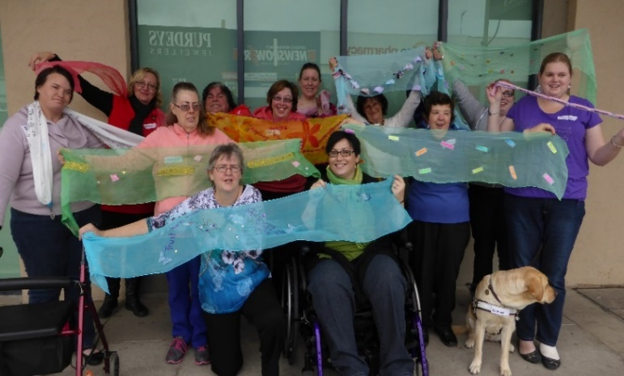**Enabling Women will encourage:**

* Leadership skills
* Confidence
* Connections with other women
* Information about your rights
* Learning with fun
* Self esteem

**Goulburn Valley Graduates, 2015**

There is **no cost** to be involved. It is great opportunity for local women with disabilities from diverse backgrounds to come together. Program participants can share their own experiences, make friends, connect and support one other to achieve their goals.

**For more information, you are welcome to come to the information session on:**

Thursday, 29 June from 10:30am-12:00pm at the Northcote Library, 32-38 Separation St. Northcote.

Please **register** your attendance for the Information Session or if you have any queries, please call Carly Myers, Women with Disabilities Victoria, on 9286 7815 or email [carly.myers@wdv.org.au](mailto:carly.myers@wdv.org.au) . If you have any access requirements, please let Carly know.

**You can directly apply for Enabling Women by contacting Carly!**

*In partnership with Supported by*

