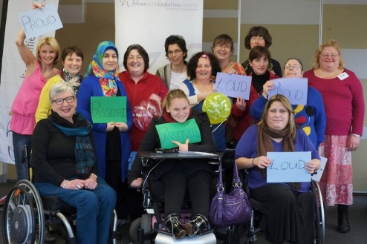

Enabling Culturally and Linguistically Diverse
Women Leadership Program Footscray 2017

Are you a woman who sees their disability as a strength?  Are you a migrant woman whose first language is not English?  Are you a woman who takes on life’s challenges?  The Enabling Culturally and Linguistically Diverse Women Leadership Program is an exciting free opportunity for culturally diverse and migrant women with disabilities to come together, share their lived experiences and support each other to develop a strong sense of leadership within their community. | This program is a safe environment that respects and welcomes women of all cultures and abilities.  This program will give you:  - Leadership skills  - Confidence  - Connections with other women  - Information about your rights  - Embracing your culture  - Learning with fun  - Self esteem
The program runs every Monday over 6 weeks. These dates are:  4th September 2017  11th September 2017  18th September 2017  25th September 2017  2nd October 2017  9th October 2017 and graduation on  16th October 2017  The program is open to culturally diverse and migrant women with disabilities living in Melbourne’s Inner West Region.  The program will be run in Footscray at Maribyrnong City Council | If you are interested in the program, it is strongly encouraged to come and attend the information session to find out more about the program and have the opportunity to ask questions.  Information Session:  Monday July 24th  3.00pm - 5.00pm  Maribyrnong City Council, Community Services Building, corner Hyde and Napier Streets, Footscray  To register for the information session or for more information or assistance to apply please contact Jessica De Mercurio, Women With Disabilities Victoria on 9286 7816 or email: Jess.demercurio@wdv.org.au

