***Brenda Gabe***

Brenda Gabe was a much loved and respected member of Women with Disabilities Victoria.

During her life, Brenda had many roles, including psychologist, champion swimmer and mother. After she was diagnosed with multiple sclerosis, Brenda also went on to become a strong and committed disability advocate.

Amongst her numerous commitments, Brenda represented WDV on various committees, forums and conferences. She played a leading role on disability related campaigns, including accessible housing and public transport, and preventing violence against women with disabilities.

Making a positive difference for women with disabilities was very much at the forefront of all of Brenda’s activities.

*Women with Disabilities Victoria (WDV), kindly acknowledges the significant contribution and support provided by Dr Helen Sykes, AM, Director of Future Leaders, in making this Award available.*

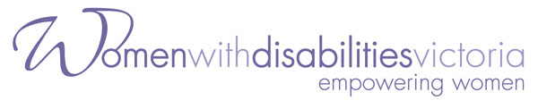

**The 2017 Brenda Gabe**

**Biennial Leadership Award**

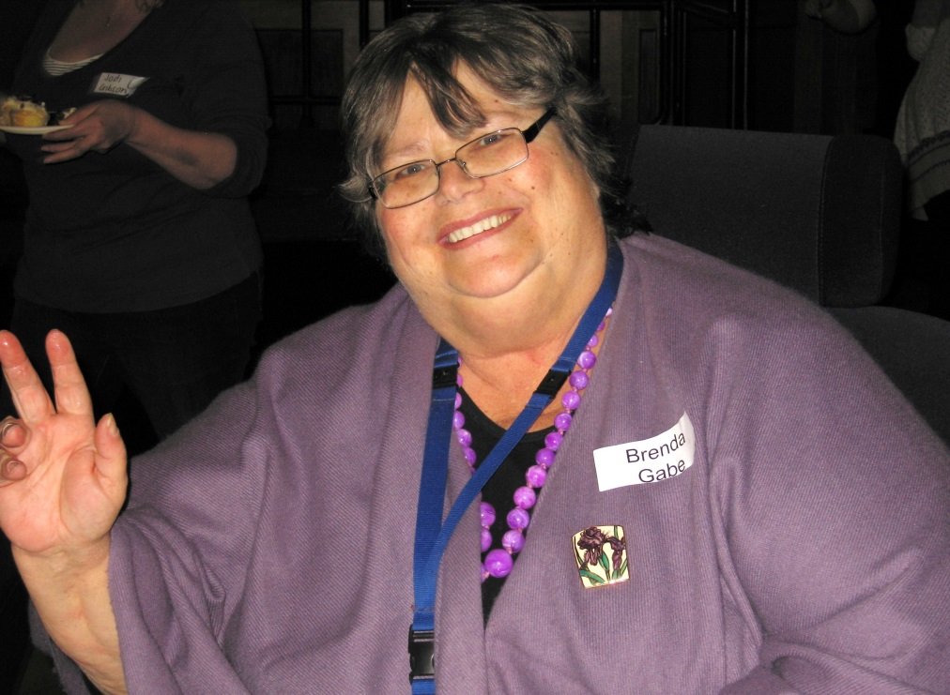

***Celebrating Leadership of***

***Women with Disabilities***

Nominations Close: 7th August 2017

**Eligibility:**

1. Individuals nominated for this award must be a woman with a disability, who is a resident of Victoria; **or**
2. Groups nominated for this award must be women with disabilities, who are residents of Victoria

**Selection Criteria:**

1. The contribution the individual or group has made to benefit the individual or group status of women with disabilities; **or**
2. The contribution the individual or group has made to making a more inclusive community

**Nomination Period:**

Nominations open: 1st May 2017

Nominations close: 28th August 2017

**Selection Panel:**

A panel of community leaders, including at least two women with disabilities, will select the successful nominee

**Requirements of the winners:**

1. Demonstrate the award money has been used for professional development
2. Provide a post 12 months award profile

**The Brenda Gabe Biennial Leadership Award recognises and rewards the contribution women with disabilities have made, that is of direct benefit to women with disabilities, or to making a more inclusive community, in Victoria.**

**We encourage women with diverse backgrounds and/or life experiences to be nominated.**

The winner of the Award is announced at *Women with Disabilities Victoria*’s Annual General Meeting during the day of 13th Nov 2017, and receives $2,000 towards a capacity building project or professional development.

**For further information about the award, including nomination forms, or details about previous nominees and winners, please visit our website at** [**www.wdv.org.au**](http://www.wdv.org.au) **or contact:**

Bridget Jolley

Women with Disabilities Victoria

[E: bridget.jolley@wdv.org.au](mailto:E:%20bridget.jolley@wdv.org.au)

Ph: (03) 9286 7813